Litearras(Literacy)  - The pupils will learn about phonics learning a new sound each week. They will use newly learned words to form basic sentences using full stops, finger spaces and capital letters.  - The pupils will learn about character descriptions using simple adjectives.  - For writing they will learn how to retell events using our weekend news as a focus.  - The pupils will take part in various listening and talking activities to improve their Gaelic language skills.  - They will have access to reading books in the class library and will also have story time each week with Miss Lindsay. | 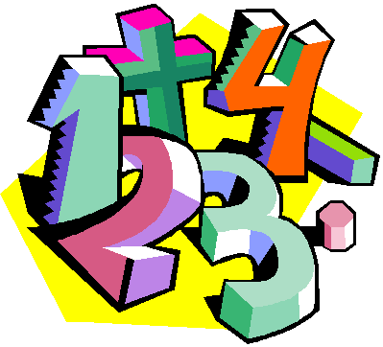  Matamataigs(Maths)  - The pupils will read and write numbers from 0-20 and then beyond. They will count forwards and backwards from 100 and understand and give numbers before and after any given number to 100.  - Later, we will begin place value using 2 digit numbers.  - They will work on their addition and subtraction skills to 20 using their knowledge of number bonds.  - In beyond number they will focus measure. | Slàinte is Sunnd  (Health and Wellbeing)  - In PE on a Monday the pupils will be taking part in a variety of activities to increase their fitness levels. We will also take part in the Daily Mile challenge aiming to run around the pitch 9 times. This will be done over the course of the whole year. On a Thursday the pupils will learn how to work well as part of a team taking part in a variety of fun team games.  - Our Health & Wellbeing lessons will focus on keeping safe and healthy. We will also discuss our feelings on a daily basis and the importance of following the school rules, focussing on listening and respect.
Topaig  - Our topic this term is My Community (Mo Choimhearsnachd). This has social subjects, Art and literacy focuses. We will discuss what makes a good community, investigating our school’s community and each pupil’s home community. | Cuspairean Eile  (Other curricular areas)  - In RME we will look at the story of Jonah & the Whale, then onto Diwali..  - In Technologies the pupils will learn about Internet Safety and coding.  - In Science the pupils will learn about senses and how we use these daily.  - The pupils will learn new Gaelic words through song and in Drama we will be focussing on portraying characters through voice and body movements. | 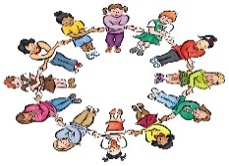  Nòs Agus Beatha Na Sgoile  (Ethos and school community)  - Montaidh is our Gàidhlig Sgoinneil Teddy who will go home with a lucky pupil each Friday, to be returned on the Monday. This will begin on Friday 13th September.  - Homework will be issued for the first time 02/09/19. The pupils will receive a Homework grid where they must complete the starred activities followed by another activity of their choice. The Homework Grid will also be sent out via Parent Mail. Please ensure pupils provide evidence in their homework jotters of the tasks they complete.  - Please have a look on our Twitter page @Glendalegaelic for weekly class updates.
Dòighean Is urrainn Dhuibh Mo Chuideachadh Aig An Taigh- (Ways you can help me at home)

** Please note** As a school we are developing play into P2. The children will have play on various occasions throughout the week, giving Miss Lindsay the opportunity to work with small groups for Literacy and Maths. We also have 1 session a week for Outdoor learning where we team up with P2/1.

Reading for enjoyment is important to encourage children to pick up books and want to read. I would encourage you to read at home, discussing books with you children. Once the children have received their reading book, audio copies can be found on the following website: https://www.gaelic4parents.com/maoilios/read-aloud/storyworlds-series-one

I aim to provide P2 with their first reading book towards the end of the year when they have covered enough phonics work to begin to read basic words.

I would also encourage pupils to take advantage of the excellent programmes available on BBC Alba. This will help with their oral language skills.

I have attached a list of useful websites to help with your Gaelic language skills and ideas for home learning.
www.mygaelic.com
www.bbc.co.uk/alba
www.gaelicforparents.com
www.playtalkread.org
www.familyeducation.com
www.readingrockets.org
www.bbc.co.uk/alba/foghlam/beag_air_bheag
www.communicationcookbook.org.uk

