Blogging Bootcamp Week 1 Spring 2015
This outlines all the suggested activities for week 1 and provides some instructions.
A quick overview of Week 1 can be found at the end of this document.

Welcome to Week 1
This document is based round the Week 1 Glow meet slides
https://glowscotland.org.uk/glowblogs/bloggingbootcamp

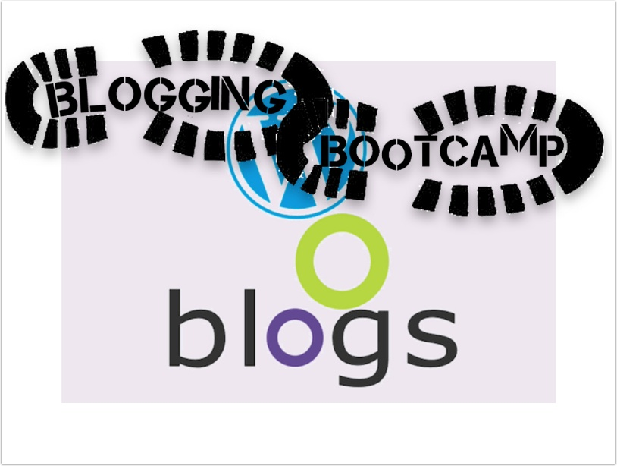

What is a blog, Why are you blogging?
It is worth thinking a wee bit about what you aready know about blogs, and what you think you will get out of blogging. We will have a discussion about this and you are encouraged to blog about this , either as part of you initial post or as a subsequent one.
If you write a blog post you can look back later and see if your ideas change.
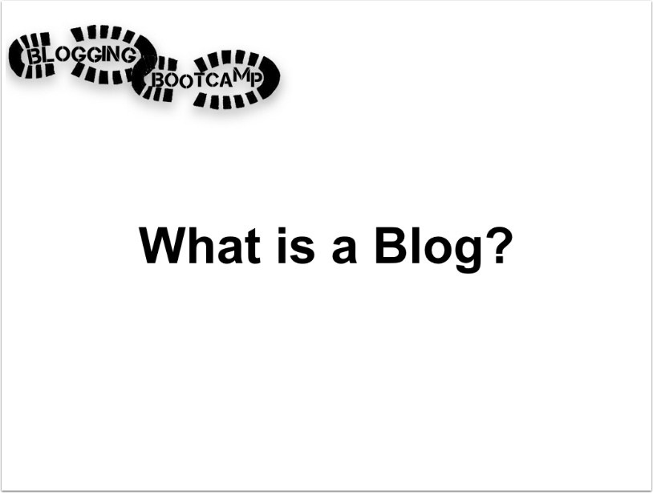

Before We start.
Writing in public needs a bit of though.
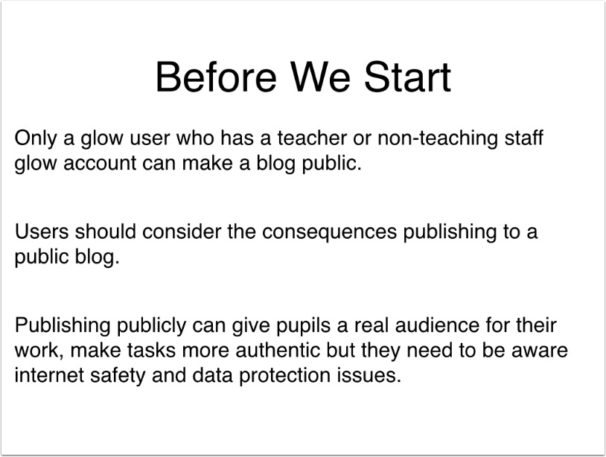

Creating a Blog
the following steps take you through blogging with the Glow Blog's WordPress solution. Other systems may differ in the details.
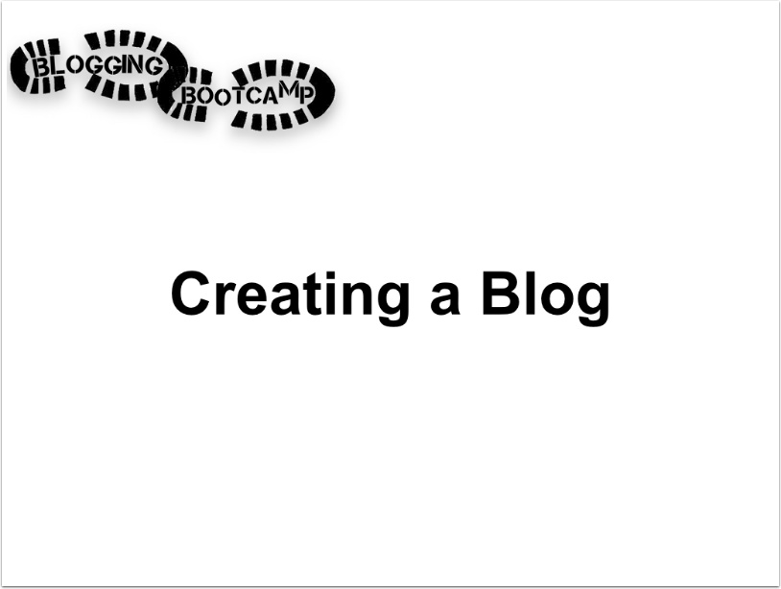

Log onto Glow
And click the tile for your Local Authority Blogs, in my case North Lanarkshire.
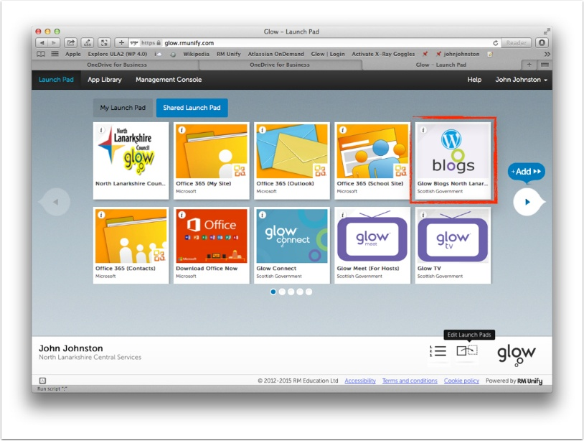

LA Blogs Homepage
The LA hope pages lists the most recently updated Public Blogs. There are links to Help; My Sites, which links to all of the blogs you are a member of and to Create a Blog.
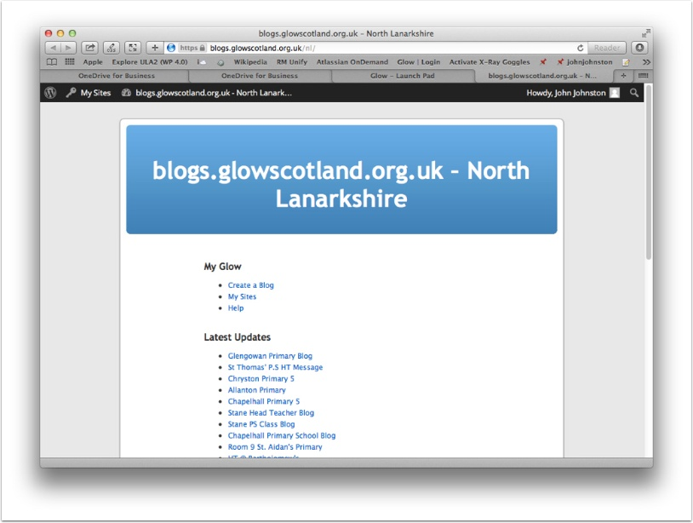

Create a Blog
Click on Create a Blog
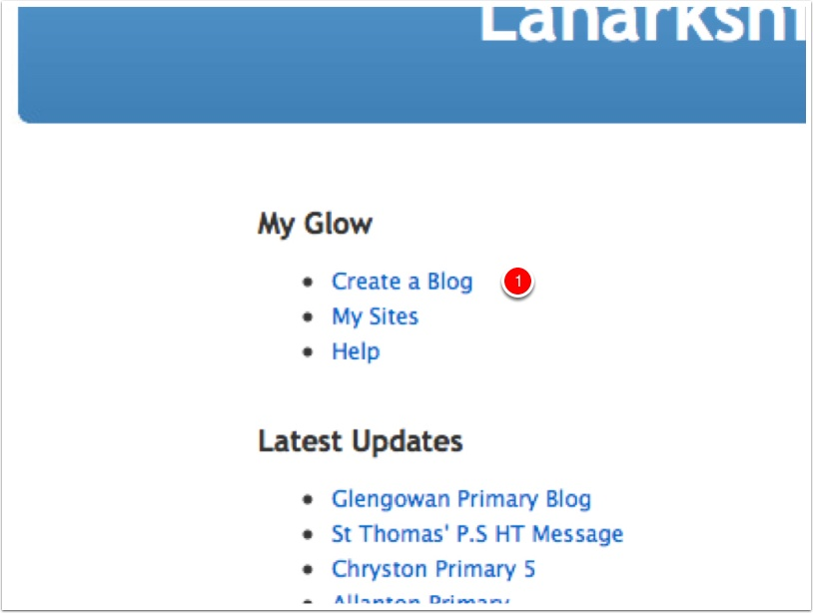

Name your Blog
The next page will show a list of any blogs you have.
You need to type in a name which is the last part of the url. Lovercase and no spaces.
The Title is what visitors see on the blog. You can change the title later, not the name.
Click Create Site.
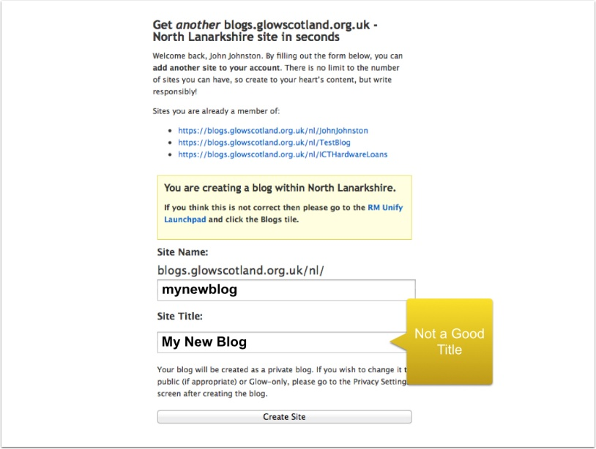

Your Blog is created.
There are links to the Dashboard and the site itself.
The Dashboard is where you work on the blog.
Click Visit your Blog.
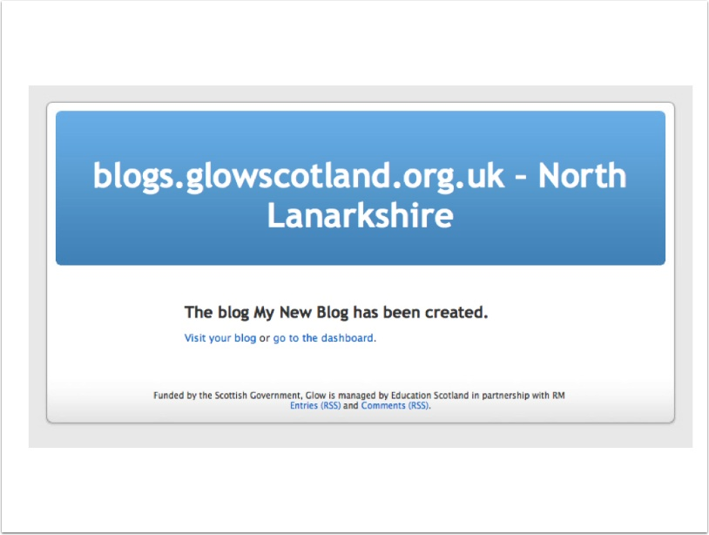

Your Blog
It doesn't look to great at the moment, but we will fix that over the coming weeks.
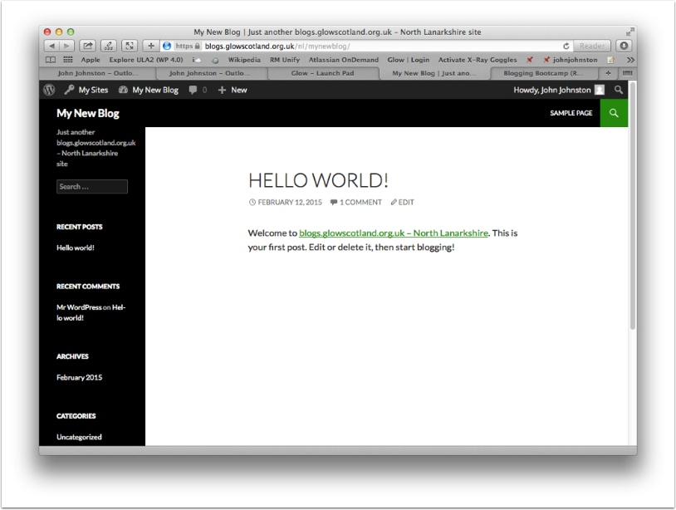

Go to the Dashboard
Click the name of your blog and then Dashboard.
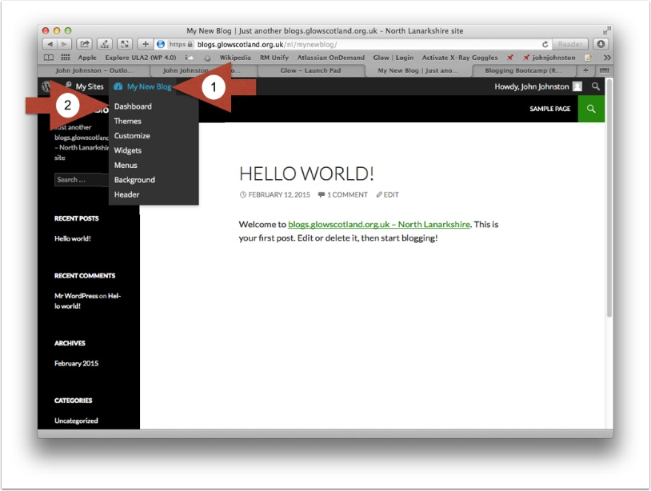

Making the Blog Public 1
Click on Settings in the Dashboard sidebar, then on Reading.
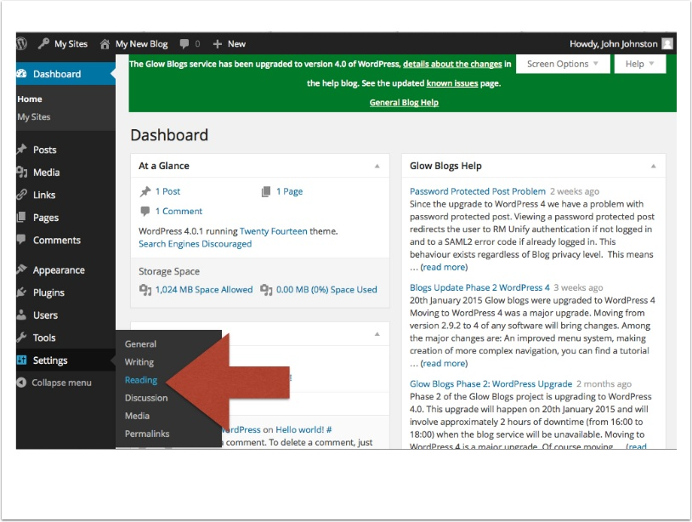

Making the Blog Public 2
Highlight the Public radio button and then Save Changes.
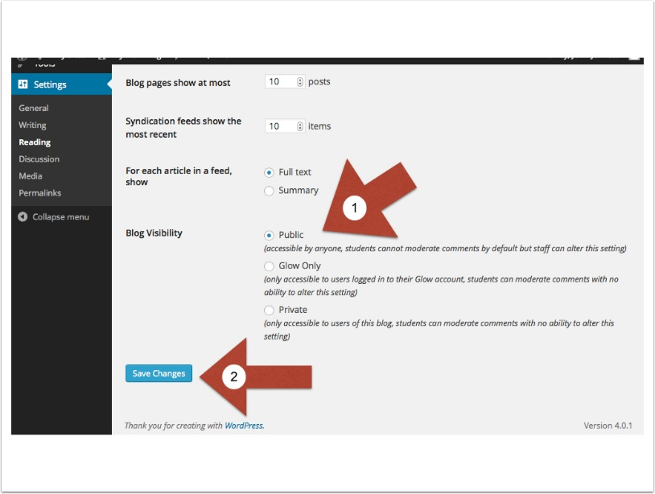

Adding Users 1
Click on Users in the sidebar.
Click on Add Users.
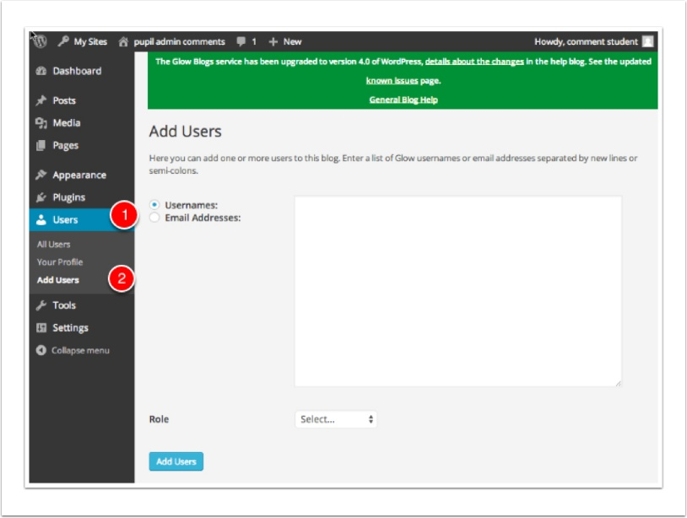

Adding Users 2
1. Add the glow users names of the other people you want to have a role on your blog.
You Glow Admin should be able to download a csv file of your class. You can copy the username column out of this and paste it in.
Or get your pupils to type there names in a list on a document and copy paste from that. (You could use a share word doc in glow)
2. Set the Role, if you want your pupils to write and publish on the blog the best choice is Author.
3. Click Add Users.
See the Glow Blog help blog for more details:
https://blogs.glowscotland.org.uk/glowblogs/glowbloghelp/?p=705
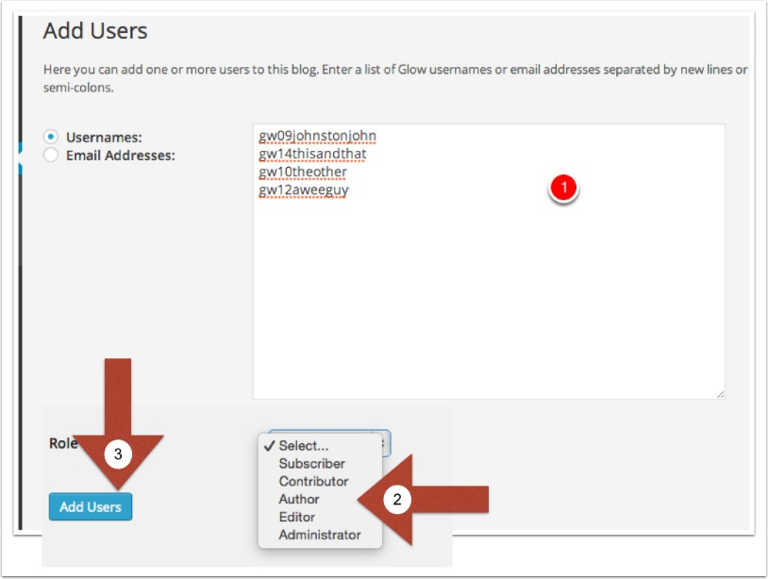

Edit Users
On the All Users screen on the Dashboard you can remove users or change their role.
Users you have added to the blog but who have never logged onto Glow Blogs will be marked as PENDING.
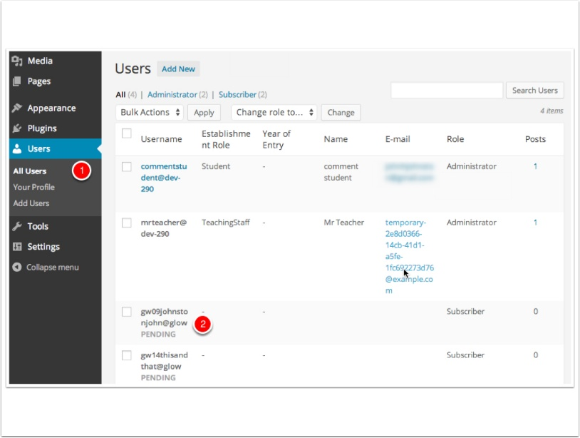

Your First Post
There are a myriad of other settings in the Dashboard and we will explore some of them in the next few weeks.
But it is time to make your first Post.

New Post
Once you are logged onto Glow, both in the Dashboard and on the blog itself, you will see a +New link, hover over that and click Post.
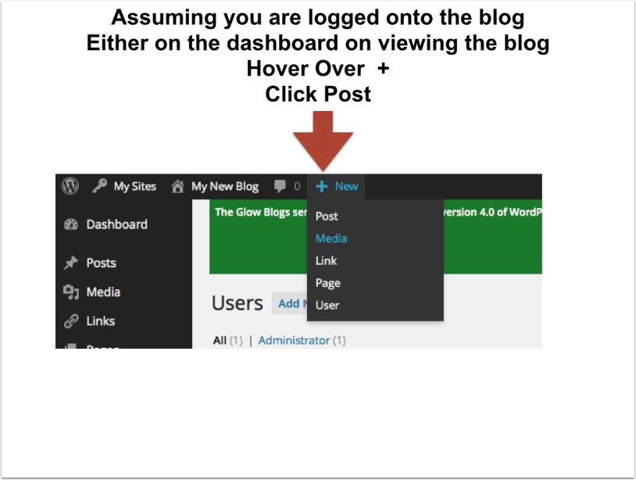

Writing your post
The simplest possible post consists of a Title and the post Body.
For the bootcamp it is also essential that we categorise our posts bootcamp. We will show how to do this on the next slide.
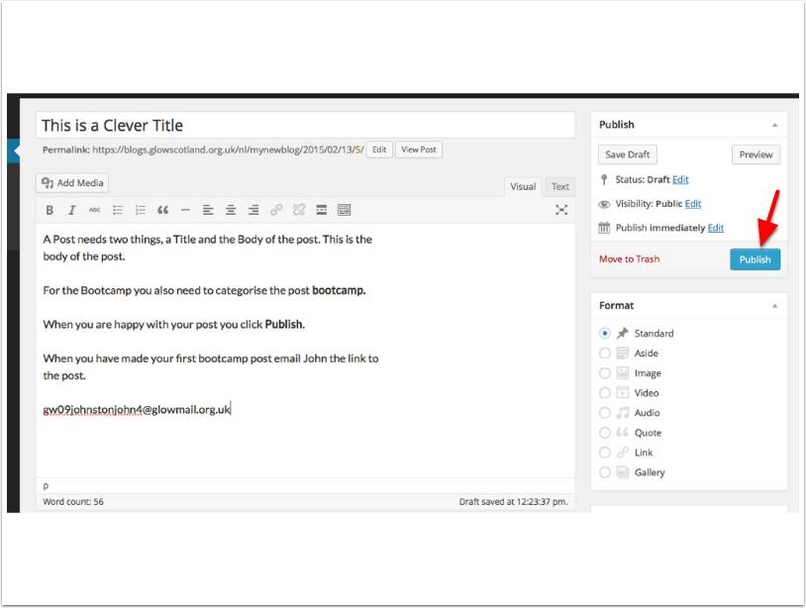

Adding a Category
Categories are a way to organise the posts on your blog. We will talk a bit more about them later. For now all we want to do is make sure we categorise all our posts for the bootcamp bootcamp.
This will allow me to display the latest posts from the bootcamp participants on the sidebar of the bootcamp blog.
Remember to Publish your post once it is done.
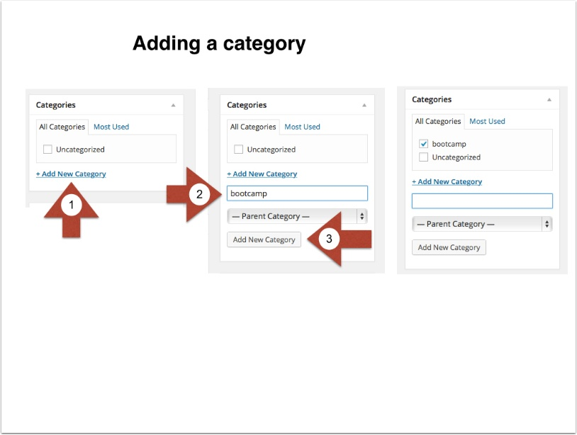

Send in your link
After you have published your first post please send the link to it to:
gw09johnstonjohn4@glowmail.org.uk
I only need the first one. but you can also email any questions or observation throughout the bootcamp.
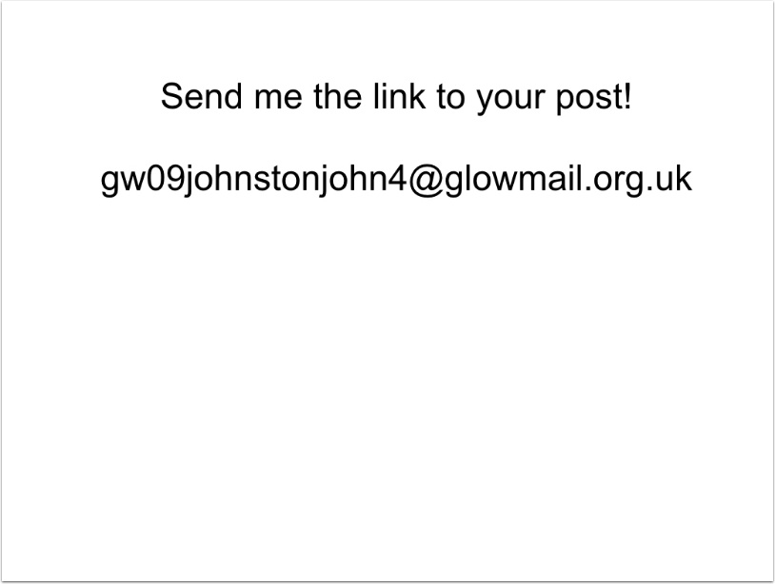

Week 1 Overview
- Set up Your Blog
- Make the First Post
- Discuss why you are blogging blog about this
Categorise your posts bootcamp.
Send John the link to your first post.
Visit the bootcamp blog, visit other participants posts. Leave them comments.
The material in this document is © Crown copyright . You may re-use this information free of charge in any format or medium, under the terms of the Open Government Licence. The OG Licence is equivalent to the Creative Commons Attribution License 4.0 All this means is that you can copy, remix, and reuse anything in his document as log as you give credit. A link back to the bootcamp blog would be appreciated.

