Cultural Competence in Practice: A Reflective Tool for Trainee and Newly Qualified Educational Psychologists
Developed by Rachel Beattie, Ashley Cairns and Jemma Coysh (Trainee Educational Psychologists)

This tool has been developed by Trainee Educational Psychologists in collaboration with peers and practitioners at all stages of the training journey. It is designed to support those in training or the early stages of their careers in reflecting on and enhancing their cultural competence. By encouraging self-awareness and critical reflection, the tool aims to empower users to explore their practice during shadowing experiences and independent work, helping to identify strengths and pinpoint areas for growth.
Cultural Competency’ refers to the ability of psychologists to understand, appreciate and interact effectively with individuals from diverse cultural backgrounds. This involves recognising the diversity both between and within cultures, conducting cultural self-assessment and adapting personal behaviours to meet the needs of culturally diverse populations.
Cultural competence is vital in Educational Psychology to ensure that support for children, families and schools is fair, inclusive and responsive to diverse cultural contexts. Developing this competence early not only promotes equitable practices but also builds trust with communities and equips practitioners to work effectively in Scotland, a vibrant and multicultural society enriched by its diverse communities.
In using this tool, you are invited to reflect deeply on your developing practice, identify areas for improvement and commit to personal growth. Cultural competence requires ongoing effort, and the journey from fear to learning to growth involves taking personal responsibility and proactive steps. The infographic over the page illustrates how the process of becoming anti-racist progresses through stages of awareness, learning and action. Remember, the key to growth is not perfection but a willingness to engage, reflect and take meaningful steps toward more equitable and inclusive practice.

Journey to Becoming Anti-Racist
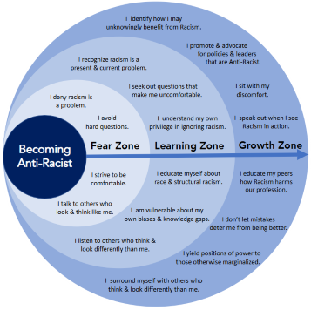
Ibrahim, A. M. (n.d.). Becoming anti-racist. Surgery Redesign. Retrieved from https://www.surgeryredesign.com
How to Use the Self-Reflection Tool
The Self-Reflection Tool is divided into eight sections, each representing a different area of the work of an Educational Psychologist where cultural competence is required. These areas cover the five core functions of the role, as well as practitioner awareness, knowledge of cultural competence and ability to challenge discrimination.
To use the wheel, consider the centre (0) to represent ‘not confident at all, with a lot of development needed’ and the outer edge (10) to represent ‘very confident, thoroughly considered in my daily practice’. Reflect on your current confidence level in each area and mark a score out of 10 for each section on the wheel. Each area of the wheel is accompanied by a set of corresponding prompt questions to help guide your reflection. These questions can be used explore whether the areas are strengths or if further development is needed. These questions could also be useful to support your reflections after shadowing colleagues or while preparing for independent work to help guide your thinking. Shadowing and engaging in reflective discussions with colleagues are key to developing cultural competence.
Reflecting on cultural competence and anti-racist practices can evoke challenging emotions, including discomfort or feelings of shame, particularly as we confront biases or gaps in our understanding. It is important to approach this journey with kindness toward yourself and others, recognising that growth is an ongoing process. We encourage you to engage in these reflections within a supportive and safe space, such as during supervision or discussions with trusted colleagues, where open and non-judgmental dialogue can promote deeper learning and confidence in your practice.

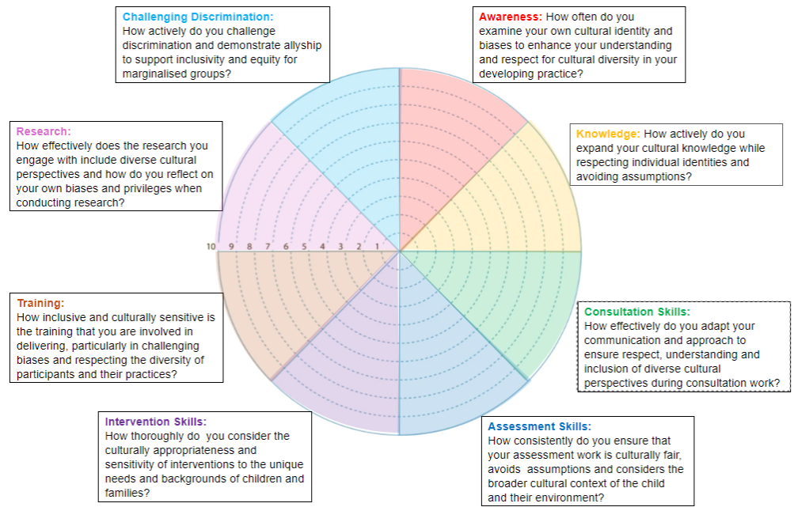

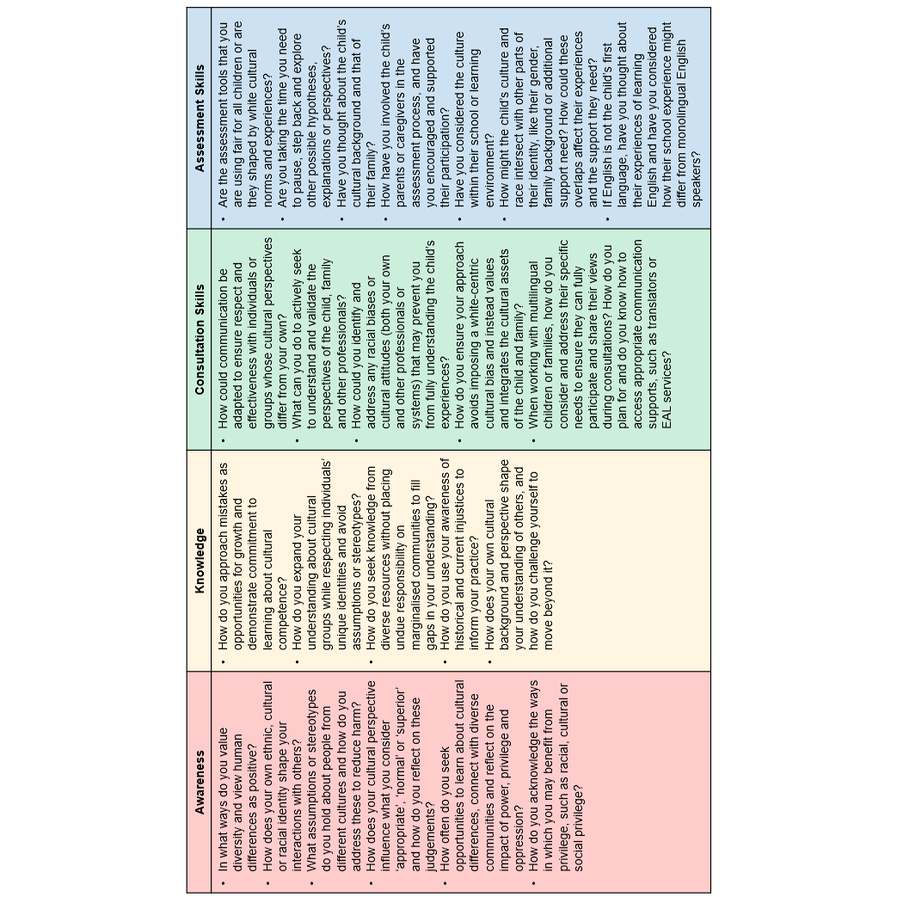

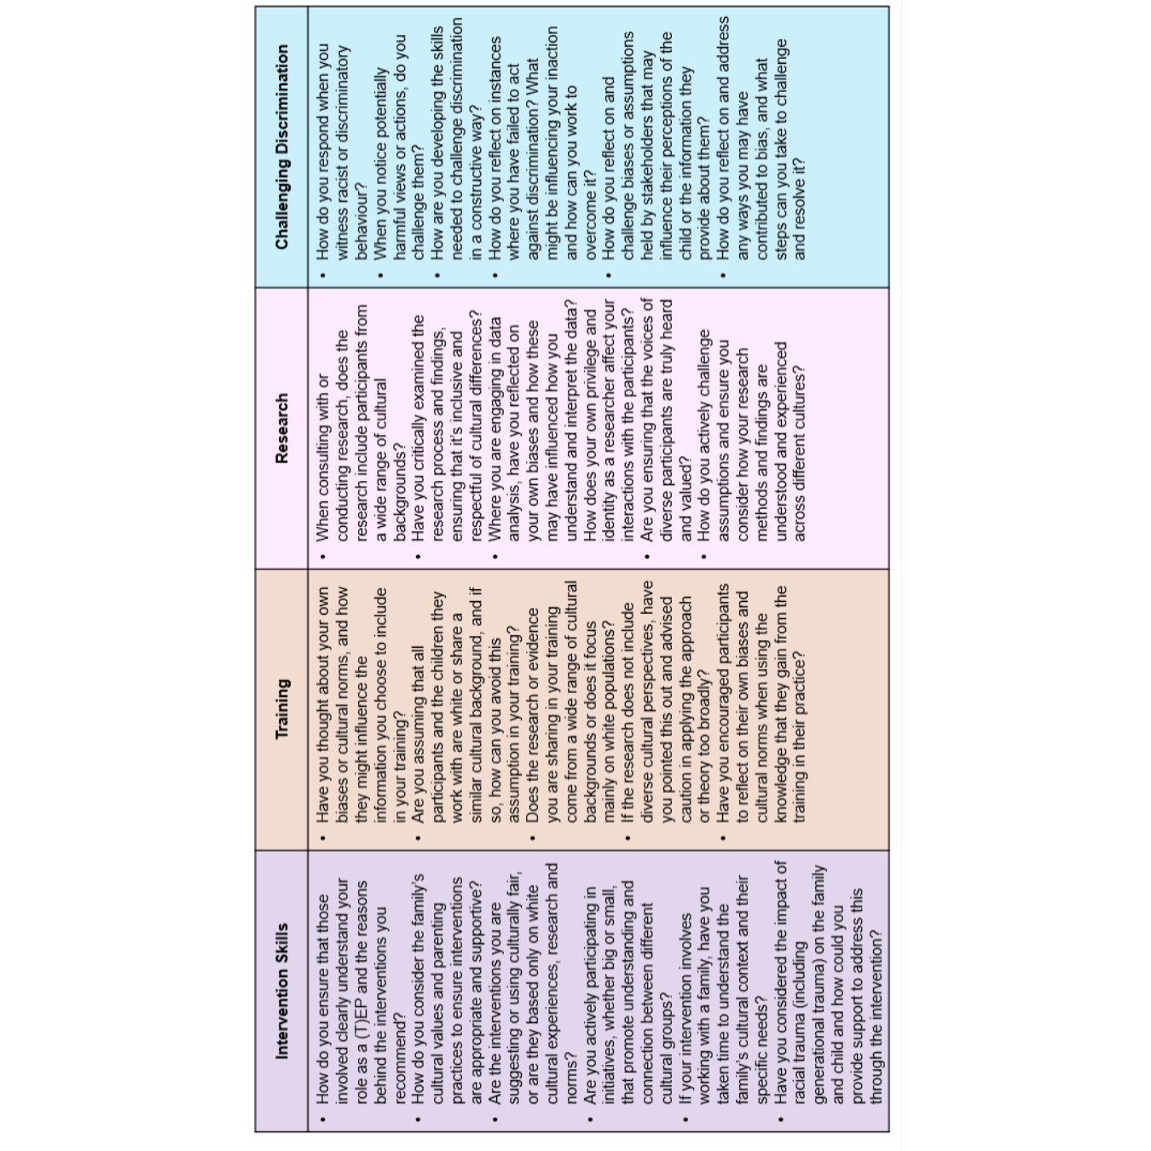

What areas are gaps? ___________________________________________________________________________________________________________________________________________________________________________________________________________________________________________________________________________

What is my priority?
___________________________________________________________________________________________________________________________________________________________________________________________________________________________________________________________________________

What is most important for me to develop to support my developing practice?
___________________________________________________________________________________________________________________________________________________________________________________________________________________________________________________________________________

What are my key strengths? ___________________________________________________________________________________________________________________________________________________________________________________________________________________________________________________________________________

How might these areas interact? ___________________________________________________________________________________________________________________________________________________________________________________________________________________________________________________________________________

Scaling Framework (EP Version)
As you engage with the tool you may wish to consider the following scaling framework to support in rating your cultural competency in the 8 areas outlined within the wheel. The statements below may support you in considering your confidence and development needs with your practice. Please be aware that the suggested actions for growth are by no means conclusive but may offer helpful suggestions on how you can develop your cultural competency throughout your journey.
Please remember that the journey to becoming culturally competent is not about achieving perfection but about committing to continuous growth. Therefore, there is no expectation that you will move through each stage of this scale in the same timeframe or in a linear manner, rather you may find yourself working within a particular stage for a longer period and you may wish to move back and forth within the scale.
0–2: Beginning Awareness
- You are beginning to notice cultural differences but struggle to identify specific ways cultural competence applies to your role.
- You are uncertain about how bias might influence your practice with stakeholders and colleagues.
- Actions for Growth: You may wish to engage with further reading, engage in CLPL, or shadow colleagues to observe culturally responsive practices.
3–5: Developing Practices
- You are starting to adapt your practice to reflect cultural competence but still feel this is inconsistent.
- You are becoming aware of how implicit biases might affect interactions but need more confidence in addressing them.
- Actions for Growth: You may wish to seek peer or/and formal supervision to reflect on and refine your practice. You may also wish to consider psychological theory and evidence-based tools and strategies which are representative of the cultural backgrounds of the individuals you work with.
6–8: Established Practices
- You regularly adapt your practice to meet the needs of individuals from diverse cultural backgrounds.
- You actively consider systemic factors affecting the communities you work with and consider them when engaging with individuals you work with.
- Actions for Growth: Continue to engage in peer discussions to share effective strategies and contribute to a shared understanding of cultural responsiveness within your team.
9–10: Leadership and Advocacy
- You adapt your practice consistently to meet the needs of individuals from diverse cultural backgrounds.
- You model cultural competence and mentor others in considering and developing their own cultural competency within their practice.
- You advocate for systemic change, promoting cultural competency within service delivery and wider processes.
- Actions for Growth: You may wish to consider providing supervision for TEPs, EPs or within schools. At this stage you may wish to lead initiatives that challenge discriminatory practices and promote equity across the profession.

Tracking Your Development
When using this tool you may wish to use the table below to document your progress.
Things you may wish to think about . . .
- How do I feel about this?
- What experiences (personal/professional) have influenced my thoughts about this?
- Have I engaged in any discussions (personal/ professional) about this?
- Have I engaged in further reading and research from a range of sources to support my thinking around this area.
- Have my views on this changed?
- Is this an area I would like to prioritise?

Date | Area of focus (i.e. Awareness, Consultation, Research etc.) | Score (0-10) | Key Insights/Reflections | Actions for Growth

