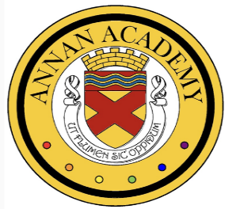
Annan Academy: LGBT Youth Scotland Gold Award Update for Parents/Carers

Annan Academy is proud to share with you the progress we have made on our journey towards the LGBT Youth Scotland Gold Award process. This award recognises our commitment to creating an inclusive, respectful, and supportive environment for all pupils. We achieved the LGBT YS Silver Award in 2020 and our gold award portfolio is due to be reviewed in July 2025, where we hope we will be awarded the LGBT YS Gold Award.

Whole-School Commitment to Inclusion
The LGBT Youth Scotland Charter Award is currently the only awarding body of its kind which focuses on inclusivity in schools. Whilst it is important that the evidence in the portfolio meets the standards required by LGBT Youth Scotland, we wanted to ensure that the school environment became more inclusive for all pupils, including those with other protected characteristics.

Staff Training & Development
All staff were invited to complete LGBT Awareness training in 2023 and Supporting Trans Young People training in 2024. This training was followed up by live workshops which helped to identify strengths and areas for improvement. This information shaped our action plans moving forward.

Staff Champion Group
The role of the Gold Award Staff Champion group was to gather and collate evidence to demonstrate how we have met the standards required for the award. For example, school policies were reviewed and updated to ensure they were inclusive. A dedicated LGBTQIA+ policy was developed and this will be launched next school year. Another part of the process was to conduct a survey about bullying, which we decided should be conducted annually. Our results from 2023 to 2024 demonstrated a 14% decrease in LGBTQIA+ bullying, a 4% decrease in pupils witnessing bullying and a 3% decrease in pupils reporting being bullied.
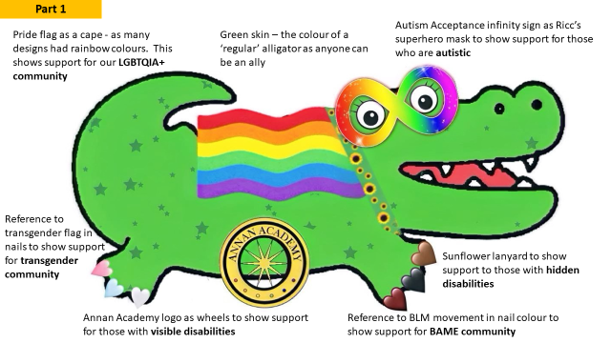
Pupil Champion Group
Pupils from S2–S6 volunteered to be part of the Pupil Champion group. Over the two years they have led anti-bullying campaigns based on survey results, created RICC the Ally-gator - a mascot promoting allyship and developed the Ally Pledge which encourages pupils and staff to commit to being allies.

Whole-School Engagement
Annan Academy has embraced a culture of inclusivity by recognising and celebrating key events throughout the year. These include LGBT History Month, Pride Month, and Transgender Day of Remembrance, alongside other important observances such as Women’s History Month, Mental Health Awareness Month, Black History Month, and Remembrance Day. These activities have helped foster a respectful and inclusive environment for all pupils.

Community Engagement and ongoing support
Our GSA won a Caledonia Park competition with their unicorn design which celebrated LGBTQIA+ identities. The unicorn is now proudly displayed in the school. The GSA continues to meet weekly, offering a safe space for LGBTQIA+ pupils and allies. GSA members can also contribute to school-wide initiatives.

We are proud of the progress made and remain committed to fostering a school culture rooted in Respect, Integrity, Care, and Compassion. If you would like to discuss any of the information detailed here please email: gw08officeannan@ea.dumgal.sch.uk

