Uploading your work to an Assignment and Submitting Task.
Overview for Visual Learners (Youtube video)
Open the assignment.
It will explain what the task is you have to do and what documents you need to submit.

Once you have finished your work for the task make sure you save your file. If you downloaded the file it will be saved to either your computer or Onedrive.
- Make sure you have the assignment page open. (Like the example one below.)
- You need to click on the Add work + link
- It will now open a window which allows you to select where your work is currently saved to. Select the area your work is saved in eg OneDrive or your own computer.

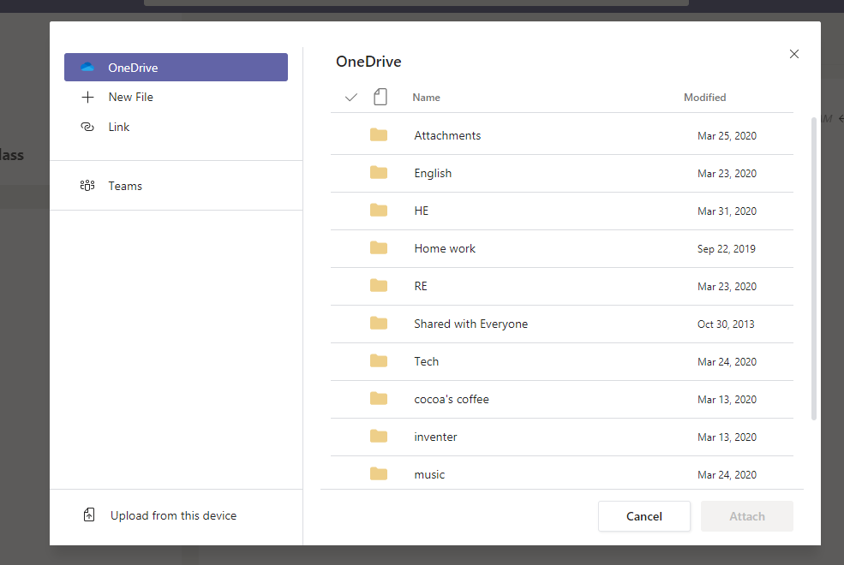

If it is on your computer a window will open to let you select the folder the file is in like this.

Or Like this if you open a OneDrive folder.

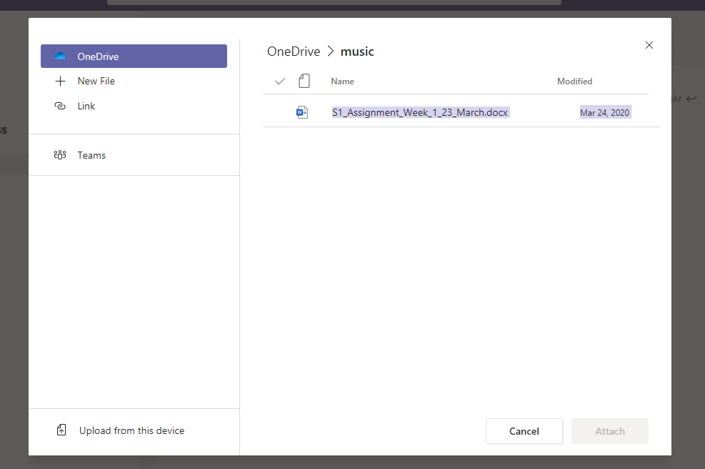

- Once your file is showing in the window click on it once to highlight it and then click the Open button

- Your file will now begin to be uploaded, wait until a thin blue line appears cross the screen, this is it uploading.

- When it has completed the upload the screen will show a done button Click this.

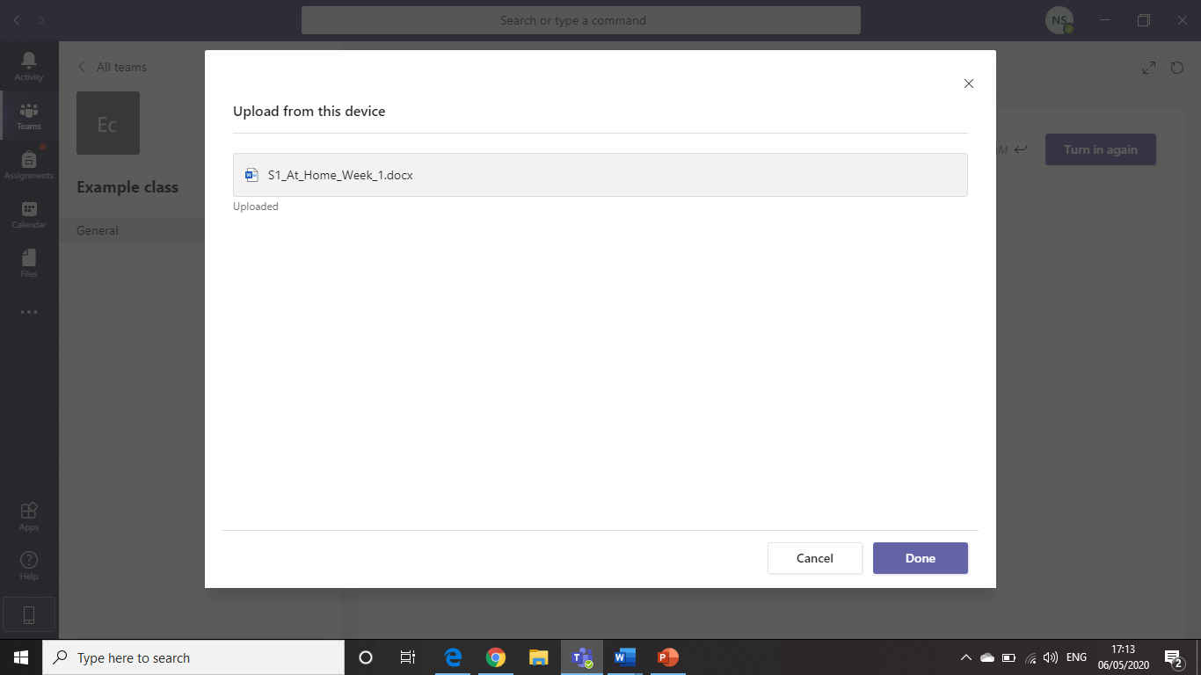

- Your screen will now show your file has been uploaded

Uploaded file

If you need to load more file just repeat the steps 1-7 again, for every file you need to upload.

Finally
When you have uploaded all your files you are now ready to submit your work to your teacher.

In the top right corner of the assignment you will see a Hand in button
Click this button and work will be submitted for marking.

