Welcome to the Additional Support Needs Department! We are a team of adults who support pupils within the school. We work very closely with PTPS and class teachers. You will see the Learning Assistants in your classes. They are there to help everyone in the class with their learning, so please feel free to ask them for assistance, as well as your class teacher, and they will do their best to help you. If you need help at break or lunch time, we can be found in G43, which a safe space that is open and has staff on hand if you need to speak to us, or would just like a quiet place to sit if the playground is too busy or you are on your own. G43 is also open at 8.45am for breakfast club. Come along and have a piece of toast and a cup of tea if you are in school early! The teachers in the department teach English and Maths and are based in G42.

Mr Whitelaw, ASN Teacher Mrs Wells, Principal Teacher of ASN Mr Maxwell, ASN Teacher
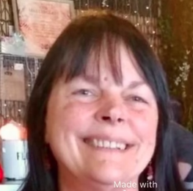
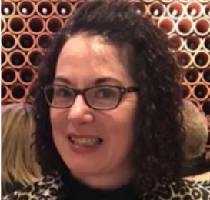
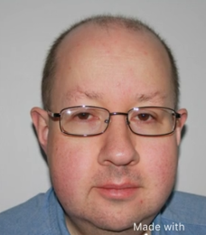

Miss Johnstone, Learning Assistant Mr Mitchell, Learning Assistant Mrs Palmer, Learning Assistant Mrs Simpson, Learning Assistant
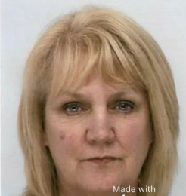
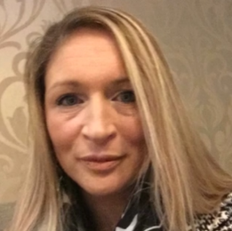

Mrs Story, Learning Assistant Miss Walker-Jones, Learning Assistant Mrs Watson, Learning Assistant

