

2023-2024
STANDARDS AND QUALITY REPORT AITHISG INBHEAN IS CÀILEACHD

Airport House, Caithness I.S.V.T.U


Introduction: Local and National Context

This Standards and Quality Report is influenced by both Highland and national priorities. These can be summarised as follows:

Highland Priorities  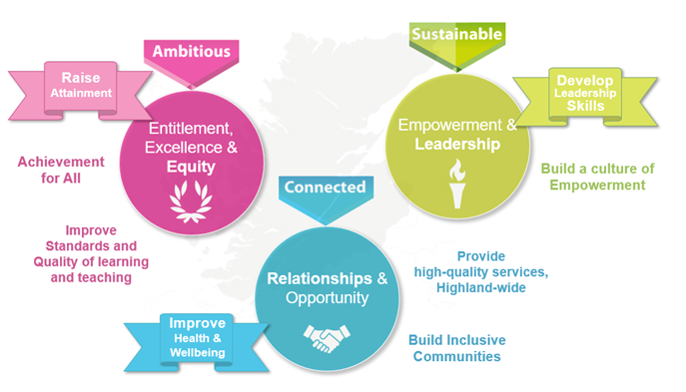  Entitlement, Excellence & Equity:  We will raise attainment and achievement for all, especially for children and young people from disadvantaged circumstances, including rural deprivation. We will focus relentlessly on improving standards and the quality of learning and teaching, to ensure that entitlement, equity and excellence are delivered across the system.  Empowerment & Leadership:  We will develop leadership skills at all levels of the system, for now and the future, building a culture of empowerment and professional capital.  Relationships:  We will maximise health and wellbeing for all children and young people, to give them the best possible start in life. We will ensure every child and young person feels part of the community they live in.  Opportunity:  We will maximise opportunities for our children and young people, and for the wider Highland community and its visitors, through the provision of high-quality services. | National Improvement Framework Priorities  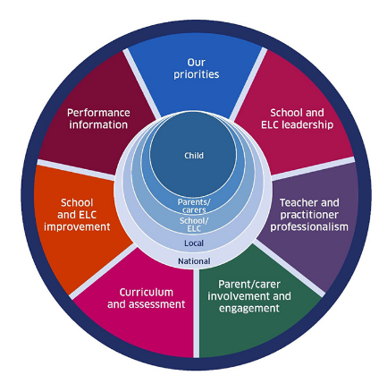  The key priorities outlined in the National Improvement Framework are:  - Placing the human rights and needs of every child and young person at the centre of education  - Improvement in children and young people's health and wellbeing  - Closing the attainment gap between the most and least disadvantaged children and young people  - Improvement in skills and sustained, positive school-leaver destinations for all young people  - Improvement in attainment, particularly in literacy and numeracy.  Self-evaluation  To support self-evaluation, quality indicators from the national evaluative framework How Good Is Our School?4 are referenced.  Links to these sources (and others referenced) can be found here:  National Improvement Framework Improvement Plan  HGIOS? 4 and HGIOELC  Health and Social Care Standards  National Gaelic Language Plan
In this report the following words are used to describe the numbers and proportions used:

All | Almost all | Most | Majority | Less than half | Few
100% | Over 90% | 75% - 90% | 50% - 74% | 15% - 49% | Up to 15%

We are pleased to present our Standards and Quality Report for Session 2023-24. This report forms part of our quality improvement framework and provides important information regarding our school’s progress to date and our next steps in school improvement.

Self-Evaluation for Self-Improvement is at the heart of our practice. We continue to develop our practice in making robust use of evidence as a basis for judgements regarding the impact of our work on our learners. All staff understand that self-evaluation is an integral aspect of our approach to continuous improvement through addressing the 3 key questions:

- How well are we doing?
- How do we know?
- What are we going to do now?

Throughout the year we continuously evaluate what we do and how it makes a difference to our learners. We want to know what is working well for our school community and what needs further improvement. We inform decision making and actions through a continuous process of looking inwards, outwards and forwards.

Looking inwards - starts with those working with our children and young people
We focus on the impact on outcomes for learners. Our self-evaluation processes triangulate information, data, people’s views and observation of practice to measure impact and inform planning for improvement.

Looking outwards - learning from others
Looking to others for new ideas that challenge our practice and support continuous improvement allows us to learn from what works and what doesn’t. This includes practice in other schools, learning communities and learning from educational research.

Looking forwards - creating a vision and planning for implementation
Through leadership at all levels, we anticipate challenges and explore creative solutions. This helps us to create an aspirational vision for our school which shapes our actions and provides a focus for improvement.
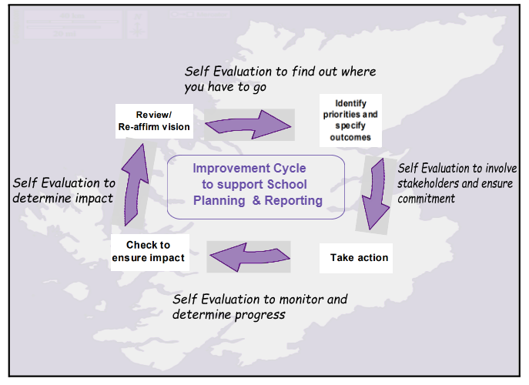
Our children and young people are actively consulted and involved in this process. We also give staff, parents/carers, and other partners the opportunity to participate in discussions and activities to shape our improvement journey.

When we develop our improvement plan, we use key questions at scheduled review times throughout the session to know how well we are progressing towards achieving these positive outcomes and changes.

Together we are working hard to ensure the Highlands is the best place for children and young people to grow up safely, learn, develop and achieve.

With positive experiences, our children and young people will always see the Highlands as home.
Le eòlasan deimhinneach, bidh ar cloinn is ar n-òigridh daonnan a’ faicinn na Gàidhealtachd mar dhachaigh.

Kimberley Sinclair
Manager – Principal Teacher ASN
Airport House

Centre Profile

Airport House is an Intensive Support and Vocational Training Unit established in 2005 to complement other support services for young people of secondary school age residing in Caithness. Young people who attend Airport House from either Wick, Thurso or Farr High Schools remain on their school roll and attend Airport House on a part-time basis only. On occasion, Airport House staff work with young people as they prepare to leave primary school. Airport House is managed by a Principal Teacher of ASN on a full time basis and there is currently one full time teacher to support literacy and numeracy and three Children’s Services Workers to support young people’s vocational, social and emotional learning.

Our ethos is to promote learning and enable young people to plan for their future in a safe, supported environment. Staff work with young people in an emotionally literate manner, and they aim to help the young people better understand and manage their emotions and reactions, as well as their relationships with others.

Airport House currently offers part-time support for up to 16 young people who have social, emotional or behavioural needs and are having difficulty engaging or coping in full-time mainstream education. After implementing an attendance protocol, we have experienced a higher level of attendance over the 23-24 session from some young people who were finding it difficult to attend and staffing levels have met the current demand. Most young people can engage well with the sessions that are delivered in Airport House. Collaborative problem solving is used between staff and young people when issues around engagement/attendance arise.

Staff understand the individual needs of the young people well and instead of a behaviour policy we focus on ‘working together’ and building relationships through a trauma informed approach. Timetable planning is well thought out to avoid conflicting personalities and social groups to ensure that young people have the best chance at being able to engage with their sessions. At present, this is working well.

Our young people often join staff in the community, and they are able to demonstrate great personable qualities such as politeness and manners. Parents and guardians are very supportive of the work that Airport House does, and key working staff keep in regular contact with them via email, phone, text and face to face.

Airport House has close links with Skills Development Scotland and Developing the Young Workforce, along with other partners, to ensure that our young people are supported towards a positive destination.
As there is a relatively small number of young people attending, attainment and progress will be expressed in ‘overall’ statements, rather than specific year groups or Curriculum for Excellence levels. This is to ensure the identity of individuals is not disclosed.

All of the young people who attend Airport House face barriers to their learning and have additional support needs. All of the young people who attend have a Child’s Plan that is led by the school and an Action Plan outlining their targets in Airport House. Almost all young people who attend Airport House are making very good progress towards meeting their individual targets in literacy, numeracy and health and well-being.

Senior Phase
The majority of the young people attending Airport House are working towards senior phase qualifications in English/Literacy and Maths/Numeracy. The majority of young people attending Airport House are also accessing English/Literacy and/or Maths/Numeracy at either Wick High School or Thurso High School.

School Leavers
Almost all school leavers in the 23-24 session have moved on to a positive destination, with the most common destination being college. Leavers who did not have a positive destination upon leaving were engaging with the Highland Council Employability Service.

We have had no exclusions this year.

School vision, values and aims

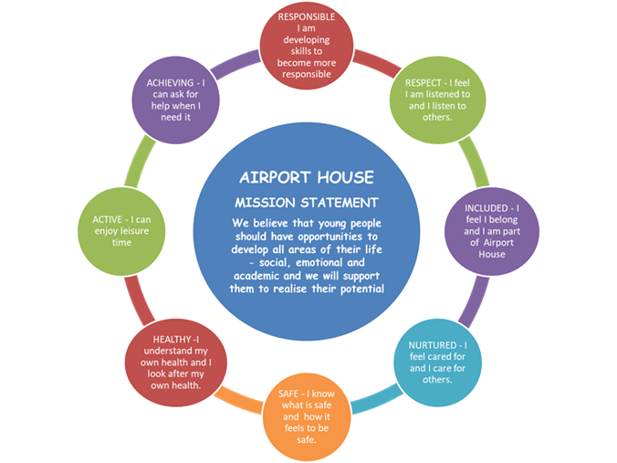

To promote learning and teaching to enable our young people to achieve their full potential by –
- Providing appropriate programmes based on individual needs
- Providing positive learning experiences
- Setting realistic and achievable goals
- Evaluating and reviewing with the high schools

Encourage our young people to become good citizens by –
- Ensuring our young people have the right support in place to help them meet the expectations that are put on them through problem solving practices
- Modelling positive behaviour and attitudes and encouraging it’s use
- Supporting young people to address their social and emotional needs
- Promoting confidence and self-esteem in our young people
- Adopting a non-judgemental and non-discriminatory attitude towards our young people
- Encouraging inclusion in positive activities
- Instilling self-belief in our young people that they can achieve good things

To create a calm and safe environment where our young people’s developmental needs can be met –
- Setting good examples by providing appropriate role models
- Ensuring staff development is ongoing and relevant to improve practice
- Using Trauma Informed Practice and the Nurturing Principles

Support and prepare our young people to make a successful transition into adulthood by –
- Forming good links with partnership agencies and maintain good working relationships
- Identifying local resources e.g., colleges, employers etc
- Ensuring parents/carers are involved in all aspects of their young person’s life at Airport House
- Involving young people in the decision-making processes

Review of progress for session

These projects are linked to the vision and priorities for Scottish Education based on delivering excellence and equity. Parent/Carer information is available here.

School Priority:
Embedding Trauma Informed Practice

Purpose:

This project was developed in response to improving practice in line with national agenda in the interactions we have with the young people who attend Airport House. Staff had a good baseline of knowledge of Trauma and Trauma Informed Practice and with training, planned to embedd Trauma Informed Practice at the heart of all interactions with our young people to enhance their well-being and self-esteem.

Progress:  - All of the young people who responded to our student questionnaire (7) have said that they feel that staff treat them and others in a ‘Trauma Informed Way’  - 83.3% of young people who responded to our student questionnaire (6) said that they feel Airport House has had a positive impact on them – either socially, emotionally or academically.  - All of the young people who responded to our student questionnaire (6) have said that Airport House offers a safe and comfortable environment to learn in  - Staff views are that they feel they have been consistent in ensuring they interact with young people in a Trauma Informed Way and are confident in their abilities to make a positive impact on our young people’s lives  - Well-being web scored have increased in relation to how young people feel within Airport House | Impact:  - Young people have been consistently met with kindness and compassion when they enter Airport House  - Young people’s basic needs are assessed and met (where possible) to ensure we give them the best start to their day and they are ready to learn  - Young people have been introduced to discussions around trauma and are allowed to reflect on past experiences that may contribute to how they feel about school/education now  - Staff are able to continually think about their interactions with young people in order to help support them with their emotions due to the Trauma Informed Training and practice that they have completed
Next steps:

We will continue to embed Trauma Informed Practice within our policies over the next year.

School Priority:
Raising Attendance Levels

Purpose:

This project was developed in response to chronic low attendance for a number of young people with timetabled sessions with Airport House. We hoped to investigate the underlying difficulties that were impacting on our young people’s ability to attend Airport House and to work with parents/carers to help raise attendance.

Progress:  - Attendance protocol discussed at staff meeting, created and implemented – this was a specific protocol for Airport House that came from a Trauma Informed viewpoint and that was designed to work in partnership with parents/carers and our young people  - Attendance was monitored for all young people and protocol implemented where appropriate – attendance fluctuated throughout the year due to illness or mental health difficulties. However, almost all young people who had been not attending/engaging with Airport House improved their attendance. |  | Impact:  - Young people have taken an active role in expressing why they have found attending Airport House difficult  - Young people have taken up offerings of support to help them get through to Airport House  - Staff took bus journeys with young people, picked up and collected them, helped them get up and organised in the morning, kept close contact with parents via in person meetings and regular phonecalls  - Parent/staff relationships have strengthened and have worked together to help our young people to attend more regularly.
Next steps:

Attendance protocol is established and staff will continue to refer to the steps within it to ensure that we can help all of our young people to access Airport House. Attendance difficulties will be discussed with parents/carers before young people start at Airport House so that the correct supports can be put in place to help ensure that we give our young people the best chance of a great start.

School Priority:
Improving Partnerships

Purpose:

This project was a continuation of advancements made with this priority from last year.

Progress:  - Termly reviews have continued to be in place and help to share the learning that is happening in Airport House with the school  - Action plans were created to outline specific targets within Airport House which were shared termly with the school  - Regular contact maintained with the school via monthly update meetings and e-mail correspondence between staff and guidance teachers  - Linked in with google classroom for one high school to keep up to date with clubs, DYW support and activities that young people could engage with | Impact:  - Staff in school and at Airport House have a good understanding of where young people are making progress and where they need further support  - Young people have maintained time in school or started to have more time within their High School as part of close collaboration with the schools  - Young people have attended after school clubs that their school has to offer due to the link up with google classroom
Next steps:

We will continue to maintain our close relationships with the High Schools of Caithness to ensure that our young people are given the right support to help them engage with their educational package.

School Priority:
Qualifications and Wider Achievement

Purpose:
This project was a continuation of advancements made with this priority from last year.

Progress:  - Further qualifications have been on offer to our young people this year that were not on offer previously  - Connections have been made with other partner agencies who offer wider achievement opportunities | Impact:  - One young person completed and passed a unit from the Wellbeing Award.  - One young person helped plan and take part in activities as part of work towards their Personal Development Award  - Two young people completed a John Muir Award in partnership with High Life Highland
Next steps:

We will continue to engage with our young people to help them develop their interests and find qualifications that can match these. We are going to continue to engage with partners in order to ensure that our young people are being offered as many options as possible to support their educational package.

Wider achievements

- Our young people helped to raise almost £500 for MFR Cash for Kids Christmas appeal. Our young people hosted their parents/carers/family members at our ‘Festive Family Fun Week’ where they were able to sell baking/crafts to their parents. They also sold baking items to the local businesses.
- One of our young people completed a litter pick to help towards his Personal Achievement Award. They were praised by the local community members who saw what they were doing.
- Our young people have completed most of the F24 build with our Stem Ambassadors and have now started to complete the outside design. Once it is completed, some of our young people will have the chance to drive the car.

Comments from learners, families, stakeholders and staff

Information has been gathered from young people from their End of Term reviews/feedback questionnaires –

- “Airport House is good. Airport House has helped me to build up my timetable in school. I feel I am more regulated in school now.”

- “Airport house needs wi-fi. I enjoy the kitchen and would like to do some work in the workshop.
- I still enjoy coming to Airport House.”

- “It is better than high school because you get more 1-1 time”

- “Thank the lord I actually came here, I am so thankful that we have been given a space here.”

***

Information that has been gathered from parents/carers feedback questionnaires –

- “If it wasn't for Airport House, My Son would not have progressed as far as he has today. I can not praise Airport House enough for their hard work, help, support and dedication to their pupils. I am buzzing and also as my daughter has now started too. Airport House deserves all the support and funding it gets as it is utilized with the pupils in mind always. Keep up the good work guys. You are all appreciated!”

- “Staff are lovely and supportive, our young person really enjoys their time in Airport House. Thank you”

***
Information that has been gathered from partner feedback questionnaires –

When asked “Are there any ways that Airport House could expand and improve what is already on offer?” –
- “Outwith their control but an expanded service”
- “Could they offer more practical classes like car mechanics for instance”
- “More places available”

When asked for any further comments –
- “Staff are both empathetic and committed to helping the youngsters, they provide a hugely needed service”

Capacity for continuous improvement

Using indicators from ‘How Good is our School 4’ together with learner, parent, carer, partner and community feedback we believe we have made the following progress this session:
 | SECONDARY
QI 1.3  Leadership of change | Very good
QI 2.3  Learning, teaching and assessment | Very good
QI 3.1  Wellbeing, equality and inclusion | Very good
QI 3.2  Raising attainment and achievement/Securing children’s progress | Very good

Our overall evaluation of our capacity for continuous improvement is:
We are confident in our capacity for continous improvement.

Key priorities for improvement planning

- Embedding Trauma Informed Practice
- Improving opportunities for parent/carer engagement
- Young people’s voice

Planning ahead

Full details of the school’s 2024/25 improvement priorities and actions are detailed on the Centre Improvement Plan, which can be accessed on our website https://blogs.glowscotland.org.uk/glowblogs/airporthouse/ or by contacting the Airport House manager directly on 07775012194.

