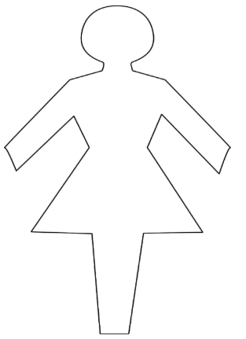

Selfish

Controlling

Heartless

Envious

Independent

Dominant

Beautiful

Powerful

Dark

Unsympathetic

Spiteful

Malicious

Queen

Evil

Step-Mother(Lady Tremaine)