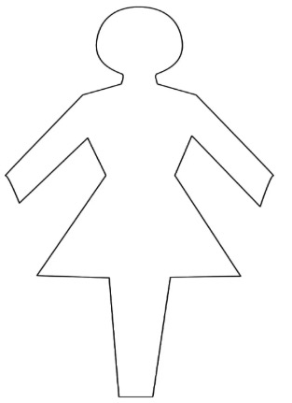

Arrogant

Wealthy

Popular

Confident

Beautiful

Funny

Insecure

Unattractive

Selfish

Spiteful

Malicious

Wicked

Cruel

Immature

Jealous

**Ugly Step-Sister (Anastasia/Drizella)**