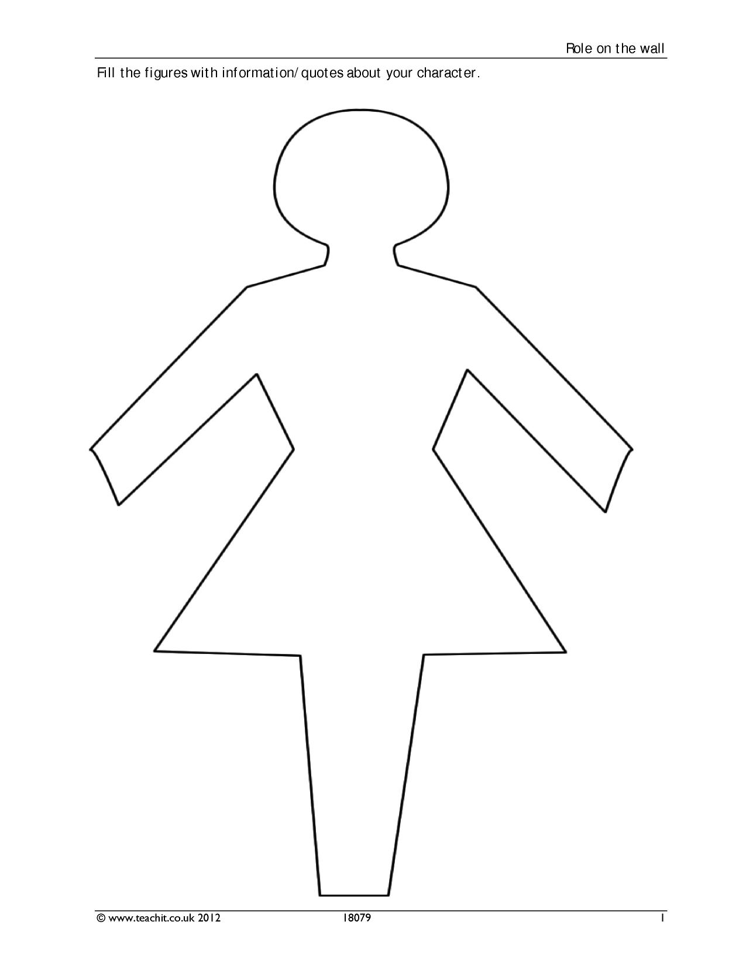

Exhausted

Beautiful

Selfless

Kind

Charming

Hardworking

Brave

Independent

Loyal

Lovely

Insecure

Trapped

Isolated

Lonely

Unhappy

Cinderella