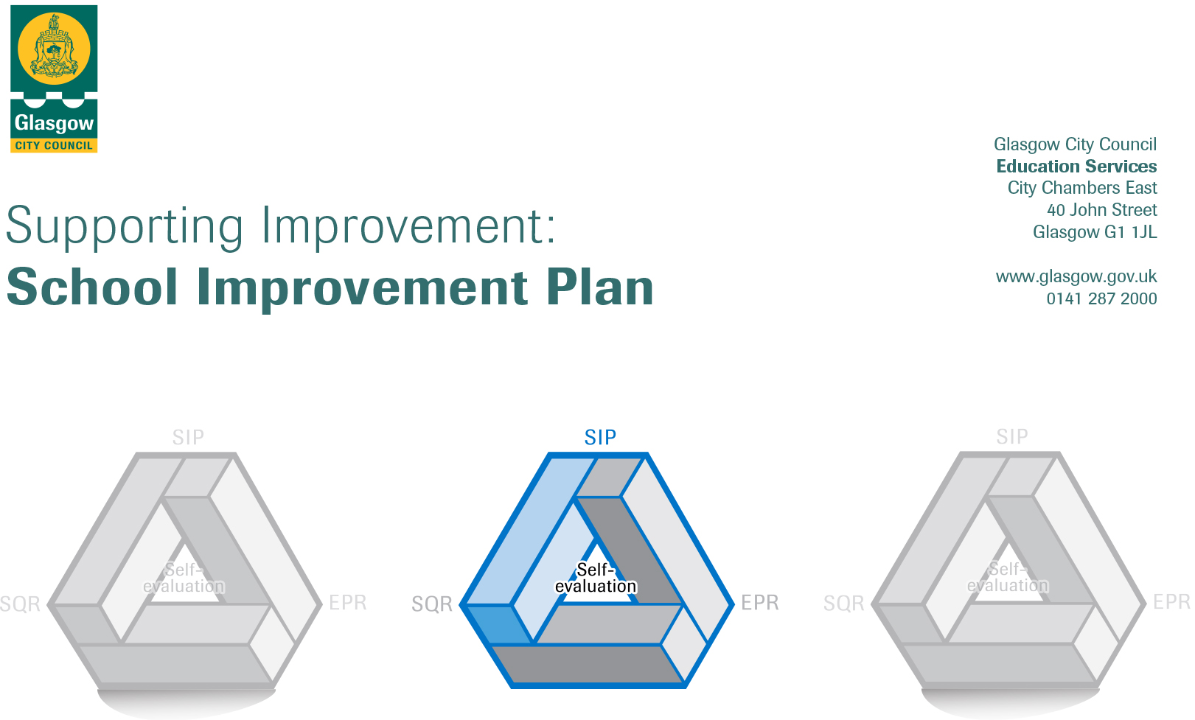

2023-2024
Establishment |  | Adelphi Nursery 2023-2024
Head of Establishment |  | Karen O’Hara
Area/Local Improvement Group |  | Holyrood
Head of Service |  | Douglas Hutchinson
Area ELC Manager |  | Sharon Constable

CONTENTS
1. Vision, Values and Aims
2. Summary of Self-Evaluation Process / Priorities for Improvement in the current session
3. Action Planning

Action Plan Summary for Stakeholders

1. Our Vision, Values and Aims
Statement
Our vision in Adelphi Nursery is cultural inclusion for all our service users.
We aim to support all children to reach their full potential and support progression using a nurturing and holistic approach.
We value and respect each individual children’s rights and differences supporting them to have a voice and be heard.
In Adelphi our main priority will be for the wellbeing, happiness and holistic development of each individual child, family and staff team. We aim to have honest and supportive interactions will all of our families to ensure that you are supported and nurtured at Adelphi.

We encourage all our children to explore and make choices within our learning environment both indoors and outdoors on a daily all-day basis. Our children feel safe and protected in Adelphi Nursery and we strive to nurture and develop each child’s skills for learning, skills for work and skills for life.

We support all of our children to become confident individuals, effective contributors, successful learners and responsible citizens.

Be Bold – Be Brave – Be You!

ACTIVELY working with the staff, families and the wider community.

DIVERSITY within the community will be supported within the settings

EQUALITY for all children families and stakeholders.

LEARNING we will use CFE, Realising the Ambition, Building the Ambition, GIRFEC and HGIOELCC and the Nurture principles to deliver the highest quality learning within our setting.

PARTNERSHIP Our setting will work closely with parents and partners to support on-going learning and smooth transitions.

HOLISTIC needs will be nurtured throughout the setting with the staff adopting the nurture principles and being positive role models to all children. Through staff training they will be skilled in delivering a quality curriculum to meet the individual needs of all children.

INCLUDED All children and families will be included and valued with equal opportunities for all.

2. Summary of our self-evaluation process.
In the setting we have a systematic monitoring and evaluation process using a calendar for quality assurance supported by How Good is our early learning and childcare and Care Inspectorate Quality framework document. We have regular quality assurance discussions to audit relevant quality indicators throughout the year based on current practice and outcomes from monitoring and observations of learning, practice and change. This supports the team to have ownership within the setting and professional discussions which informs areas for development and a reflection on practice. This is done individually and in groups.
The Improvement plan is evaluated and achieved by priority working groups within the setting that feedback to the team at relevant points in the year and during processes of change.

Strengths identified:

- Programmes to support parental involvement with Inspiring Scotland, Triple P, Book bug, Mini Kickers, Loose part, Paths GCC trackers and Terrific transitions.
- Planning is now more robust and is meeting learners needs with relevant observations and next steps for learning.
- Communication is supported by whole team approach and room reps to cascade and discuss relevant information. Weekly and 4 weekly rotas in place for team meetings.
- Care plans in place and regularly reviewed to reflect changes and progress. Targeted support plans show evaluation and progress made toward short term /Long term plan.
- Seesaw is embedded and shows clear individual learning for all children and where there are gaps in children’s learning.

Priorities for development
We plan to weave the 5 Grand challenges throughout our improvement planning and capture the vision of GCC of ALL LEARNERS ALL ACHIEVING

1: Identifying next steps in learning and ensuring all learners needs are inclusive and through robust evaluation there is breadth and balance of the curriculum

2: To support the wellbeing and nurture of individual children and families identifying barriers and supporting early Intervention

3: Working in partnership with parents to help them understand that their involvement in the setting enhances their child’s learning and the importance of their involvement.

3. Action Planning

No. | Quality Indicator | Priority – (This should be a measurable outcome)
1 | 3.2 Leadership of play and learning  2.2 Curriculum | - Development of the identification of significant learning being captured and effectively used to support individual next steps  - Breadth, Depth and Balance of the curriculum is planned appropriately to ensure that we further develop and challenge our learner’s individual needs.

Tasks/Interventions to achieve priority | Staff leading on this priority – including partners | Timescale/  Checkpoints | Success Criteria – What do you predict will be the impact on learners?  (Data, observation, views)
Complex milestones document -Education Scotland | Leeanne Depute | Term 1 | Embed a learner centred approach to learning. Observations /data on progress of children with complex needs. Celebrating milestones and support practitioners in this process using the Continuum of engagement.
Individual Learning and Achievement plans | Karen/Leeanne | Term 2 | Practitioners understand and track relevant learning
Individual Trackers and Targeted Support plans | SMT and all keyworkers | Term 2 | Progress evident in trackers for individual and group learning /next steps are followed through and impact recorded
Navigate the Birth to three documents adapted to link with RTA and support learner’s interactions and progress. | SMT /2-3 team | Term 2 | Meet learner’s individual and group needs provide appropriate experiences to challenge and extend learning.
EAL programme will support individual learning and support breadth depth and balance in the curriculum |  | Term 1
Annemarie
Racheal
Lindsay
Fiona J

Looking Forwards - Next Steps
(Not to be completed until priority achieved)

No. | Quality Indicator | Priority – (This should be a measurable outcome)
2 | - Nurturing care and support  1,1 Self Evaluation for self -improvement | - To actively promote the wellbeing and engagement of all of our children and can demonstrate that they are being supported to feel safe, healthy, achieving, nurtured, active, respected, responsible and included.

Tasks/Interventions to achieve priority | Staff leading on this priority – including partners | Timescale/  Checkpoints | Success Criteria – What do you predict will be the impact on learners?  (Data, observation, views)
Build on further developing a whole nursery nurture approach | Fiona/ all staff |  | Nurture being fully embedded will provide our children and young people with opportunities to connect with others, to build important relationships, and to develop a sense of self-worth. It helps them learn, play and communicate and it is enabling children to thrive. In becoming Effective Contributor, Confident Individual, Successful learners and Responsible Citizens
Attachment and Resilience Training | Gillian Ruddock / Karen HOC |  | In line with supporting children with ASN identifying individual needs and barriers to learning. Supporting families to share their views and concerns and embed an early intervention model.
Early Protective Messages | Kim CDO /Robina Simpson NHS | Term 1 | Children understand their rights and correct names for body parts. Children are open and understand privacy and appropriate interactions with consent.
Outdoor learning enhanced and areas developed through David Sobel’s 7 principles toolkit and action plan/Working closely with Inspiring Scotland. | Jo Fitzpatrick /Mairi Ferris | Term 2 | Rich real -life Opportunities for all learners to engage with Glasgow’s heritage, its people, its outdoor spaces and its facilities, beyond the walls of the playroom. A rich outdoor environment that has been developed in consultation with children and Parents.
Outdoor Garden /Mindfulness embedded  Resources used daily and gardening group re established | Sarah /Courtney /  Thrive Outdoors | Term 1 | Children are making connections and understand how food is grown and the process.  Children are able to have space and regulate /children can understand emotions and express themselves while exploring their rights and being consulted.
Brittany
Salma
Shameem
Courtney
Sarah
Fiona TL
Kim

Looking Forwards - Next Steps
(Not to be completed until priority achieved)

No. | Quality Indicator | Priority – (This should be a measurable outcome)
3 | 1.4 Family engagement  2,5 Family Learning  2.7 Partnerships | - To promote the importance of parental engagement to enhance children’s learning.  - To build awareness that participation and partnership is crucial in the life of the setting and lifelong learning

Tasks/Interventions to achieve priority | Staff leading on this priority – including partners | Timescale/  Checkpoints | Success Criteria – What do you predict will be the impact on learners?  (Data, observation, views)
Leading outdoor training for parents and carers | Inspiring Scotland /Jo Fitzpatrick /Mairi Ferris | Term 1 | Parental Involvement on a planned basis /Understand importance of outdoor learning and risky play
Seesaw event for parents/carers | Kim ATL  Katy LPA | Term 1 | Celebration of learning children have an  understanding of what they have learned and what they now know
Consultation with children on learning and next steps /sharing learning at home using QR codes | All staff | Term 2 | Celebration of learning children have an  understanding of what they have learned and what they now know
Glasgow counts literacy and numeracy  Learning at home packs | Katy LPA / Family Partnership team | Term 3 | Parents and children can extend learning to home and from home to nursery.
Champion roles in place and  termly  programmes shared with parents | Fiona Team Leader | Term 1 | Distributed leadership and teamwork to achieve and celebrate learning and share knowledge and skills.
EAL programme re introduced to support achievements and engagement for children and families with EAL | Martin McGinn EAL teacher / working group staff  Coleen  Ewan  Katy  Mhairi  Chloe  Joanne | Term 1 | Meeting learners needs to engage in English.  Supporting parents

Looking Forwards - Next Steps
(Not to be completed until priority achieved)

