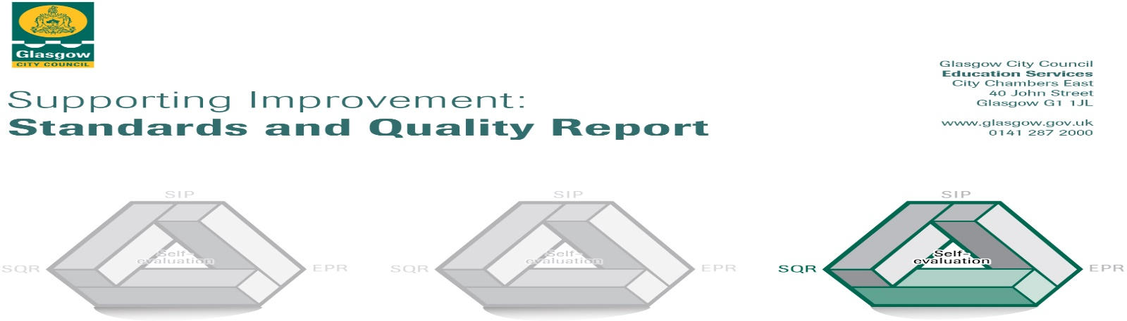

The summary report is provided for parents/careers and partners to outline our achievements this session and our priorities for next session. Throughout this session we have taken forward our priorities as detailed in our school improvement plan. Through our processes of self-evaluation, we have identified how we can improve outcomes for our children and young people.

Our achievements and improvements this year.
We would like to highlight the following improvements/achievements:
In Adelphi we aim to provide you and your child with an environment that helps them to learn about their rights and the diversity of the community that they live in. Our main priority will be for the wellbeing, happiness and holistic development of each individual child, family and staff member. We will encourage a healthy active lifestyle and to care for our environment, community and each other. We will support your child to become confident individuals, effective contributors, successful learners and responsible citizens.
Together we can ensure your child is given the best start in life.

ACTIVELY working with the staff team, families and the wider community.

DIVERSITY within the community will be supported within the setting.

EQUALITY for all children families and stakeholders.

LEARNING We will use Curriculum for Excellence Building the Ambition, Realising the Ambition Getting it Right for Every Child How Good is our Learning and Childcare and Glasgow City Council Nurture principles to deliver the highest quality learning within our setting.

PARTNERSHIPS Our setting will work closely with parents and partners to support on- going learning and smooth transitions.

HOLISTIC Needs will be nurtured throughout the setting with the staff team adopting the nurture principles and being positive role models to all children. Through staff training they will be skilled in delivering a quality curriculum to meet the individual needs of all children.

INCLUDED All children and families will be included and valued with equal opportunities for all.

Each year we strive to improve the education and care that we provide. This report tells you all about what we think we are doing well, what we have improved and what we plan to develop in the coming year. Thank you for your ongoing and continued support over this very difficult period. We will continue with our communication on Seesaw, Website and twitter.

1.3 Leadership of change

This year we have mostly consulted with parents online seeking views and sharing regular information on our events and improvements. We also reconnected our families through a parent’s event in November to share our learning environment and vision at Adelphi. Supporting the staff team to share their knowledge and skills through supported planning sessions and regular weekly meeting has ked to informed improvements in our play room environments and in our outdoor space. The staff team are supported and enthusiastic in their forward thinking and striving to learn new skills through training and further education. As a team we learn together at team training and have recently trained at Baltic street outdoor playground. We have consulted with you to obtain your views and opinions on how well we are doing and what improvements are needed to improve our setting. We have shared with your responses with you and our action plan to make these changes. The team are empowered to lead change and achieve a high quality of learning for our children and families. Staff members have lead roles for a variety of curricular areas to support the environment and learning within the setting. Quality Assurance and self- evaluation is prioritised within the setting with all staff members supported to reflect on their practice and practitioner enquiry.
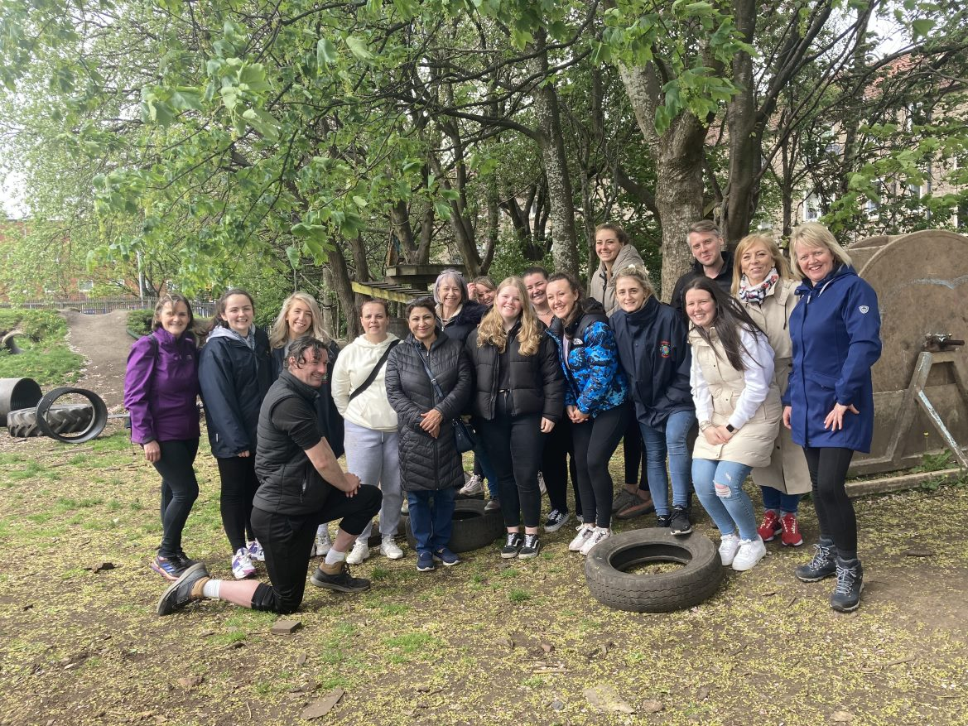
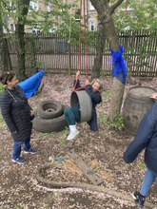
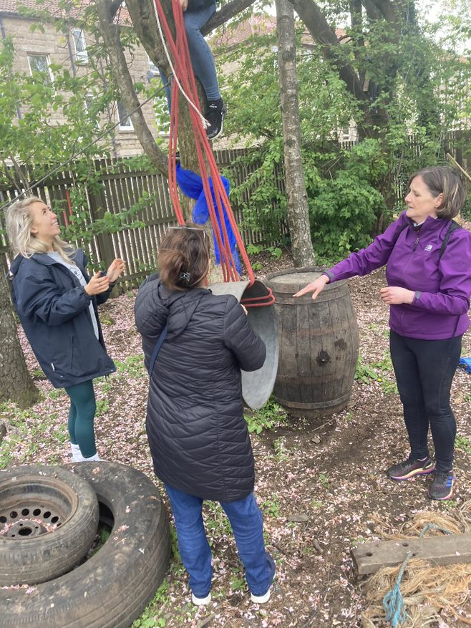
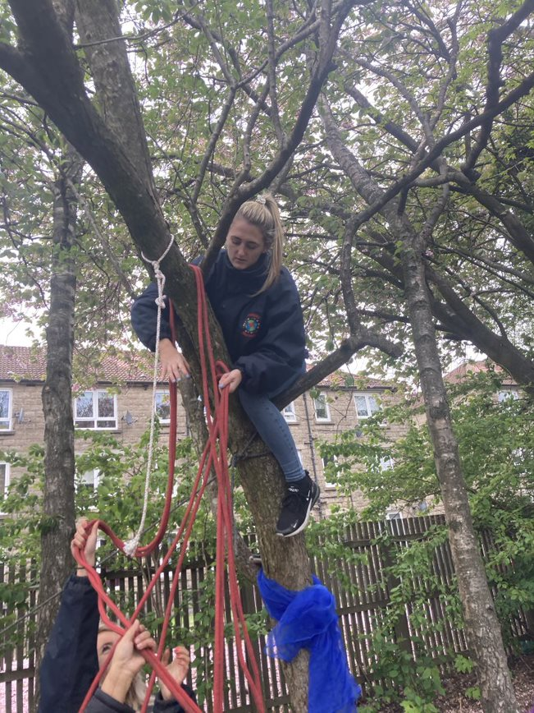

2.3 Learning teaching and assessment

Here at Adelphi Nursery we continue to ensure that children are at the heart of our Learning teaching and assessment processes. This year we have focused on how we track and record children’s individual progress across all areas of the curriculum when record significant and meaningful observations ensuring that we regularly review and evaluate their progress sharing information verbally and through see-saw with our parents and carers.
This also ensure that our children are consulted and actively provided with meaningful opportunities to take lead in their own learning that is supported by staff who facilitate a balance of high quality planned and spontaneous provocations and experiences that provides our children with the opportunities to develop their creativity and curiosity. Our Knowledge and skilful staff will use children’s interest to provide learning experiences that further develop and challenge children’s individual needs as they continue to develop their skills for long life learning using real and natural resources as well as exploring the local environment to provide real life experiences.
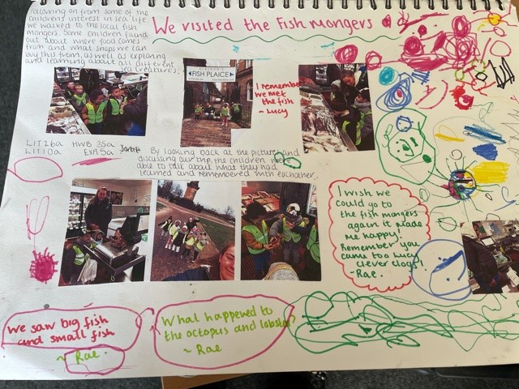
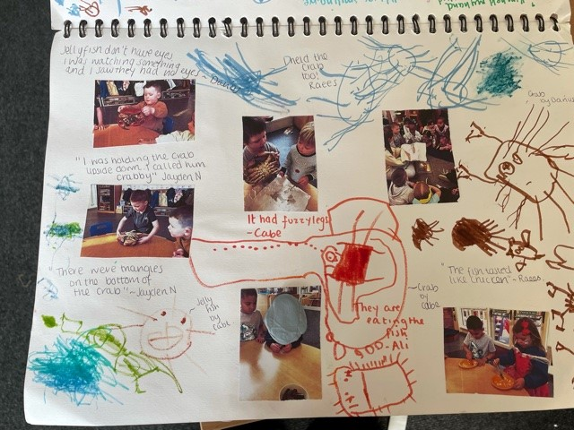
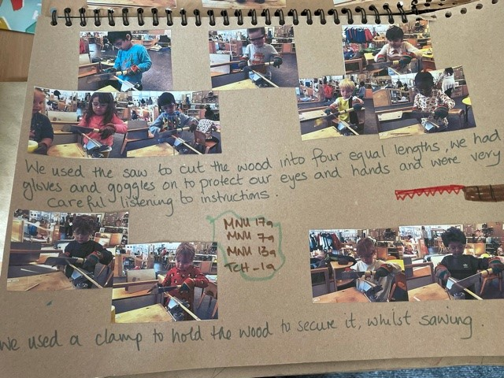
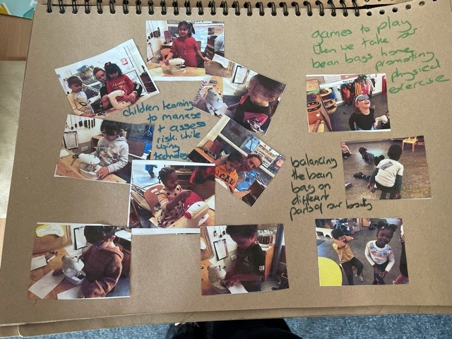
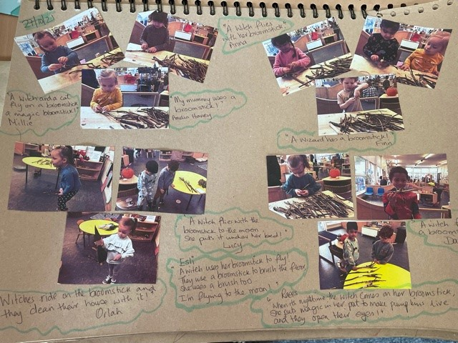

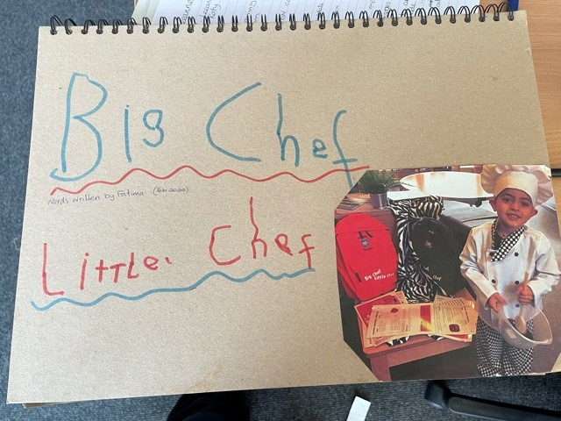
We as a staff team also recognise the importance of our parents and carers being a child’s first educators as they play and learn from birth. That is why we strive to ensure that we develop close positive relationships with our families and children, as this provide us with the opportunities to work collaboratively sharing learning from home to nursery and from nursery to home. We will continue to ensure that when planning from children’s individual needs we continue to provide opportunities for children to extend their learning at home when enhancing
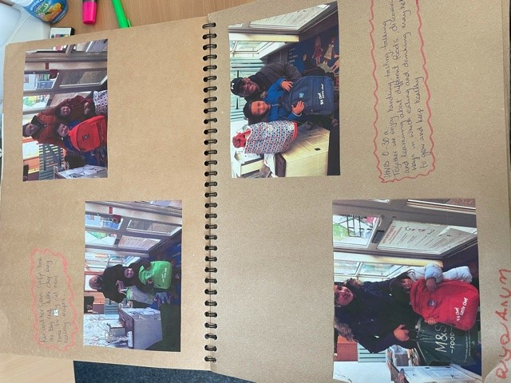

3.1 Ensuring Wellbeing, equality and Inclusion
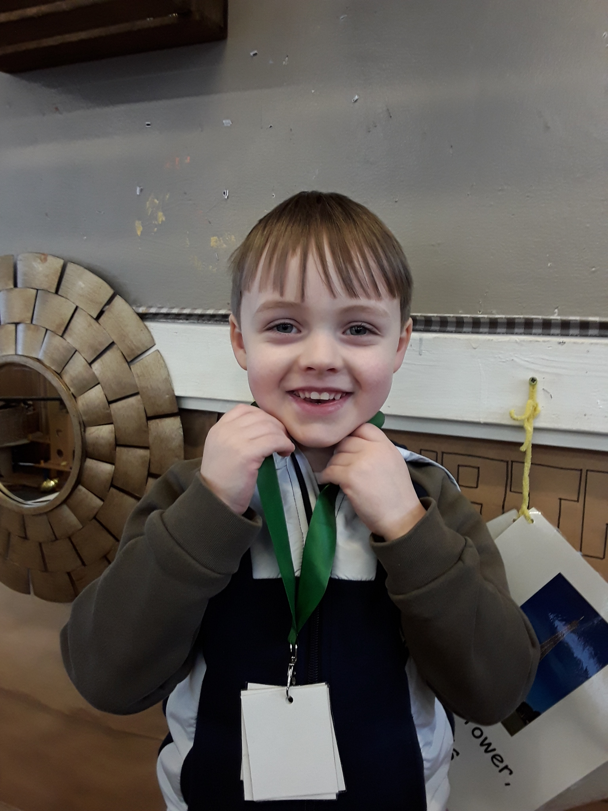
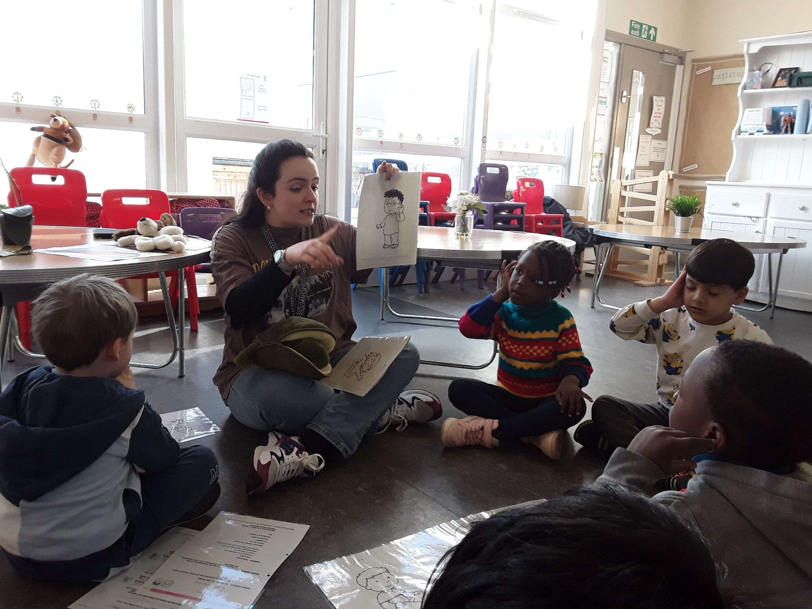
Getting it Right for Every Child is at the centre of our vision for all children and their families in Adelphi Nursery. We support our children from their visit to the nursery. We have a Getting It Right For Me information booklet that we ask parents to complete with a staff member to obtain all the information we need to support your child when they are in our care. We work closely with other professional’s health visitors and speech and language therapists to work collaboratively and achieve the best outcomes for your child. All children are supported individually and have a learning profile within the playroom and an online profile on Seesaw which is shared regularly with parents and family. Children that require additional supports to meet their individual needs have individual targeted support plans created with your consultation that support their learning and inform the whole staff team on how this can be achieved. Supporting children and families to understand and support children to learn about their rights has been a priority over the last year. We will continue to embed this within our practice with more parental involvement. PATHS (Promoting Alternative Thinking Skills) is a programme that we use within the setting to support your child to understand their emotions and how they can share how they are feeling and express themselves. All staff have been trained in attachment and nurture and we have staff members with a nurture qualification. Ensuring the wellbeing of all in Adelphi is paramount to create a safe place to learn with a sense of belonging. We support all cultures and strive to learn more about how different festivals are celebrated within our community.

2.5 Family Learning
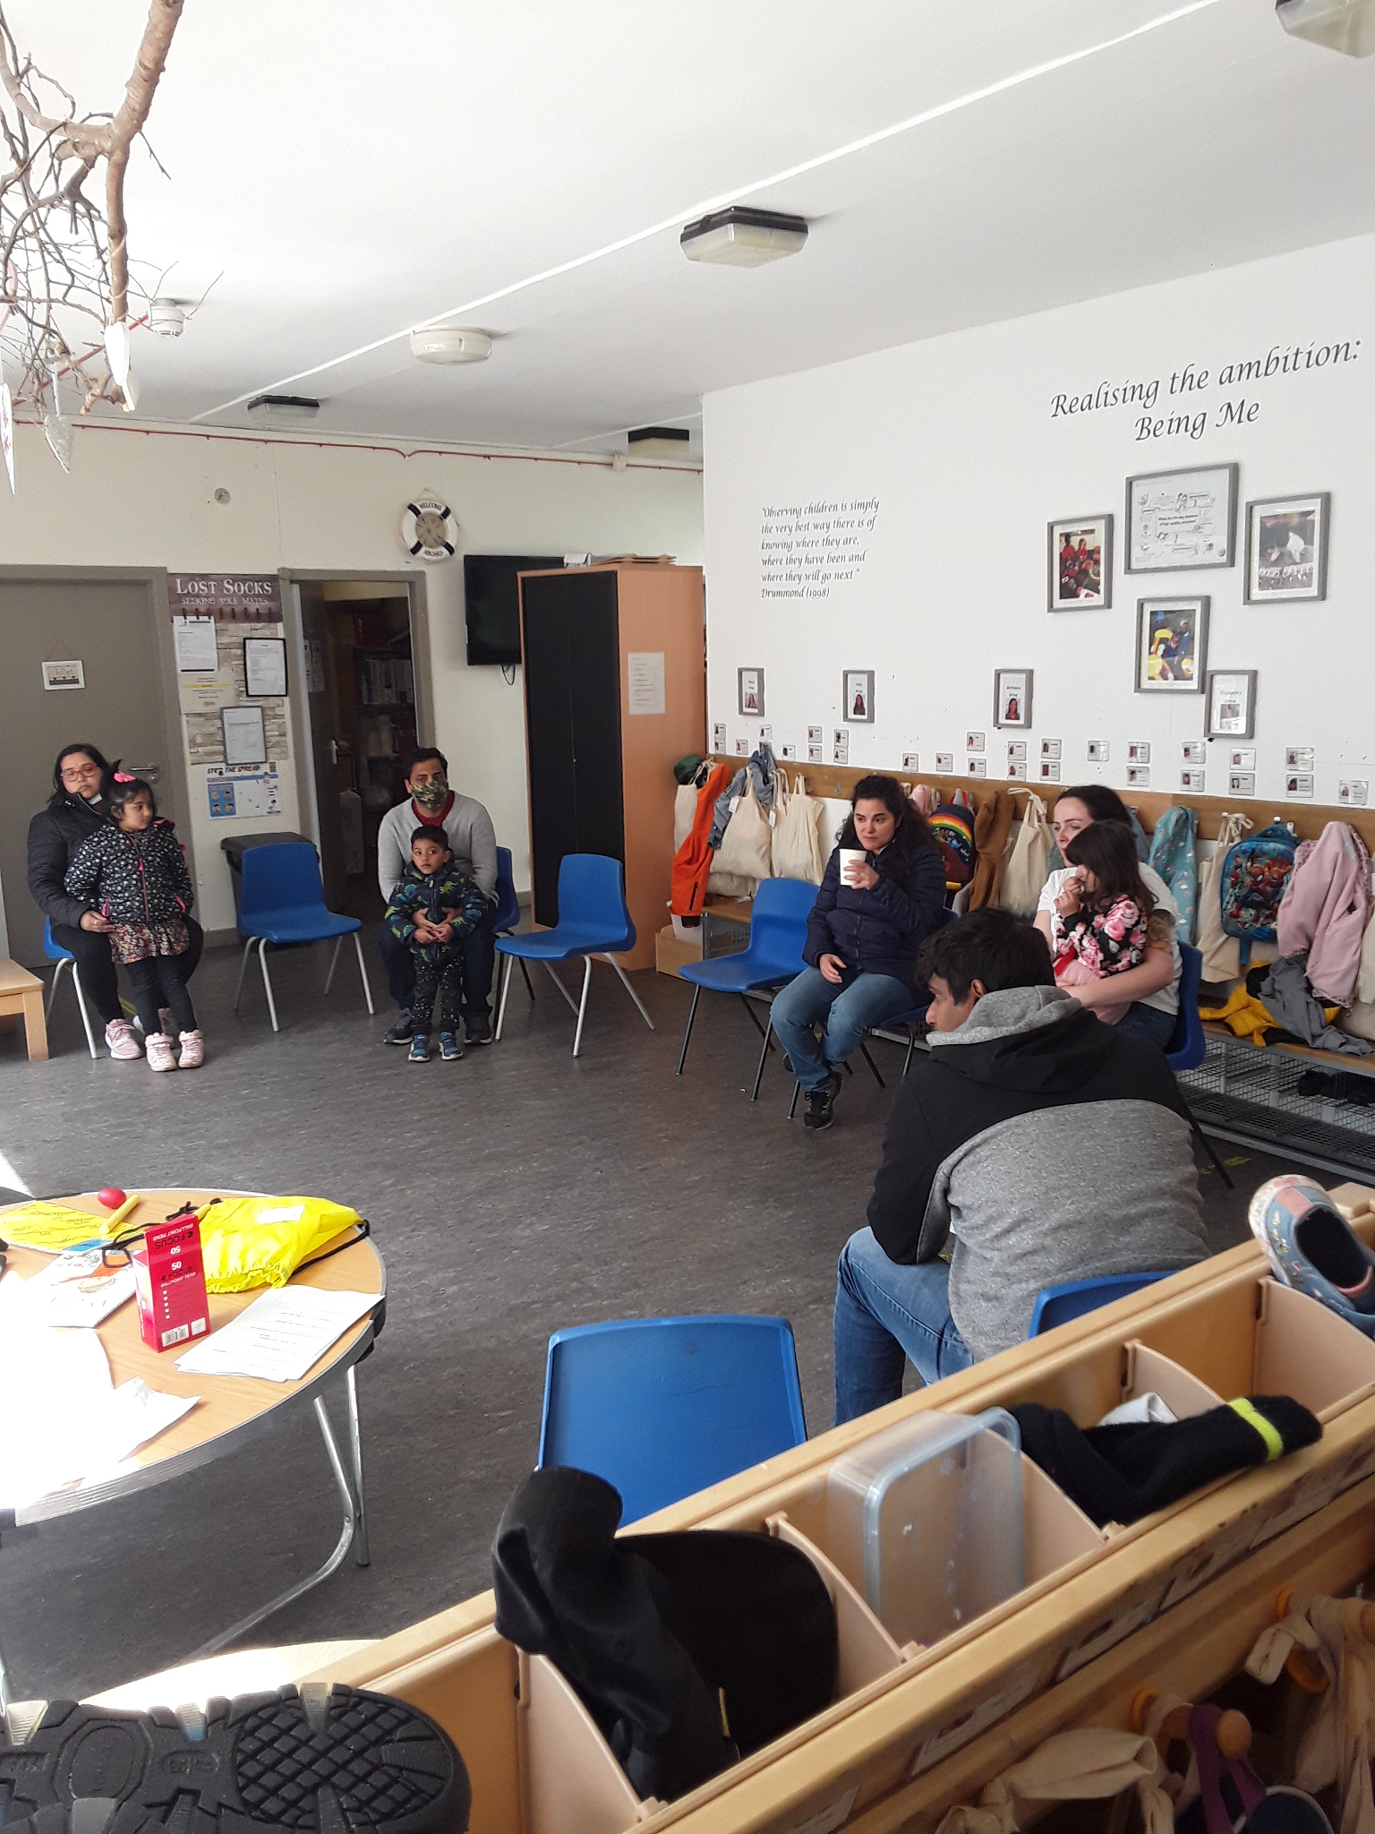
Engaging families in their child’s learning has predominantly been done through the Seesaw online learning app. All learning is posted regularly and parents can feedback on the posts regarding their child. We have also supported family learning at key points within the year at Enrolments, Transitions and individual meetings. Monthly parent drop in and chat sessions, stay and play sessions and other learning programmes that would normally be on offer to support current improvements will now start up again for our new session in August 2022.
Book bags, take home teddy and individual learning bags for children i.e new baby, visiting the dentist and toilet training are shared when appropriate.
Close relationships with the team support families at times of need and interventions can be timely to ensure strong family support.

3.2 Securing children’s progress
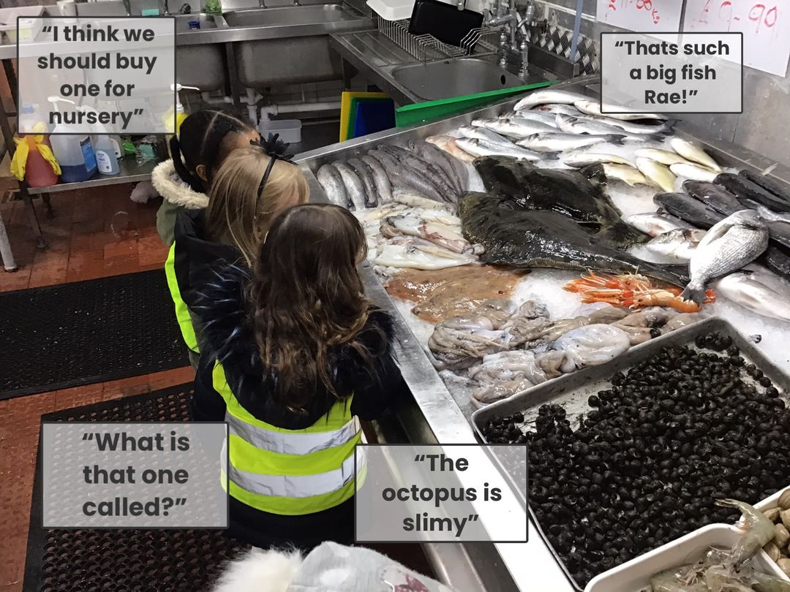
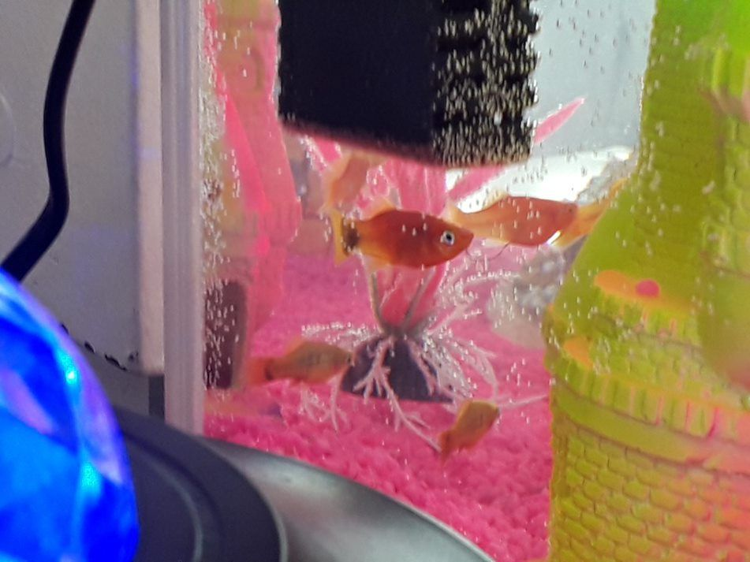
This year, we have seen a positive impact on how the children’s interests have influenced their learning in all areas of the curriculum. A good example of this is when the children’s learning was developed from their interest in sea life and pirates. The children made treasure maps and went on treasure hunts with them, developing their awareness of space and their local environment. This then helped the children look at maps of the local area and the world, where they chose The Netherlands as their country of the month. They then went on various outings to the fishmongers and to the tall ship, where they explored our local community whilst learning about different sea life creatures and how they live. They learned about weighing and measuring and explored their senses as they smelled, cooked and tasted the fish they had purchased and tasted Dutch cheese. The children then went to Pets at Home where they bought fish to look after in the nursery. During trips to the fish mongers and pets at home, the children were looking at differences between people and sea life. They then discussed their differences between each other and why we are all unique. On their outings to the fishmongers, the tall ship, pets at home the local area, the children explored different modes of transport and how to travel safely and be safe when out and about.
Children’s other interests have been developed in a similar way, ensuring that their learning is interesting as well as developing their knowledge and skills across all areas of the curriculum.

Here is what we plan to improve next year.
1. As a priority we have continued to support our families on an individual and small group basis when government restrictions were still in place.
2. We have made continuous improvements in supporting children’s individual needs, ensuring staged intervention is specific and supports progress.
3. Transitions are meaningful and individualised, consulting with parents and children to measure success and identify areas for improvement.
4. Working closely with partners in health, Speech and Language and our link EP has improved the staff team’s knowledge and recognition that they are achieving sustainable outcomes for children and their families.
5. Embedding the Seesaw learning tool to capture learning and share with parents and carers.

How can you find out more information about our school?
Please contact us directly if you require further information or if you wish to comment on the report.

The contact e-mail address is: KO’Hara@adelphi-nursery.glasgow.sch.uk

Our telephone number is: 0141 429 1471

Our school address is: 40 Waddell Court Gorbals Glasgow G5 OQA

Further information is available in: newsletters, the Nursery website, and the Nursery handbook

