Roadshow
Teacher Guide

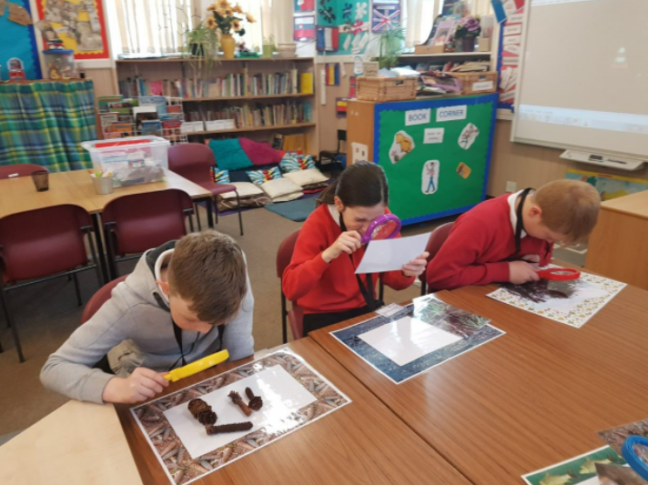

Contents

Introduction Page 3
Roadshow Overview Page 4
Curricular links Page 6
Event Organisation Page 7
After the event Page 8

Introduction

Transport Scotland has recognised the educational benefits to be derived from the A9 Dualling programme. This has resulted in the educational initiative known as “Academy9”.

Academy9 is a collaborative and evolving initiative spanning from pre-school to tertiary education and into community engagement. Acknowledging the power of partnerships between industry and education, Academy9 promotes skills and learning, STEM education and employment opportunities for future generations,

The initiative combines the technical expertise of industry professionals, the talents and knowledge of experienced educational professionals, together with the wide and diverse competence and experience of teachers and education establishments to create truly unique experiences for people of all ages and abilities.

Roadshow Overview
The Roadshow is placed at the centre of ‘A Curriculum for Excellence’ and ‘Developing Scotland’s Young Workforce’ initiatives, aimed at Second Level (P6/P7).
There are 3 parts to the Roadshow that encourage both breadth and depth of learning.

Introductory Lessons
Comprising of two lessons, this section gives pupils the opportunity to learn new information about the A9 Dualling programme in order to raise awareness of its size and scale. They are also taken on a journey of exploration and discovery while they research the wide variety of animals that must be considered when designing and developing a large-scale infrastructure project.

Meeting the Professionals
As part of a ‘real life’ learning opportunity pupils work with professionals from three diverse disciplines currently working on the A9 Dualling project. Through a series of practical tasks, they will develop an understanding of the purpose and role that Ecologists, Geologists and Engineers play on a project of this magnitude.

Post – visit Lesson Plans
In this series of 8 lessons pupils build upon their newly acquired information about the Dualling of the A9, looking in more depth at the three disciplines and how their work contributes to the project. While each lesson is developed to follow an interdisciplinary approach the many interactive team activities have been designed to enhance pupil engagement throughout. Furthermore, to fully support teaching and learning, each lesson has been carefully planned to support delivery by the non-specialist. As such a wide array of resources have been included, as well as step-by-step instructions for successful delivery of the component parts of each lesson.

You will be sent a file transfer containing all the lesson plans and printables for the above sessions.

Curricular Links
Curricular Areas | Experiences and Outcomes | Career Benchmarks
Health and Wellbeing Science  Literacy  Numeracy  Social Studies Technologies | HWB 2-20a  SCN 2-02a  SCN 2-17a  SCN 2-04b  SOC 2-08b  LIT 2-02a  LIT 2-09a  LIT 2-10a  MNU 2-20a  MNU 2-03a  MNU 2-20b  SOC 2-08a  SOC 2-08b  TCH 2-02a  TCH 2-13a | Experience a curriculum through which they learn about the world of work and job possibilities and which makes clear the strengths and skills needed to take advantage of these opportunities.  Develop skills for learning, life and work as an integral part of their education and be clear about how all their achievements relate to these.  Opportunities to engage in profiling that supports learning and the development of skills for work and future career choices.

How to get involved
Your Academy9 Education Liaison Officer will organise the Roadshow Event and will be in touch with to gather relevant information. All you need to do is:

- Confirm dates for the event
- Confirm pupil numbers
- Confirm school rooms/hall availability for the duration of the event
- Provide school timetable information around start times, intervals etc

After the Event
Academy9 continually aim to improve the experiences offered to schools to ensure events are relevant and engaging. To achieve this please take a few moments to complete this short survey.

