Gateway
Teacher Guide

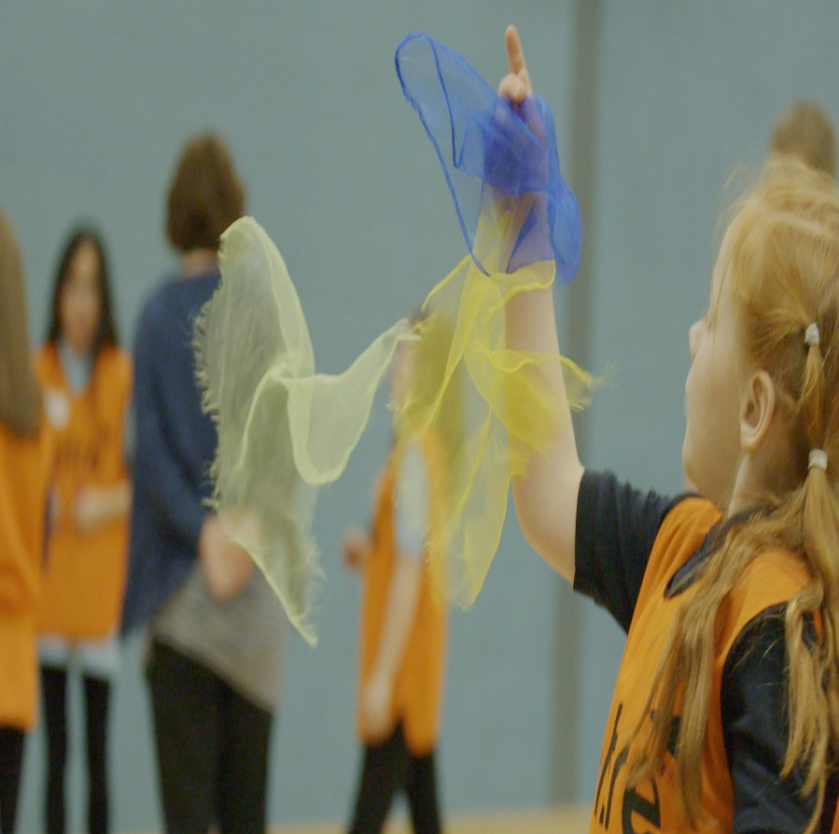

Contents

Introduction Page 3
Gateway Overview Page 4
Curricular links Page 5
Event Organisation Page 6
After the event Page 7

Introduction

Transport Scotland has recognised the educational benefits to be derived from the A9 Dualling programme. This has resulted in the educational initiative known as “Academy9”.

Academy9 is a collaborative and evolving initiative spanning from pre-school to tertiary education and into community engagement. Acknowledging the power of partnerships between industry and education, Academy9 promotes skills and learning, STEM education and employment opportunities for future generations,

The initiative combines the technical expertise of industry professionals, the talents and knowledge of experienced educational professionals, together with the wide and diverse competence and experience of teachers and education establishments to create truly unique experiences for people of all ages and abilities.

Gateway Overview
The Gateway is placed at the centre of ‘A Curriculum for Excellence’ and ‘Developing Scotland’s Young Workforce’ initiatives, aimed at Second Level (P5). Pupils take part in a half-day team event, completing six challenges focussed on transport and safety whilst incorporating a growth mindset theme. *Hosted at the associated secondary school, there are two parts to the Gateway event involving pupils from both primary and secondary schools:

- Senior Mentor Training
Volunteer S3 pupils, attend a 2-hour training session with the Academy9 Team to become Senior Mentors at the upcoming Gateway event. During the training, S3 pupils understand the rationale behind Academy9 and experience first-hand the team challenges P5 pupils will take part in. The training sees S3 pupils firmly embedded as part of the delivery team, alongside Academy9 professionals to facilitate the event.
Taking on the role of a Senior Mentor at the event provides S3 pupils with an opportunity to demonstrate their communication, organisation, leadership and team skills that can be documented and used as evidence in the future.
- Gateway Event
The event enables primary pupils to learn more about the dualling of the A9 and introduces some of the professionals who work on the project. Pupils are split into mixed teams of school, gender and ability to complete team challenges facilitated by the S3 Senior Mentors and the Academy9 Team.
The Gateway can be viewed as a transition event for the primary schools, as pupils experience their local secondary school environment and meet their future year group as they work together in teams to tackle new challenges.

*Transport Scotland will arrange and cover the cost of return transport for participating corridor schools to the event

Curricular Links
Curricular Areas | Experiences and Outcomes | Career Benchmarks
Health and Wellbeing Literacy | HWB 2-11a  HWB 2-12a  HWB 2-14a  HWB 2-16a  HWB 2-18a  HWB 2-19a  HWB 2-20a  HWB 2-23a  HWB 2-24a  LIT 2-02a  LIT 2-09a  ENG 2-12a | Experience a curriculum through which they learn about the world of work and job possibilities and which makes clear the strengths and skills needed to take advantage of these opportunities.  Develop skills for learning, life and work as an integral part of their education and be clear about how all their achievements relate to these.

How to get involved
Your Academy9 Education Liaison Officer will organise the Gateway Event and will be in touch with to gather relevant information. All you need to do is:

Associate Primary Schools | Host Secondary School
 | Confirm two consecutive dates for the event: S3 Mentor Training and Gateway event
Confirm attendance and complete a Primary School Information form
 | Discuss event itinerary, S3 participation, event accommodation, resources and event risk assessment.
Review event itinerary, team lists and event risk assessment.  Disseminate and collect pupil Participation & Photography Permission form  Visit the Academy9 website and share with pupils the:  A9 Dualling Programme Overview Video – Schools’ Version | Review event itinerary and event risk assessment  Disseminate and collect pupil Participation & Photography Permission form  Provide names of participating S3 pupils

After the Event
Academy9 continually aim to improve the experiences offered to schools to ensure events are relevant and engaging. To achieve this please take a few moments to complete these short surveys:

Pupil survey

S3 pupil Junior Mentor survey

Teacher survey

