Early Birds
Teacher Guide

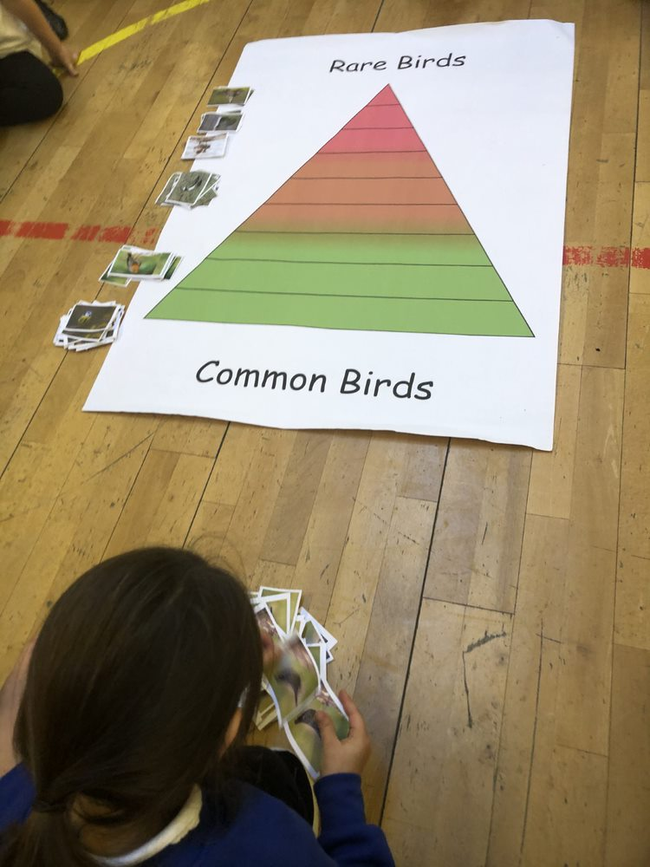

Contents

Introduction Page 3
early birds Overview Page 4
Curricular links Page 5
Event Organisation Page 6
After the event Page 7

Introduction

Transport Scotland has recognised the educational benefits to be derived from the A9 Dualling programme. This has resulted in the educational initiative known as “Academy9”.

Academy9 is a collaborative and evolving initiative spanning from pre-school to tertiary education and into community engagement. Acknowledging the power of partnerships between industry and education, Academy9 promotes skills and learning, STEM education and employment opportunities for future generations,

The initiative combines the technical expertise of industry professionals, the talents and knowledge of experienced educational professionals, together with the wide and diverse competence and experience of teachers and education establishments to create truly unique experiences for people of all ages and abilities.

Early Birds Overview
Early Birds is mapped to the Experiences and Outcomes of the Scottish Curriculum; ‘A Curriculum for Excellence’ and is aimed at First Level pupils (P2-4), specifically P2.
There are 3 activities which are run by an Ecologist with the class, as well as an additional optional classroom/homework activity that the teacher can choose to complete after the event. The learning is active and engaging for young pupils and the activities are short and fast paced.
Event Activities
Activity 1 – Bird Spotting
The first activity shows the pupils some of the local birds they might see in Scotland and introduces some facts about them. The pupils are asked to identify images of the birds by listening to information about them.
Activity 2 – Food Chains
In this activity the pupils are introduced to the concept of a food chain and given some examples of simple food chains, containing birds, that can be found in Scotland.
Activity 3 – Rare Species
The final activity draws together the learning from the prior two and looks at how changes in a food chain can lead species to become more or less prevalent or endangered. The pupils work as a group to sort species of birds according to their level of scarcity.
Classroom/Homework Activity
As an additional activity the pupils are given the recipe and instructions in how to create a bird feeder that they can use to attract some of the birds they have been learning about. This is an optional, additional activity which can be done as either as homework, or as a classroom based activity led by the class teacher.

Curricular Links
Curricular Areas | Experiences and Outcomes | Career Benchmarks
Health and Wellbeing Literacy  Numeracy  Expressive Arts  Science  Technologies | HWB 0-20a / HWB 1-20a  HWB 1-18a  LIT 1-02a  LIT 1-07a  LIT 1-10a  MNU 1-03a  EXA 1-13a  SCN 1-02a  TCH 1-02a  TCH 1-11a | Experience a curriculum through which they learn about the world of work and job possibilities and which makes clear the strengths and skills needed to take advantage of these opportunities.

How to get involved
Your Academy9 Education Liaison Officer will organise the Early Birds Event and will be in touch with to gather relevant information. All you need to do is:

- Confirm dates for the event
- Confirm pupil numbers
- Confirm school rooms/hall availability for the duration of the event
- Provide school timetable information around start times, intervals etc

After the Event
Academy9 continually aim to improve the experiences offered to schools to ensure events are relevant and engaging. To achieve this please complete this short digital form for the Early Birds Activity.

