Town Planning
Teacher Guide

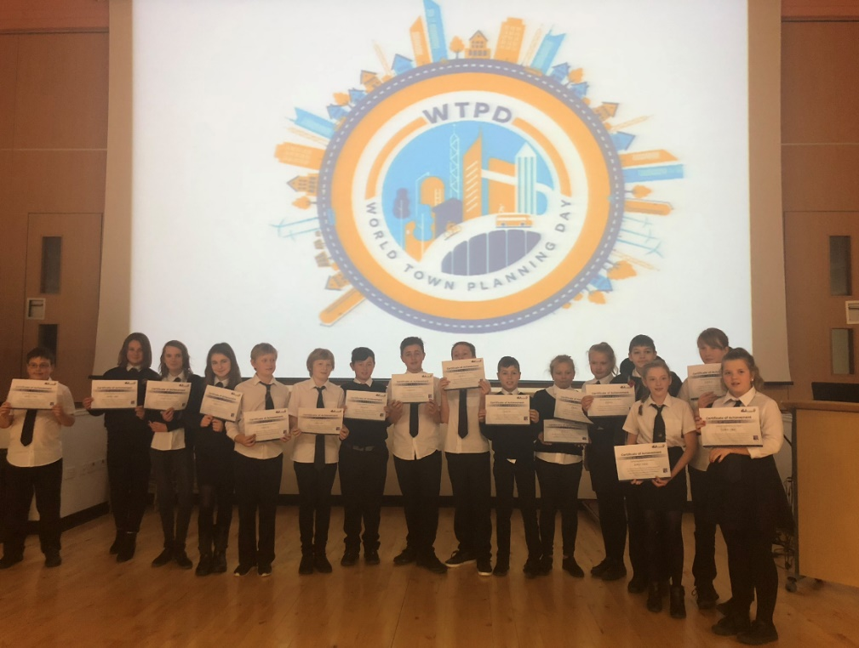
Teacher Guide

Contents

Introduction 3
Digital Town Planning Overview 4
Curricular Links 6
How to get involved… 7
Event planning prior to lesson 1 8
Event planning for lesson 2 8
Event planning for lesson 3 9
Event planning for workshop 4 – Judging Ceremony 10
After the Event 11

Introduction

Transport Scotland has recognised the educational benefits to be derived from the A9 Dualling programme. This has resulted in the educational initiative known as “Academy9”.

Academy9 is a collaborative and evolving initiative, supported by an educational framework developed by the Knowledge Exchange Partnership (KEeP Learning). The initiative spans from pre-school to tertiary education and into community engagement. Acknowledging the power of partnerships between industry and education, Academy9 promotes skills and learning, STEM education and employment opportunities for future generations,

The initiative combines the technical expertise of industry professionals, the talents and knowledge of experienced educational professionals, together with the wide and diverse competence and experience of teachers and education establishments to create truly unique experiences for people of all ages and abilities.

Digital Town Planning Overview

Digital Town Planning (DTP) consists of both teacher-led workshops and industry professional-led workshops.

DTP gives geography pupils the opportunity to learn about the roles of a Town Planner and a Geographical Information System (GIS) professional as well as getting the opportunity to use GIS software to create and develop their own towns.

Workshop 1 is a double period run by the geography teacher who introduces town planning, what it entails and why it is important. Workshop 2 is a double period run digitally by the GIS professional where the pupils get the opportunity to use ArcGIS for the first time to begin creating their towns. The pupils continue to work on this with their teacher in workshop 3. Workshop 4 takes place over a morning or afternoon and involves pupils presenting their towns digitally for judging to the planners and GIS professionals. Prizes are awarded in a variety of categories.

This teachers guide identifies the planning and preparation needed to organise the DTP experience. A file share will be emailed with all support documents.

Confirm the information below and share these details with your Academy9 Education Liaison Officer:

- Confirm dates* for the four workshops
- Confirm potential number of pupils and number of classes
- Schedule/running times (to minimise impact on the school day)
- Rooms required:
  - Lesson 1 – classroom based
  - Lesson 2 – IT suite or laptops/devices in classroom
  - Lesson 3 – IT suite or laptops/devices in classroom
  - Lesson 4 – IT suite or laptops/devices in classroom x2
- Resources planned to be used by the school (computers/devices) pupil to device ratio and type.
- ICT access planned to include registering for free ArcGIS, familiarity with software or training requirements for teachers.

*World Town Planning Day is on 8th November each year. Whilst it may be beneficial to set the final workshop for this date, the event can be held at any time of the year. badged as ‘Digital Town Planning’.

Curricular Links

Curricular Areas | Experiences and Outcomes | Career Benchmarks
Literacy  Social Studies  Numeracy  Health and Wellbeing Technologies | IT 3-02a  LIT 3-05a / LIT 4-05a  LIT 3-09a  SOC 2-08b  SOC 2-09a  SOC 3-14a  MNU 3-08a  HWB 3-23a  TCH 4-03b  TCH 3-04a  TCH 3-06a  TCH 3-08b | Experience a curriculum through which they learn about the world of work and job possibilities and which makes clear the strengths and skills needed to take advantage of these opportunities.  Develop skills for learning, life and work as an integral part of their education and be clear about how all their achievements relate to these.  Opportunities to engage in profiling that supports learning and the development of skills for work and future career choices.  Develop understanding of the responsibilities and duties placed on employers and employees.

How to get involved…

Event planning prior to lesson 1
- Confirm programme fits in with school arrangements
- Ensure there are enough laptops/devices for 2-4 pupils per group
- Workshop 2 can either be run in a classroom with laptops/devices (such as Chromebooks) or in an ICT suite.
- Workshop 4 needs 2 classrooms/ICT suites.
- The school needs to register with ArcGIS and make sure the GIS professional has the schools log-in details to create the maps. Instructions can be found in Appendix G
- Please review lesson 1 plan as this is to be taught by the teacher. Land use playing cards will be provided by your Academy9 Education Liaison Officer. If this is your first time running this event, they will be posted to your school. Please ensure all resources are in place or requested in good time. This lesson plan can be found in Appendix E The presentation can be found in Appendix E2

Event planning for lesson 2
Workshop 2 is digitally led by the GIS professionals and lasts a double period or morning/afternoon. It can be held in a classroom with laptops/devices such as Chromebooks or in an IT suite. We begin with a short presentation on what GIS is and what it is used for. It includes information on how to get into a career using GIS and what a typical day to day life of a GIS professional is like.
Following this section of the presentation, the teacher is asked to hand out the login details and tip-sheet to each group and ask them to log in. It may be useful for the GIS professional to do this on the big screen at the same time, so that pupils can follow.
With pupils watching and copying, talk them through how ArcGIS works, what the various functions do, how to place and label pins etc. Then explain that their challenge is to create their own town using ArcGIS.
Pupils then work in their teams, using their knowledge of land uses from workshop 1, to create their town. The teacher should ensure they label each pin placed, to be able to tell the professionals the reasoning behind their decisions as in workshop 4, when their towns will be judged.
Pupils to continue working on their towns for the remainder of the period and must save their towns.
Alternatively, if the teacher is confident in the use of ArcGIS, after the GIS professional’s presentation, they can take over the activity, ensuring a GIS professional remains available over the phone for the remainder of the period to support if necessary.
Actions for lesson 2:
- Although the GIS specialist will run lesson 2 we may need teacher assistance before and during this session to get the software setup and all pupils logged in.
- A twilight session can be arranged to familiarise teachers with the GIS software. There are also some instructions for using the software available in Appendix G
- The lesson plans for lessons 2-4 can be found in Appendix H
- The presentations for Lesson 2 and Lesson 4 can also be reviewed.

Event planning for lesson 3
This session allows pupils to continue to design and build their town.
The teacher may wish to remind pupils that there will be a judging session next and that they will be awarded merit in the following categories:
- Most sustainable
- Most innovative
- Best teamwork
- Best use of geospatial systems
- Best overall
Pupils may wish to spend time during this session preparing for the judging session. Considering the answers to questions they may be asked. Please refer pupils to the judging proforma in Appendix F

Event planning for workshop 4 – Judging Ceremony
Workshop 4 is led by the planning professionals and lasts a morning/afternoon. It should be held in two classrooms or IT suites: one for judging and one for pupils to continue working on their towns.
On the class smartboard, the ELO should digitally introduce the session, explaining that there are planning and GIS professionals ready to judge their towns in whichever room, under the following categories:
- Most sustainable
- Most innovative
- Best teamwork
- Best use of geospatial systems
- Best overall
Each group will move into the judging room in turn where a laptop will be set up with judges on the screen. The judges have the pupils’ town pre-loaded. Pupils present their town to the judges, discussing the points in the judging proforma.
Judges should listen to the pupils’ explanations of how they have built their town and asking appropriate questions to tease out information on which award they may be most eligible for. Judges should ensure pupils’ understanding of the challenge and notice any additional information they may have included.
During the judging, pupils can continue working on their towns in the other classroom.
Unlike the face-to-face event, this is now the end of the judging session. In the following days, the ELO should book a meeting with the judges to decide which team wins which prize. This information should then be shared with the geography teacher who can write up the certificates and award the pupils accordingly in their next class.
Actions for Lesson 4:
- Ensure two rooms have been booked and laptops set up in each one, along with a projector in the classroom.
- Ensure pupil names have been sent for certificates. Certificates will be printed and sent to the school.

After the Event

- Please ensure cards used for session one are packaged up and ready to be sent back.
- Please fill in our event evaluation form available below:

Pupil survey

Teacher survey

