Apprenticeship Academy
Teacher Guide

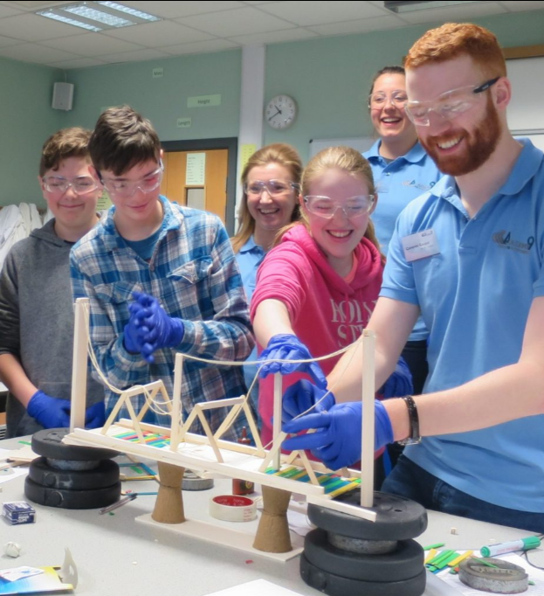

Contents

Introduction Page 3
Apprenticeship Academy Overview Page 4
Curricular links Page 7
Event Organisation Page 8
After the event Page 9

Introduction

Transport Scotland has recognised the educational benefits to be derived from the A9 Dualling programme. This has resulted in the educational initiative known as “Academy9”.

Academy9 is a collaborative and evolving initiative spanning from pre-school to tertiary education and into community engagement. Acknowledging the power of partnerships between industry and education, Academy9 promotes skills and learning, STEM education and employment opportunities for future generations,

The initiative combines the technical expertise of industry professionals, the talents and knowledge of experienced educational professionals, together with the wide and diverse competence and experience of teachers and education establishments to create truly unique experiences for people of all ages and abilities.

Apprenticeship Academy Overview
The Apprenticeship Academy is 2.5 day immersive experience targeted at S2/S3s, brings together planning and engineering/construction together to work with pupils (parents and wider community) to explore the scale and complexity of such an infrastructure project and develop their skills working in a team environment and encouraging innovation.
Apprenticeship Academy Ice Breaker Challenges
The first element of the Apprenticeship Academy brings pupils from the two participating schools and the professionals from the A9 Dualling project together in teams to complete a series of icebreakers. Communication plays a significant role throughout the event and the icebreakers are used to ensure all pupils feel equal participants and engage fully within their teams.
Quiz blurb
How well do you understand the A9 Dualling? A competition for teams to test their knowledge across a variety of categories, including the A9 Dualling project.
Team Travel
There are over 1200 people working together on the A9 Dualling project, one of the biggest construction projects ever to happen in Scotland. Working as a team participants are challenged to travel from one location to another without their feet touching the floor.
Traffic Senses
One of the project aims is to make the A9 safer for users and local communities. Participants guide each other to traverse an assault course whilst one of them is blind folded.
Juggling
Working on the A9 Dualling programme can mean learning new skills. The physical skill of juggling provides an opportunity to understand how the brain develops to practise and refine skills.
Two truths and a Lie
When you work with others on a project you learn a lot about your colleagues. Players must think of three statements about themselves. Two must be true statements, and one must be false. Each player then shares their three statements, in any order, to the group. The aim is to determine which statement is false.
Batack
Batak is a piece of equipment specifically designed to improve reaction, hand eye co-ordination and stamina…providing an element of fun and competition. (Taken from the official Batack website)
Apprenticeship Academy Mentor Challenges
The learning builds throughout the event as mentors run a series of activities focused on their area of expertise to prepare them for their bridge-building Mega Challenge.
Routes to Success
Participants explore routes across a given landscape, considering how best to navigate constraints, culminating in pitching their route to the group.

Risky Business
This challenge introduces the concept of managing engineering, environmental and health & safety risks through a series of short tasks. These include; matching the correct risks with mitigations, strategizing how best to get from one destination to another whilst avoiding risk and exploring PPE as a method of risk minimisation.

Bridge Challenge

The structures challenge for the GBAA is a crash course in structural engineering. The aim is to teach the young people about structural engineering in a fun and intriguing way. Through challenges, activities, and input from senior mentors, we provide insight what the A9 Dualling Project involves and what engineers actually do.

Environmental Challenge

This challenge touches on a variety of EIA disciplines including water management, ecology, and noise management, as well as survey techniques to explore the consequences of environmental constraints as experienced by EIA professionals.

Mega Challenge

Can you design and build a bridge? Participants need to use all their experience and understanding from throughout the event to inform their choices around; location, design, and budget/material management.

The event culminates with pitching and testing finished designs in front of a set of judges. As part of this process designs are tested to assess load levels by stacking them with weights until they give way.
Parents, friends, and family are invited to attend a prizegiving on the final day of the event.

Curricular Links
Curricular Areas | Experiences and Outcomes | Career Benchmarks
Health and Wellbeing Social Studies Technologies  Numeracy  Literacy  Science  Expressive Arts | HWB 3-01a, HWB 3-04a  HWB 3-11a, HWB 3-12a  HWB 3-14a, HWB 3-15a  HWB 3-16a , HWB 3-18a  HWB 3-19a, HWB 3-20a  HWB 3-21a, HWB 3-22a  HWB 2-23a, HWB 3-24a  SCN 3-01a, SCN 2-17a  SCN 3-18a, SOC 2-06a  SOC 2-08a, SOC2-08b  TCH 2-06a, TCH 3-07a  TCH 3-07b, TCH 2-09a  TCH2-12a, TCH 3-14a  LIT 3-02a, LIT 3-05a  LIT 3-06a , LIT 3-09a  LIT 3-10a, LIT 3-24a  LIT 3-28a, LIT 3-29a  MNU 3-03b, MNU 3-07a  MNU 3-09a , MNU 3-11a  EXA 3-02a, EXA 3-03a  EXA 3-06a | Experience a curriculum through which they learn about the world of work and job possibilities and which makes clear the strengths and skills needed to take advantage of these opportunities.  Develop skills for learning, life and work as an integral part of their education and be clear about how all their achievements relate to these.  Opportunities to engage in profiling that supports learning and the development of skills for work and future career choices.  Develop understanding of the responsibilities and duties placed on employers and employees.

How to get involved
Your Academy9 Education Liaison Officer will organise the Apprenticeship Academy and will be in touch with individual schools to gather relevant information.
All you need to do is:

- Market the Apprenticeship Academy Programme to pupils
- Compile a list of pupils (max. 30) who would like to volunteer into the programme
- Confirm school rooms/hall availability for the duration of the event
- Provide school timetable information around start times, intervals etc
- Provide name of each pupil taking part
- Liaise with ELO regarding further organisation/logistics

After the Event
Academy9 continually aim to improve the experiences offered to schools to ensure events are relevant and engaging. We are very keen to hear your feedback on the Apprenticeship Academy event. Please provide pupil feedback using this link

