

**EDUCATION GUIDANCE**

**GUIDANCE on: 10 Strategies for the effective teaching of writing**

**Produced: March 2019**

**Review: June 2019**

**Owner: Clare Bryden**

1. Children need to see themselves as writers



*Sue Ellis’s 3 Domain model of literacy*

**IDEAS:**

***NB ‘writing’ happens in all areas of the curriculum, not just in designated ‘literacy’ times. Literacy should be seen as being at the heart of all learning.***

There should be multiple opportunities from P1 upwards for children to see that the ‘writing’ they produce has value and purpose.

They should be encouraged to ‘read’ their writing even when it is early mark making

Let children write sometimes with the purpose of reading it to others, in pairs or groups. This takes away the pressure to be entirely accurate and values the content.

Writing should not be seen as something isolated within the curriculum, but should feed into all areas of the school day including play

The teacher should create lots of opportunities to write and to talk about what’s been written and why

Have a free writing jotter which is used one day a week (Free Writing Friday?) – this is off limits to the teacher unless invited by the child, but the children can write, doodle and draw stories in it

Create opportunities for children’s writing to be published using technology

**LINKS:**

For EY / P1: <https://www.makebelievearts.co.uk/helicopterstorieslettingimaginationfly>

<https://literacytrust.org.uk/resources/free-writing-friday-resource/>

1. Children need to write within meaningful contexts

*“when children write about what they already know, they already have the information at their fingertips – they are full of confidence. This allows them to think about how to write it instead of having to concentrate on* what *it is they are being asked to write”*

*literacy for pleasure: wordpress.com*

**IDEAS:**

Approaches such as Storyline Scotland give children the opportunity to write as part of a context over which they feel ownership. NB Storyline should be used as a context for ALL learning, not just writing

Unless children write within a context they understand, they may not succeed at the writing task and writing becomes more an assessment of previous experience than of skill. This particularly disadvantages the most deprived children.

Try blogs, letters to real people, emails and diaries

Create a diagram at the start of the year on the things children are interested in or know about and refer to this when thinking about contexts for learning

Don’t make assumptions – find out about your pupils’ prior knowledge at the start of any learning.

**LINKS:**

ABLE2 – Storyline Scotland resources: <https://blogs.glowscotland.org.uk/glowblogs/able/storyline-scotland/>

<https://literacyforpleasure.wordpress.com/2017/02/04/the-sea-of-writing-ideas-10-ways-we-got-children-choosing-their-own-topics/>

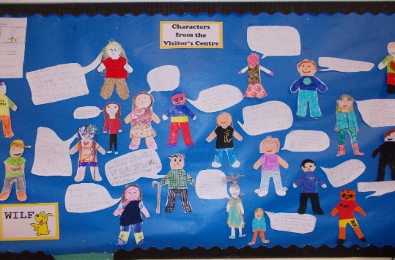<https://clpe.org.uk/library-and-resources/what-we-know-works-booklets>

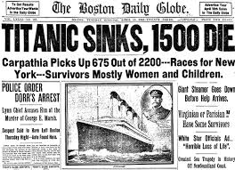3 Begin with concrete examples of texts (Reading into writing)

*“The cultural understandings and linguistic repertoires that writers bring to their writing are heavily shaped by their reading experiences.”*

*Myhill & Fisher: Editorial: Writing development: cognitive, sociocultural, linguistic perspectives*

There is no need to be an expert in the type of writing you are about to teach: you can work with the class to identify what makes a good newspaper report, reflective piece, discursive essay, recipe, letter of complaint etc

**IDEAS:**

**An example** of how to start with a concrete example (depending on levels of experience, you might ask the pupils to work through it themselves without you modelling the process):

* Find an example of the text (or write it yourself)
* Share the type of text it is – what do we expect its purpose to be? Who do we think its audience might be?
* Model reading the text critically – pulling out bits that are worth commenting on. This could be:
* specific text features (headlines, subheadings, bullet points etc)
* stylistic features (word choice, types of sentence, length of sentence, images etc)
* features of register (tone – formal or informal?, level of complexity etc)
* Ask the pupils to work together to read it critically, highlighting anything they think is important
* Discussion about what makes it successful as this type of text
* From this you can create the success criteria that will apply to children’s own writing – these can be easily co-constructed by the children
* It can also be boxed up into sections to provide a scaffold for independent writing

**LINKS:**

<https://blogs.glowscotland.org.uk/glowblogs/able/test/test-2/writing/> - Sue Palmer’s presentations on the types of non-fiction writing and their features

4 Keep talk at the heart of all writing activities

*“It’s all about building up a bank of text types in their head so that the language patterns are familiar to them and become part of their linguistic competency.”*

*Pie Corbett*

**IDEAS:**

If children can’t talk something they can’t write it. They can’t talk it until they’ve heard it.

The Talk for writing approach is very useful – more details can be found at <https://www.talk4writing.co.uk/> In outline it involves the following:

* Children listen to a text, creating a text map together, then spending lots of time on the children recreating the text in different ways orally until they know it inside out.
* Work is done on understanding its language and structure and the skills associated with it.
* A shared version of the text is created with the teacher taking ideas on how to recreate and refine it.
* The children write their own version, using all the resources you’ve used in the teaching.
* Finally, the teacher looks for opportunities for the children to independently create the same type of text but independently, in a different context.

Many other opportunities for talk can support writing:

* Lots of discussion around key areas that are going to be written about.
* 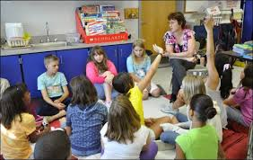Games to practise certain structures such as “First . . . next . . . finally,” or “the leaves fall because of the wind, the grass grows because of the rain, the children shiver because of the cold.”
* <http://www.shakespeareandmore.com/talk-in-english-lessons.html> - ideas for using whole class, group and paired discussion

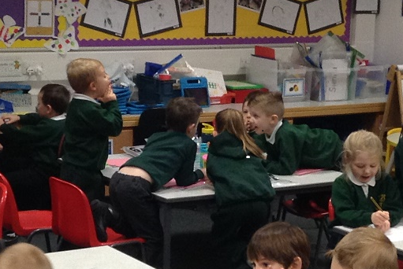

5 Teach relevant skills according to the needs of the type of writing

Certain types of writing will require the teaching and exploration of certain skills such as:

* Note taking from a range of different texts
* Finding information online
* Skimming / scanning
* Linking paragraphs
* Topic sentences
* Creating complex sentences
* Using formal language
* Persuasive techniques
* Using evidence to back up points
* Checking the reliability of sources

Decisions as to which of these skills need to be taught can be made in discussion with the children.

**LINKS:**

Note-taking: <https://blogs.glowscotland.org.uk/glowblogs/able/test/test-2/writing/> - Sue Palmer’s presentations on the types of writing is useful for the different ways you can take notes, according to purpose.

Skimming/ scanning: <https://busyteacher.org/10731-5-activities-for-teaching-reading-strategies.html>

Finding information online / checking reliability: [www.kathleenamorris.com/2019/02/26/research-lessons/](http://www.kathleenamorris.com/2019/02/26/research-lessons/)

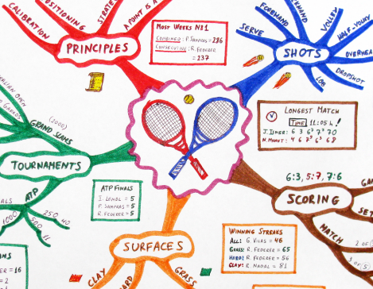

6 Share construction of writing

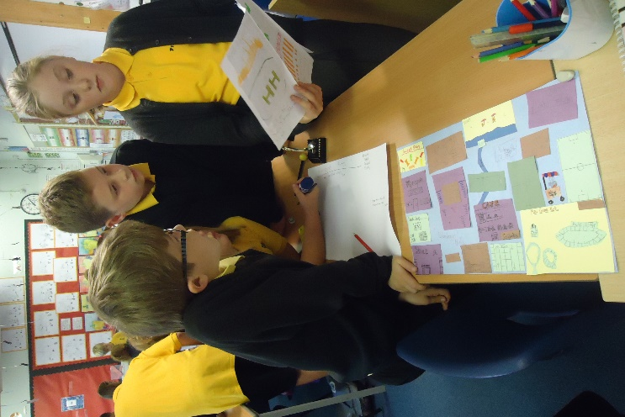

*“Collaborative writing, when students plan, draft, revise and edit writing compositions with peers, has been shown to increase attainment in writing.”*

*Graham & Perin, 2007*

*“Modelling writing, when teachers are engaged in demonstrating how writing is constructed, including ‘thinking aloud,’ making choices, the use of technical skills, revising and redrafting, has been shown to be effective in improving writing.”*

*Dombey 2013*

Initially this can take the form of co-constructing a text with significant input from the children – often referred to as ‘modelling.’

The text doesn’t have to be brand new – it can be a recreation of the original text you looked at.

The text produced together should be above the level the children are currently writing at – this supports high expectations of what they can create.

Collaborative planning is part of this – for example you can lay suggested paragraphs out on the floor and children can create their own structures.

If you are not modelling the whole thing, don’t always model the introduction. Try starting in the middle.

Children can progress onto shared construction of texts, or some groups can construct together, some with the teacher.

*“It is particularly important to encourage lower achieving pupils to talk and articulate their thinking in collaborative tasks, as they may contribute less.”*

*Education Endowment Foundation: Improving Literacy in Key Stage 2*

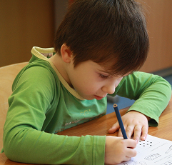7 Encourage independent writers

*“Being able to think and act independently remains one of the most important skills that a student can learn.”*

*Mike Gershon: How to develop independent learners*

The approaches above are all scaffolding activities and can be gradually removed or lessened according to the needs and experiences of your class. The aim is always to move towards working independently.

However, it is important that key skills and attitudes become embedded parts of the child’s identity so the teacher should work with the needs of their class rather than considering approaches according to age.

Aim high with your expectations of what children can produce – try not to place a ceiling on your expectations. Independent writing should be encouraged from the start.

Some children will need more reminders of structures as they write independently. Where possible these should be co-constructed – possibly in a small group or even as a whole class. For example:

* 1st lines of each paragraph
* Paragraph content reminders
* Boxed outlines filled with ideas

Too great a reliance on externally produced structures leads to formulaic writing and hinders the child’s self-perception as a genuine writer. It is better to spend a longer amount of time on the writing process to really embed skills and understanding than to ask pupils to produce huge quantities of writing with little understanding of the skills they are using.

NB In the early stages of writing, overwriting and underwriting are not activities which encourage independence in writing – these are copying exercises.



8 Don’t forget spelling, punctuation and grammar

A good command of spelling, grammar and punctuation gives children control over their written language, enabling them to communicate more effectively.

Argyll and Bute has published guidance on spelling and on punctuation and grammar that supports this document.

This can be found at: <https://blogs.glowscotland.org.uk/glowblogs/able/test/test-2/writing/>

***While it is important that spelling, punctuation and grammar are taught, the following points should be noted:***

*Punctuation and grammar in particular are most effectively taught within the context of other learning. Writing provides the ideal opportunity to discuss grammatical constructions with pupils and encourage them to play with language.*

*It is appropriate to have ongoing expectations for punctuation, grammar and spelling in ALL pieces of writing (not just designated ‘literacy’ pieces). This keeps the focus on accuracy at the heart of all learning.*

*However, teachers should beware stifling pupils’ writing in all contexts by too heavy a focus on marking errors. Accuracy can be encouraged by, for example:*

* *giving feedback on technical aspects during the writing process*
* *allowing the 1st draft to focus on content, with time then given for self-checking of accuracy*
* *encouraging peer and self-evaluation*

Be aware that, until spelling is internalised and automatic, many children’s spelling will seem to get worse as they concentrate on the content of what they write. As a result, writing should always be approached as a **process** rather than a one-off event:

* 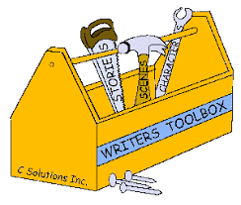plan – think things through, collect ideas and map them out
* draft – using the plan as a rough guide, have your first attempt, focussing on key ideas
* share – share ideas or drafts through the writing process
* evaluate – think about what you’ve done as a piece of writing – both content and technical skills
* revise– make changes based on your evaluation. Work may become messy at this point
* edit – make necessary changes. Spelling etc assume greater importance here
* publish – if appropriate, ensuring suitability for audience

9 Develop vocabulary

The best way to develop vocabulary is by ***encouraging a reading culture*** in your school.

Links:

<https://clpe.org.uk/content/reading-pleasure-–-what-we-know-works-0>

<https://www.readingchallenge.scot/>

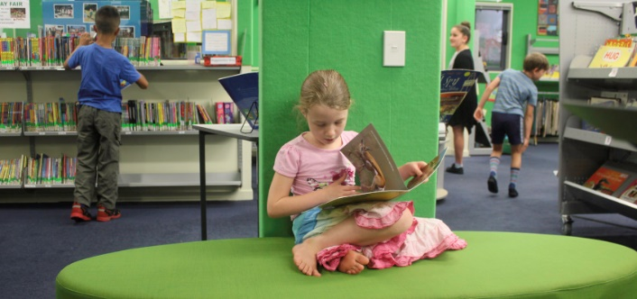<https://www.tes.com/news/six-steps-create-reading-culture-your-school>

***Pre Teaching Vocabulary***

At the start of any topic, use it as an opportunity to see what children’s vocabulary knowledge already is.

When directly focussing on building vocabulary you should focus on tier 2 words:

|  |  |
| --- | --- |
| Tier 1 | Words which most children will already have as part of their understanding and language (e.g. beach, sand) |
| Tier 2 | The words from the context that can be transferred across a number of different contexts (e.g. tide, current, erosion) |
| Tier 3 | Subject-specific vocabulary relating to the context (e.g. mollusc, neap tide) |

We recommend that you use the resources from Pip St John on pre-teaching vocabulary by looking at:

* What does it mean?
* How does it sound?
* What objects, visuals and gestures could represent the word?

Resources to support this can be found at: <https://highlandliteracy.files.wordpress.com/2018/10/pre-teaching-vocabulary.pdf>

10 Give effective feedback

*“Remember that all writers, especially young writers, are fragile. They break easily. Don’t pound them by pouncing on every error. Nurture them by keeping the focus narrow and attainable.”*

*Kelly Gallagher*

Information on effective feedback in general can be found in Argyll and Bute’s Guidance on Assessment for Learning which can be found at <https://blogs.glowscotland.org.uk/ab/sali/assessment-is-for-learning/>

Key points to remember:

* Let the children self and peer edit rather than pointing out their errors in technical skills as they’re writing a 1st draft. Writing is a process.
* Individual pieces of writing should be evaluated against the success criteria for that particular task rather than assessed against an anonymous set of criteria.
* Feedback is far more effective when it is given during the process of writing than after the event.
* Feedback is only important in as much as it has an impact on the child’s learning, so it should clearly outline what the child must do in order to improve.
* Feedback that is limited to technical accuracy encourages the view that to become a better writer you just have to improve your spelling / punctuation.

