Talking with your child

Ideas and Guidance

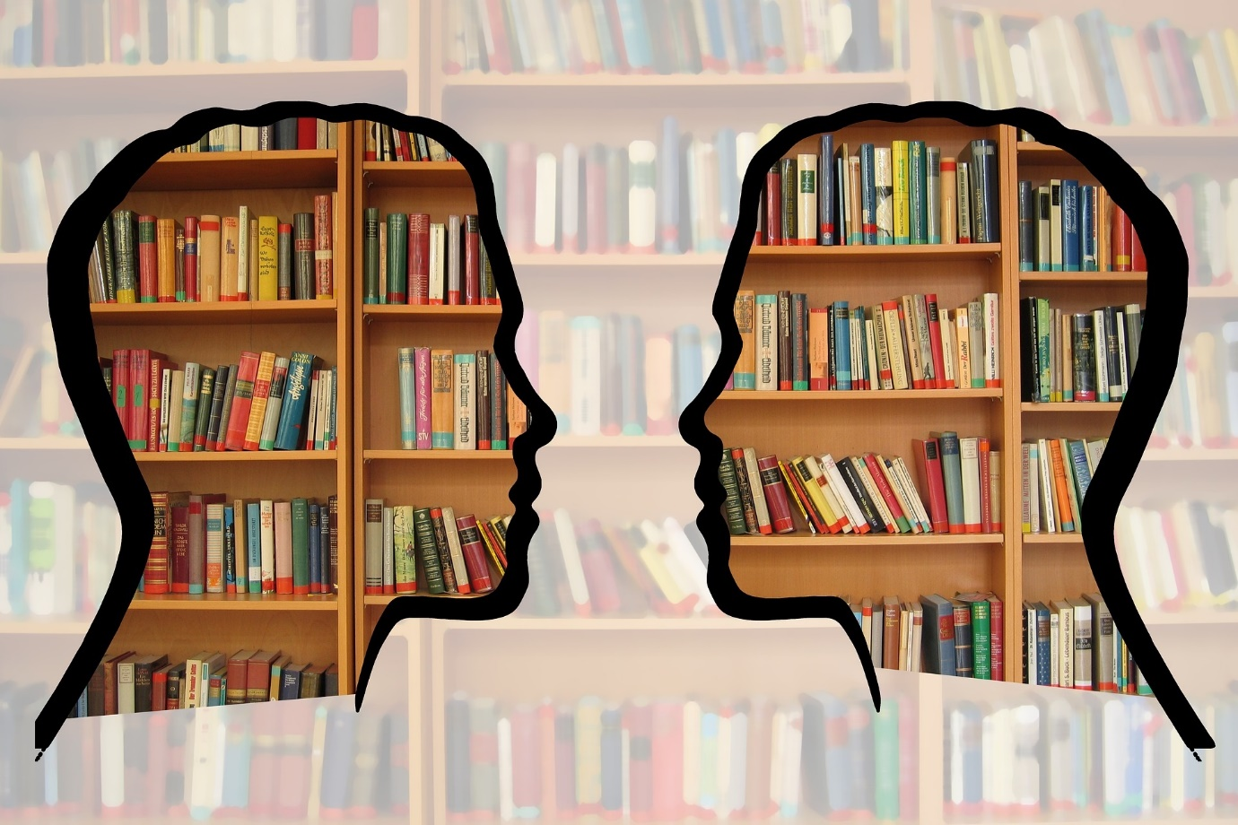

Quiz - How do you respond to your child’s questions?

Rate each example on a 5 point scale, according to how often you respond like this to your child.

1= I respond like this all the time
2 = I respond like this often
3 = I respond like this sometimes
4 = I respond like this rarely
5 = I have never responded to a question like this

Example 1: Reject the question
"Why do I have to eat my vegetables?"
"Don't ask me any more questions."/ "Because I said so."
1 2 3 4 5

Example 2: Repeat what they’ve asked back to them as the answer
"Why do I have to eat my vegetables?"
"Because you have to eat your vegetables."
"Why is that man acting so crazy?"
"Because he's insane."
"Why is it so cold?"
"Because it's 15° outside."
1 2 3 4 5
Example 3: say you don’t know OR give a piece of information as the answer
"I don't know, but that's a good question."
Or, give a factual answer to the question.
1 2 3 4 5

Example 4: encourage them to think of how they could find out
"Let's look that up on the internet."
"Let's look that up in the encyclopedia."
"Who do we know that might know the answer to that?"

1 2 3 4 5

Example 5: encourage alternative explanations
"Why are all the people in Holland so tall?"
"Let's think about some possible answers."
"Maybe it's genetics, or maybe it's diet, or maybe everybody in Holland wears elevator shoes, or…" etc.
When thinking up explanations, it is important to remember all ideas are put out on the table. Which ones are "keepers" and which ones are rejected is decided later.

1 2 3 4 5

Example 6: encourage alternative explanations AND think about how you’ll work out which one’s true
"Now how are we going to decide which answer is right? Where would we find that information?”

1 2 3 4 5

Example 7: encourage alternative explanations AND think about how you’ll work out which one’s true AND follow through on these things
“Okay, let's go find the information for a few days — we'll search through the encyclopedia and the Internet, make telephone calls, conduct interviews, and other things. Then we will get back together next week and see whether we can work out the right answer.”

1 2 3 4 5

Try to vary the way you respond to questions – this will help to develop your child’s thinking skills
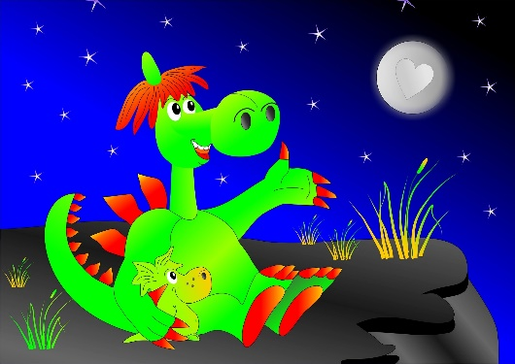

Effective talking habits

It’s important to make sure that, as a family, you develop effective habits as you talk with your child.

Which of these do you do?
1 | 2 | 3 | 4 | 5
All the time | Often | Sometimes | Rarely | Never
1 | 2 | 3 | 4 | 5
I make sure that I have their full attention before talking with them

1 | 2 | 3 | 4 | 5
I make sure that we take turns and don’t speak over each other

1 | 2 | 3 | 4 | 5
If they say something unusual I try to ask them questions about it / encourage them to say more

1 | 2 | 3 | 4 | 5
I ask open ended questions (questions which don’t just have a yes/no answer)

1 | 2 | 3 | 4 | 5
I don’t just ask questions – I try to comment on what they say to open up a genuine conversation.

1 | 2 | 3 | 4 | 5
All the time | Often | Sometimes | Rarely | Never
1 | 2 | 3 | 4 | 5
If they make a mistake I repeat back to them the right way to say it, rather than tell them they’ve made a mistake

1 | 2 | 3 | 4 | 5
We play with words – making up rhymes and silly sayings etc

1 | 2 | 3 | 4 | 5
I give them time to think through what I’ve said before they answer

1 | 2 | 3 | 4 | 5
I check to make sure that they’ve understood what I’ve said

1 | 2 | 3 | 4 | 5
We have a chat every day

Ideas for developing talking skills

Making statements to your child rather than asking questions can lead to bigger conversations
e.g. “You’re on the slide” rather than “Do you like the slide;” “That looks good, I love ice-cream,” rather than “What are you eating?”

Don’t point out if they say something incorrectly, just say it back the right way.
e.g. “I goed swimming.” “Yes, you did, you went swimming.”
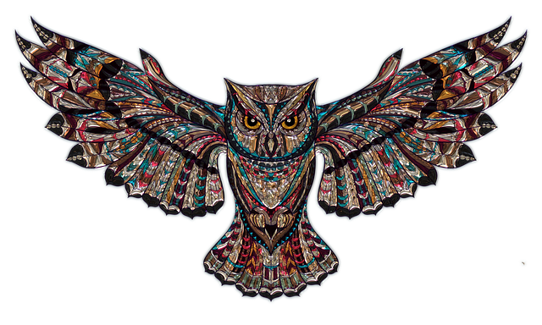
Follow the OWL pattern:
Observe and watch what they’re doing o begin with rather than forcing yourself into their space with a comment
Wait for them to interact with you
Listen to what they say to you and respond

More resources, advice and ideas can be found at Argyll and Bute’s Literacy page: ABLE 2
https://blogs.glowscotland.org.uk/glowblogs/able/

