Sharing Books
Share a story every day – try nursery rhymes, stories from memory or some of the free ideas overleaf
Ask different types of questions after reading (see other side for some ideas)
Look at the pictures together and talk about what’s happening
Ask them to guess what will happen at different stages
Point to the words as you say them
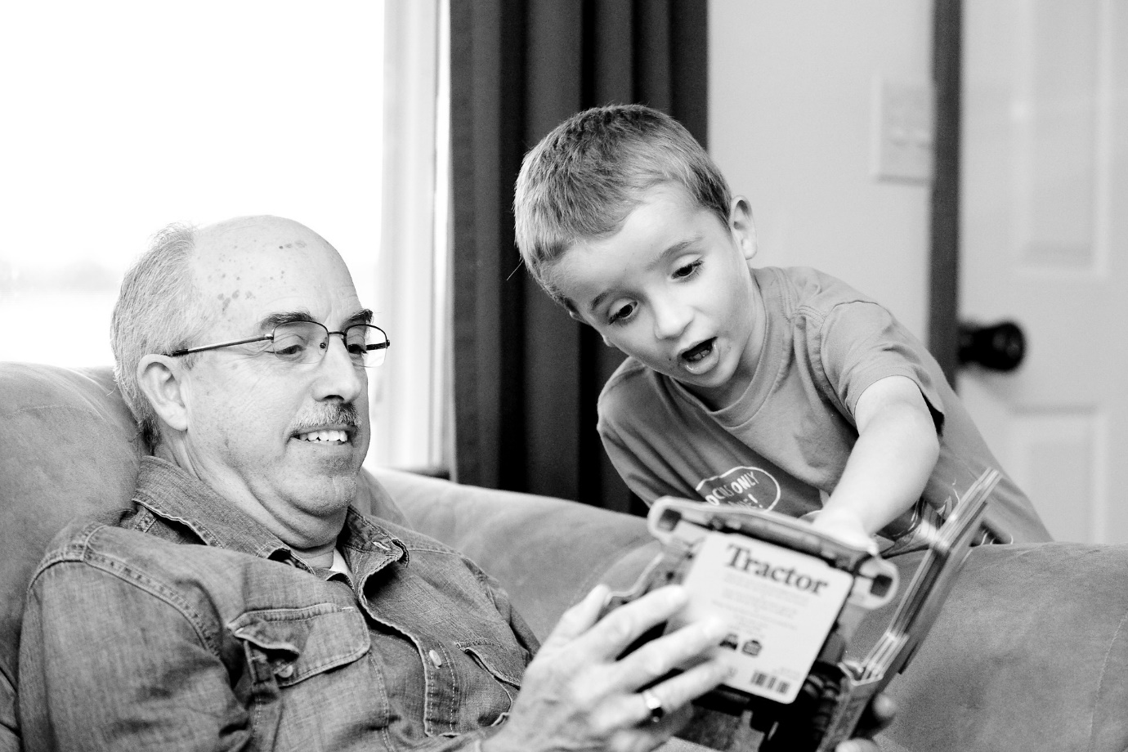

Ideas for questions
Can you remind me what’s happening?
What do you think is going to happen?
Why do you think that?
Why do you think they did that?
Why do you think he/she said that?
What would you do if you were in that situation?
What would happen if . . . (e.g. they decided not to help their friend)?
What did you think of (character)?
Why did you think that?
Was that what you were expecting? Why / Why not?
What was your favourite part?
Were there any bits you didn’t like?
Could it have ended a different way?
Finding free stories

Oxford Owl give you access to 250 free e-Books organised according to age and ability which you can access after registering your details. https://www.oxfordowl.co.uk/readingsupport/about-oxford-owl-for-home-readingsupport/
The BBC have performances of lots of nursery rhymes which you can use to remind yourself of some old ones and learn some new ones: http://www.bbc.co.uk/programmes/p037tqx1
Your local library will have lots of books you can access. Find out about your library services here: https://www.argyll-bute.gov.uk/community-life-and-leisure/libraries-and-archives
Check out Argyll & Bute’s literacy website, ABLE 2 for more ideas and resources: https://blogs.glowscotland.org.uk/glowblogs/able/

