Supporting the foundations of literacy in the home

Inside this booklet are ideas for how you can develop the key things that need to be in place as your child develops their literacy skills:
- Listening
- Talking
- Engagement with music, movement and memory
- Engagement with stories
- Concepts of print
- Awareness of sounds
- Physical readiness for writing

You can make a difference!
Listening
Things to remember:
Children need to be able to tell the difference between what’s important noise and what isn’t so they know when to listen.
Not knowing when to listen can lead to problems in school.
Listening isn’t the same as watching.
What can we try?
- Turn off the TV for some of the time you’re at home together – constant background noise can make it difficult to tell the difference between important and unimportant sounds.
- Have audio books in the car and talk about what’s happening.
- Make sure you spend some time listening to your child every day – value their ideas and opinions. Be a genuine listener yourself. Use eye contact to show you’re listening.
- Play games where people have to take it in turns.
- Choose a favourite book (or programme). Pick a word that comes up a lot. Every time they hear the word they have to shout out “sausages!” Keep changing the word.

Talking
Things to remember:
Children need to be able to talk before they can write.
Listening to talk on screen does not replace real conversations.
Children need to understand facial expressions, tone of voice and body language.
Everyone needs space – children will have times when they just don’t want to talk and that’s OK too.
What can we try?
- Answer the ‘why’ questions. If you don’t know, find out together by asking someone else and talking about it with them.
- Explain to your child what you’re doing as you’re doing it – like a running commentary.
- If you’re worried that your child never wants to talk, use a puppet (try using an old plastic bag with eyes drawn on) to ask them questions.
- Use what they say as the start of a conversation – ask who, what, when, where, how questions. And encourage them not to interrupt.
- Use some words that you think they won’t understand and talk about those words with them.
Engaging with music, movement and memory
Things to remember:
Music gives children another way to communicate.
Rhythm and rhyme are important steps towards learning to read.
Watching music videos is not the same as listening to music.
What can we try?
- Dance!
- Learn some action songs and sing them with your child (YouTube has loads of ideas – but use it as a model then turn it off and do it without the screen).
- Make drums out of saucepans, upturned bins, old paint tins etc. Make rhythms together.
- Let them balance on walls or have balancing competitions where you jump from foot to foot.
- March and clap to music when you have it on in the home.

Engaging with stories
Things to remember:
Stories help children make sense of the world
Watching TV programmes, where you just hear people speak, is not the same as listening to a story, where you hear the whole structure
Learning stories by heart through repetition helps learning to read
What can we try?
- Share the same book over and over again if your child likes it – it won’t be for ever.
- Encourage small world play (Playmobil, Lego etc) – your child will make up stories as they play.
- Write a book with your child – you write the words and they draw the pictures. Or just draw the pictures together and get them to keep telling you the story.
- Encourage them to think of more and more detail to their pictures and add it in.
- Have a story treasure hunt – every time you find an object you have to add it to the story.

SHARE BOOKS WITH YOUR CHILD EVERY DAY
Concepts of print
Things to remember:
Children need to be reminded that writing has meaning and that it is used for different things.
They need to feel that their attempts at using print are valued.
What can we try?
- Always explain to your child if you’ve used writing to find something out – e.g. “That shop is closed because that sign says so.”
- Find reasons to write in front of your child and explain why you’re doing it (notes to friends/neighbours, to do list, shopping list, diary).
- Once they start to sound out letters, make a treasure hunt with very simple words (bed, rug, cot, pan, tap etc).
- Let them help you write a shopping list, using pictures to begin with, then whatever letters they have.
- See if they can find common words (the, said, was, she, he) in stories you share.

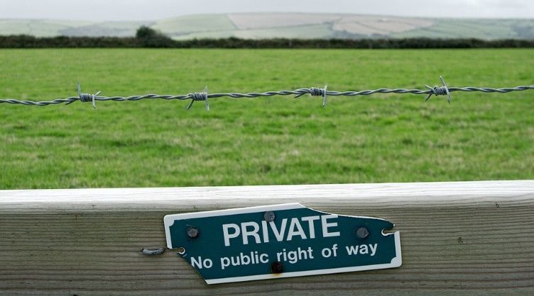

Awareness of sounds
This is a particularly important skill to develop if you feel your child is struggling to learn to read
Things to remember:
When schools teach children to read they start with the sounds we make.
Children need to be able to hear the sounds in different places in words.
It’s the sounds, not the letter names, that are important (e.g. “a” is said as “a” as in apple not “ai” as in cage, “b” as in butter, not bee etc.
What can we try?
- Make up lots of rhymes, even (especially!) nonsense rhymes.
- Play “I spy something which sounds like . . . . . “
- See how many words which start with the same sound you can get into a sentence.
- Cut pictures out of catalogues which end with the same sound.
- Read rhyming stories and encourage your child to guess which word comes next.
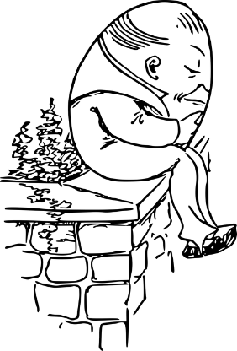
Physical readiness for writing
Things to remember
It’s OK if your child doesn’t start to formally write as soon as they start school.
If children start to write before they’re physically ready it may put them off writing in the future.
They need to do lots of activities to build up their fine motor control.
What can we try?
- Paint pasta then thread it onto string and make necklaces / snakes.
- Let your child try out lots of different types of tape – sellotape, parcel tape, duct tape – and use scissors to cut it.
- Ask them to help you spread butter, cheese spread, jam etc onto bread.
- Encourage them to try fastening zips and buttons themselves.
- Always have pencils and paper around the house where your child can access them.

Other Ideas:

A final note on literacy:

You might feel silly talking to your child with an old plastic bag on your hand, or singing out of tune, or dancing with them. You might find it difficult to think of questions to ask them or to make up stories with them. But all of these activities help to build up the connection between you and your child. You are a hugely important part of their life – they won’t judge you for looking funny or for struggling to do something. They’ll learn that:
- It’s OK to have a go, even if you can’t do it
- You value them enough to try
- Sometimes people have to ask for help
- Communication is fun
- Things get easier if they keep trying

If we work together to build strong foundations, we don’t know what our children will be able to do in the future. But we do know that we’ll be giving them the right start to succeed in whatever they want to do.

Thank you for working with us.

