**Conventions of a newspaper article**

**Headline** – is short & grabs the attention

**1st paragraph** – often introduces the who, what, when, where & why

**Subheadings** – can be used to focus on 1 thing e.g.

**Columns** – usually written in 2 or more columns

**Audience** – be clear if you’re writing for a broadsheet or tabloid

[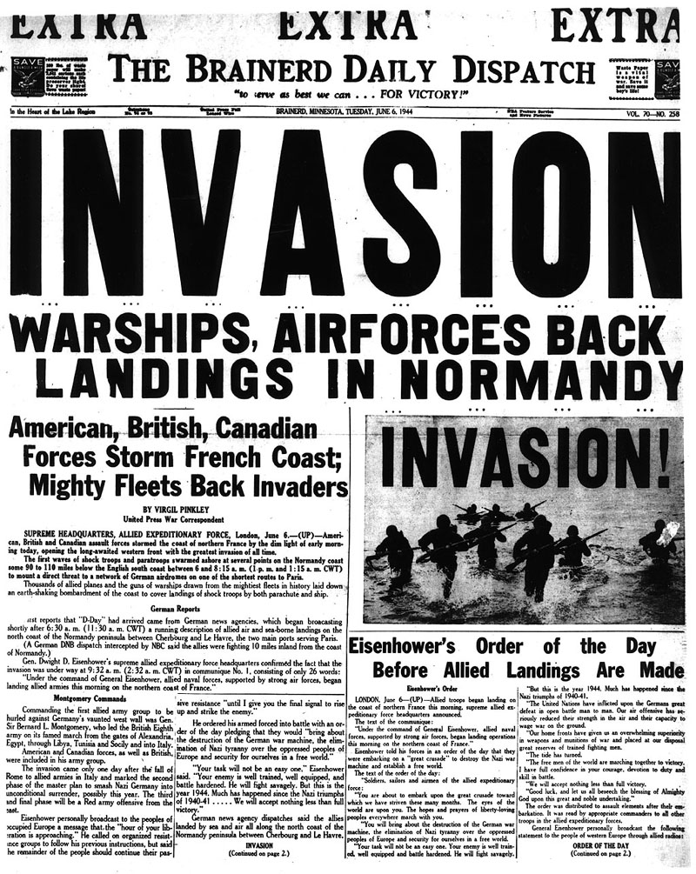](https://www.google.co.uk/url?sa=i&rct=j&q=&esrc=s&source=images&cd=&cad=rja&uact=8&ved=0ahUKEwigw6n1k_zTAhWSyRoKHVxFAnQQjRwIBw&url=http%3A%2F%2Fsections.brainerddispatch.com%2Fhistory%2Fpages%2F&psig=AFQjCNFC6EkPlYg4bV9qpU9-6Gmr6FwV7A&ust=1495290058343491)

Very informal

Date

More formal

Your address

**Conventions of informal letters**

7 Breadalbane Lane

Salen

Isle of Mull

PA72 6JH

19/05/17

Dear ______________

Lots of love / See you soon / Best Wishes

Julie