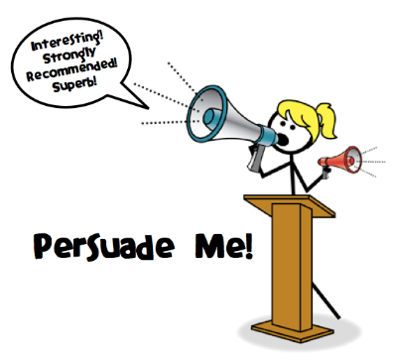
How can I sound persuasive?
Power of three It’s quick, easy and convenient
Emotive language This is an outrage!
Rhetorical questions What can be done?
Statistics/ supporting detail 100%
Understanding/ undermining others’ opinions This is unconvincing because . . .
Alliteration This callous cruelty can’t continue
Direct address I’m sure we can all see that . . .
Exaggeration I can’t imagine anything worse

