Group Discussion: things to remember

Focus and concentrate – don’t interrupt!

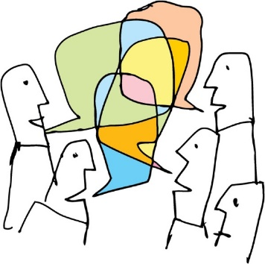
Use your verbal skills

Use your non-verbal skills

Respond to others
- If you agree
- If you disagree
- If you want them to say something

Use suitable language and express yourself clearly

Know your role

