**There, their, and they’re**

**there**Refers to the position or location of people or objects, for example, “over there”.

*How many sweeties are* ***there*** *in a tube of Smarties?*

**their**Refers to objects which belong to something or someone, for example, “their dog”, “their jumper”, “their opinion”.

*Sam and Julie took* ***their*** *dog to the park.*

**they’re**   
A contraction of “they are”; the apostrophe replace they letter ‘a’, for example “they’re coming for dinner”.

*I love Hobnobs –* ***they’re*** *my favourite biscuits.*

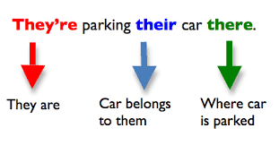

**Were and where**

**were**

The past tense of ‘be’.

Refers to the way things were before ,for example, “there are six biscuits in the tin” becomes “there were six biscuits in the tin” after someone has eaten one.

*How many pupils* ***were*** *there in your class at primary school?*

**where**

Refers to the position or location of something, for example, “where is my jumper?”

An easy way to remember this is that **where** goes with **there**.

*Do you know* ***where*** *the nearest bank is?*

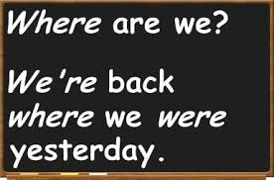

**To, too, and two**

**to**

Used to identify location, for example, “My family went **to** the beach”.

*I sent an email* ***to*** *Jack.*

**too**

Can mean “also” or “very”, for example, “is Sarah coming too?”, or “it is **too** late to catch the bus”.

*Bill would like to come to the cinema,* ***too****.*

*It is* ***too*** *warm to wear a hoodie.*

**two**

The number = 2, for example, “I have **two** sisters”.

*The bicycle has* ***two*** *wheels.*

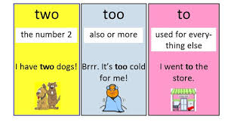

**Your and you’re**

**your**

Refers to something which belongs to you, for example “your pencil case”.

*You look so like* ***your*** *big brother.*

**you’re**

A contraction of “you are”; the apostrophe replaces the letter ‘a’, for example “you’re my best friend”.

*It is important that* ***you’re*** *well wrapped up when it is cold.*

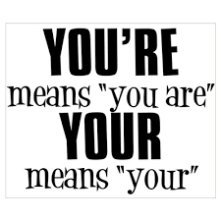

**Linking phrases**

Using words and phrases to signal:

* A continuation of a similar point of view, for example: ‘I also think that…’, ‘Another thing which reinforces this is…’
* A change to a contrasting point of view, for example: ‘However, not everyone feels like this…’, ‘But this hasn’t always been the case…’
* A drawing together of ideas, for example: ‘Overall’, ‘therefore, ‘to summarise’…



**Topic sentences in talking**

Using clear introductory statements to signal what you’re going to say, for example:

* ‘The most important thing I think I need to explain is that…’
* ‘The next part of the process was relatively simple…’
* ‘There are many possible contributing factors to global warming…’

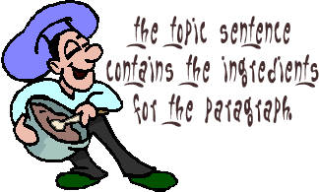

**Concluding the topic**

A conclusion should do the following:

* Make clear the writer’s view on the topic
* Reflect the development of those views through the writing
* Summarise some of the key points
* Leave the reader with an interesting final image – for example, by finishing with a story or dramatic sentence
* It should NOT introduce anything new



**Introducing the topic**

Grabbing the attention of your audience and making clear what you are going to be talking or writing about, for example:

* **Using a dramatic fact or statistic** – ‘Did you know that in 2016 there were 28,000 people in Scotland who were classified as being homeless?’
* **A quotation** – ‘Nelson Mandela said that “education is the most powerful weapon you can use to change the world”.’
* **An anecdote or news story** – ‘When I was at school, I really struggled with X but I worked through it by….’
* **An ‘imagine if…’ scenario** – ‘Imagine living in a cage, not being able to roam freely, with strangers looking in and pointing at you. How would you feel if you were an animal in a zoo?’

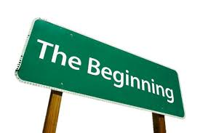

**Speech marks**

Inverted commas, or speech marks, are used to show that someone is speaking.

For example, **“**My name is Frank,**”** he said.

The words inside inverted commas are the exact words he spoke: **“**My name,**”** he said, **“**is Frank.**”**

Remember that a new speaker means a new paragraph, for example:

“I don’t think there’s anyone here,” Fergus remarked.

“Yes there is,” Peter insisted, “there’s a light on. Knock again.”

“All right,” grumbled Fergus.

Speech marks should also be used around a quotation to show that this has been said (or written) by someone else.

For example, “You must be the change you wish to see in the world” – Gandhi

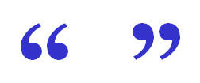

**Capital letters**

Every sentence should begin with a capital letter.

There should always be a capital letter after a full stop, question mark, or exclamation mark, for example:

* John went to the shops. He came back with a bag of fruit.
* Did you see *Doctor Who* last night? It was brilliant!
* Stop! You need to listen carefully.

You also need a capital letter for the word ‘I’ and for **proper nouns** – the names of people, places, things (days, months, films, TV shows, song titles, etc), for example:

* Anne, York, France, Saturday, November, *Strictly Come Dancing*

Initials need capital letters too, for example:

* BBC, UK, RAF, DIY

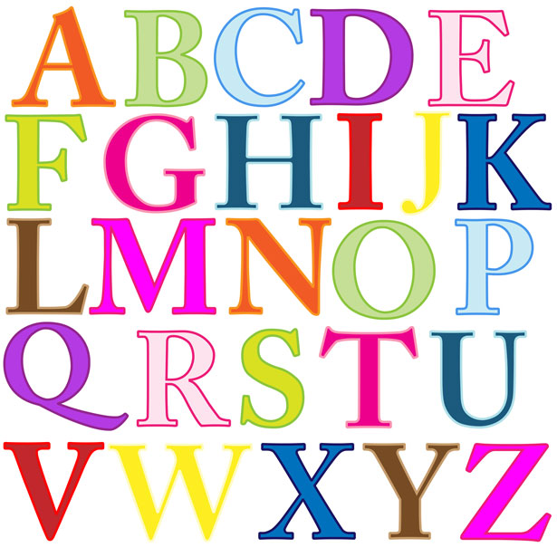

**Commas**

You can use commas to separate items in a **list** instead of ‘and’ or ‘or’, for example:

* Julie went shopping and bought a red coat, a purple scarf, a pair of shoes, and a belt.
* It was a huge, green, slimy, terrifying monster.
* The swans silently, gracefully, and elegantly glided past.

You can also use commas to add extra information into a sentence, for example:

* Laura, wearing a red dress, was the belle of the ball.
* “Let’s go to the cinema, Andrew.”

Commas are **not** strong enough to end a sentence and are very different from a full stop.

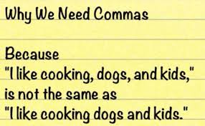

**Paragraphs**

Remember **PITS stop**.

Begin a new paragraph when there is a change in:

* **P**lace
* **I**dea
* **T**ime
* **S**peaker

Keep similar ideas together in one paragraph.

Leave a line between paragraphs or clearly indent by starting a few centimetres from the margin.

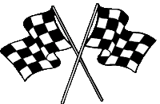

**Using sentences**

A sentence is a **self-contained** and **understandable** group of words in a particular order.

It makes **complete sense** on its own and does not need additional words to complete its meaning.

It begins with a **capital letter** and ends with a **full stop**.

For example:

* Paris is the capital city of France.
* Have you seen my PE kit?
* Follow the instructions!



**Apostrophes**

1. Used to show **missing letters**, for example:

* I will = I’ll
* I have = I’ve
* You have = you’ve
* We are = we’re
* Should not = shouldn’t
* I do not = I don’t
* It is = it’s

1. Used to show that something **belongs** to something else.

If there is one owner:

* Lucy’s pencil case.
* The teacher’s desk.
* Einstein’s theory.

If there is more than one owner:

* The boys’ changing room.
* The girls’ rugby team.
* The students’ desks.

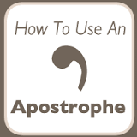

**Verbal skills** are the ways you communicate *with* words.

These include **rhetorical devices** – things you do to try to persuade people to your point of view – such as:

* **Exaggerating (hyperbole)** – for example, ‘He’s got a ton of video games’, or ‘I’ve told you a million times not to do that’.
* **Repeating words or phrases** – drawing attention to particular ideas, for example Martin Luther King’s ‘I have a dream’ speech, or Winston Churchill’s ‘We will fight…’ speech.
* **Asking rhetorical questions** – these are questions which don’t require an answer, and often ask the audience to think about the issue. For example, ‘What do you think you’re doing?’, ‘How would you feel if this happened to you?’

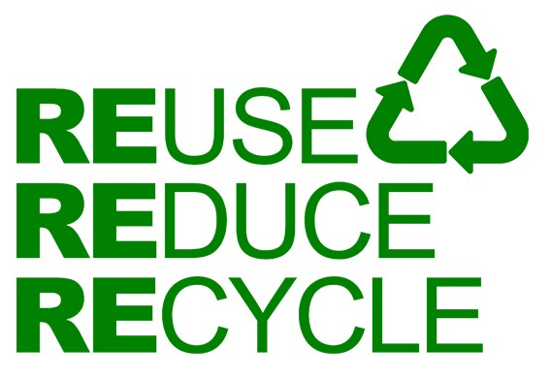

**Non-verbal skills** are the ways you communicate *without* words.

These include:

* **Eye contact** – look at your audience.
* **Body language** – leaning forward suggests engagement, arms folded suggests boredom/annoyance)
* **Pace** – the speed you talk at. Don’t go too fast for your audience. Slow down for important bits.
* **Tone** – what you reveal about how you’re feeling through your voice. A really angry tone isn’t appropriate in most circumstances. A mocking tone isn’t appropriate if you’re talking about the sacrifices of soldiers.
* **Emphasis** – you can emphasise particular words with your tone. You could also use gesture or more engaged body language.

