**Great activities to do with any book at primary**

CfE levels Early, First and Second

Fun, creative activities for the classroom and library

Resource created by Jennifer Buchan, classroom teacher at Stenhouse Primary School

**Contents**

About this resource

Early Level Activities

First Level Activities

Second Level Activities

When time is of the essence

Resource Sheets

Finding new things to read (all levels)

**About this Resource**

The activities in this resource have been designed so that they can be used with almost any fiction text. They are designed to further children’s understanding of aspects such as setting, plot and character and to provide readers with opportunities to discuss, compare and share opinions about different texts. The resource is not a linear progression of activities but rather a range of ideas from which teachers can pick and choose.

**Early Level Activities**

**Picture This**

*Listening and Talking: I enjoy exploring events and characters in stories and other texts and I use what I learn to invent my own, sharing these with others in imaginative ways.* ***LIT 0-09b / LIT 0-31a***

Give children images of settings, characters and events from their reading book. Ask them to create their own stories using the images. They can do this in pairs and then pairs can join together to share their own creations. The activity could be repeated, this time giving children 1 new image, not found in the text. Ask them to incorporate this into their story.

**Invitation to Play**

*Writing: I enjoy exploring events and characters in stories and other texts and I use what I learn to invent my own, sharing these with others in imaginative ways.* ***LIT 0-09b / LIT 0-31a***

Ask children to choose a character from a text they have read and to design a simple invitation, inviting him/her to their house. The invite should include a picture or sentence about what they will do during the visit (using information about likes/dislikes from the text).

**First Level**

**Who Am I? Hot-Seating**

*Listening and Talking: I can show my understanding of what I listen to or watch by responding to and asking different kinds of questions.* ***LIT 1-07a***

Imagine you are a character from the text you have read (ensure a range of characters has been chosen). Write a short text or draw sketches to describe how you are feeling, your relationships with other characters and what has happened to you, but do not give your name!

Work in groups. Take it in turns to read aloud your short script. After each group member has read his/her script, others should try to guess who s/he is. Others should then ask questions to the character, who is now in the Hot Seat. Question starters could include …

* How did you feel when … happened?
* Why did you decide to …?
* What are you going to do next?

Repeat the activity until all group members have had a turn in the Hot Seat.

**Through the Keyhole**

*Reading: Using what I know about the features of different types of texts, I can find, select, sort and use information for a specific purpose.* ***LIT 1-14a***

Choose a scene from the chapter or text you have read. Imagine you are peeping through a keyhole to catch a glimpse of the scene. Draw a sketch using Resource Sheet 1 to show what you would see. Include the setting and characters. Could you convey atmosphere through your use of colours or by including telling objects or details? Add labels to your sketch using post-its, taking phrases or words from the text as evidence. This evidence will show from where you have taken your ideas and justify the different aspects you have included in your sketch.

**Story Cube**

*Reading: Using what I know about the features of different types of texts, I can find, select, sort and use information for a specific purpose.* ***LIT 1-14a***

Choose a story or chapter from a book you have read. Use the template found in Resource Sheet 2 (blown up to A3) to create a story cube about it. Use drawings, sentences and thought bubbles to show the information on each side, as follows:

1 – Setting

2 – Main characters

3 – Main event

4 – Prediction of what could happen next

5 – New words and their meanings

6 – Favourite part

Work with a partner and choose 1 person to start. Roll the cube to see which side lands face up. Explain what can be seen on the side to your partner. Repeat a few times and then swap over.

**Comic Strip**

*Writing: By considering the type of text I am creating, I can select ideas and relevant information, organise these in a logical sequence and use words which will be interesting and/or useful for others.* ***LIT 1-26a***

Work in pairs to identify 6 key events in the text. Create a comic strip of these main events. Insert text and dialogue to show how the story moves on and what the characters might say. The Comic Life software has excellent templates and formats which can be used. Alternatively, the grid (blown up to A3) and callouts (to be cut and pasted onto comic strip) in Resource 3 could be used.

If you want to dive into the world of comics for 8-11, you could try some of these recommendations from comic creator Adam Murphy: <http://bit.ly/CheckOutTheseComics>

**Sharing Opinions**

*Reading: I regularly select and read, listen to or watch texts which I enjoy and find interesting, and I can explain why I prefer certain texts and authors.* ***LIT 1-11a***

This activity enables children to share and back up their opinions about a chosen aspect of a text they have read. It also encourages them to compare an aspect of a text to another book they have read. Ask children to choose either a character, an event or a setting from the text. Give them the following sentence starters:

I think that …………… (insert character, event or a setting) is ……………………….. .

Reason #1:

Reason #2:

This ………… (character, event, or setting) is similar to one in …………… (name of text with similarity) because ………………………………………………………………..

These opinions could be written onto pieces of coloured paper and made into a class book to be placed in the library. Children could refer to the class book when choosing a new text to read.

**Second Level**

**Conflict!**

*Reading: Using what I know about the features of different types of texts, I can find, select and sort information from a variety of sources and use this for different purposes.* ***LIT 2-14a***

Every non-fiction text we read contains a conflict, dilemma or problem of some kind. These conflicts can broadly be divided into 4 types:

Character v. Man (arguments, disagreements, friendships …)

Character v. Nature (storms, avalanches, volcanoes, the environment …)

Character v. Society (bullying, peer pressure)

Character v. Self (worries, new experiences, dilemmas …)

Think about the text you have read. Can you spot an example of each from the storyline? Hang 4 pieces of chart paper around the room, each with one of the above headings written at the top. Work in pairs and give each pair a marker pen. Explain that children should try to write down examples from as many books as they can, putting examples onto the correct piece of chart paper.

Now create a book blurb to briefly describe the conflict in a made-up story. For example,

“*Dan is about to embark on his first day at a new school. Terrified about making new friends and meeting new teachers, he heaves open the heavy front door to the building and his adventure at Salisbury High begins…”*

Each pair should read aloud its blurb and peers should try to work out which conflict is being described (Character v. Self in the above example).

As an extension, children could create their own Character v. Nature story. Explore Lari Don’s blog post on The Scottish Book Trust website to help children plan and develop their ideas: <http://bit.ly/SBT_Lari3>.

**Who Said What?**

*Listening and Talking: I can show my understanding of what I listen to or watch by responding to literal, inferential, evaluative and other types of questions, and by asking different kinds of questions of my own.* ***LIT 2-07a***

Working in pairs, create a series of statements which could have been said by different characters in the text. Think about the characters’ actions, behaviours and relationships that you have learnt about as you read the text. Also think about *how* the character would have spoken (muttered, screamed, whispered, huffed…). Swap your list of statements with another pair and try to work out who said what. Alternatively, read aloud your statements to another pair, putting in expression, and ask them to state whom they think is talking.

**Chat Show**

*Listening and Talking: When listening and talking with others for different purposes, I can:*

* *share information, experiences and opinions*
* *explain processes and ideas*
* *identify issues raised and summarise main points or findings*
* *clarify points by asking questions or by asking others to say more.*

***LIT 2-09a***

Look at examples of theatre, restaurant or book reviews from magazines and newspapers to explore the style and language used. Write your own column about the text which has been read, giving opinions about the book and justifying these. 2 pupils can then sit together and 1 can interview the other, who reads aloud his/her critique, as if on a chat show. A third child could video the interview. The video could be played on a school TV screen, in the library or to another class.

**Roll the Dice**

*Reading: I can select and use a range of strategies and resources before I read, and as I read, to make meaning clear and give reasons for my selection.* ***LIT 2-13a***

When you come across a new and unfamiliar word, roll a dice 3 times and complete the corresponding activities to help you understand and be able to use it for yourself:

1 – write a synonym for your word

2 – write an antonym for your word

3 – illustrate your word

4 – use the word in a sentence of your own

5 – act out your word to a friend

6 – create an alliteration containing your word and 2 others

**When Time is of the Essence…**

**Early Level**

**Freeze Frames**

Ask all children to choose 1 character from the book and to act out something that s/he does in the story. Call ‘Freeze!’ and children should stand still as statues. Tap one child on the shoulder and ask him/her to continue acting, talking about what s/he is doing. Other children should guess which character is being shown. Repeat the activity several times to show different characters from the text.

**First Level**

**Character Ranking**

List all the characters from a text you have read and rank them according to different criteria. These could include most to least powerful, kindest to meanest or bravest to most scared, for example.

**Thought Bubbles**

Write a thought bubble for a character at a chosen point in the text when s/he is not actually speaking. Describe feelings relating to events and other characters at that point in the story.

**Second Level**

**Postcards**

Look at examples of postcards and identify key aspects of the genre (careful choice of words as limited space, highly descriptive, inclusion of feelings). Choose a character and a setting from the text and write a postcard to a friend, describing the setting, the character’s feelings and key events in that setting. Illustrate the other side to show a pictorial representation of the setting.

**Even Better If …**

Ask children to work in pairs or trios. Give each a sentence from the text and ask them to improve it. This could be through using more interesting openers, adding adjectives or adverbs or extending the sentence through use of a connective and further detail. Challenge them to keep the original meaning and tone of the text. Children can swap and try this for different sentences.

**Finding new things to read (all levels)**

**Scottish Book Trust’s book lists**

Scottish Book Trust have a regularly updated store of book lists for all ages. Topics and themes are wide and varied: <http://bit.ly/SBTbooklists>.

**First Minister’s Reading Challenge website**

You can find a list of 100 inspiring books for P4-P7 at the First Minister’s Reading Challenge website. The list contains information about accessible versions of the books, and has been hand-picked by learning professionals across Scotland. Each recommended book is accompanied by 2 further reading recommendations! <http://bit.ly/300booksfor8-11s>

**Resource Sheet 1**

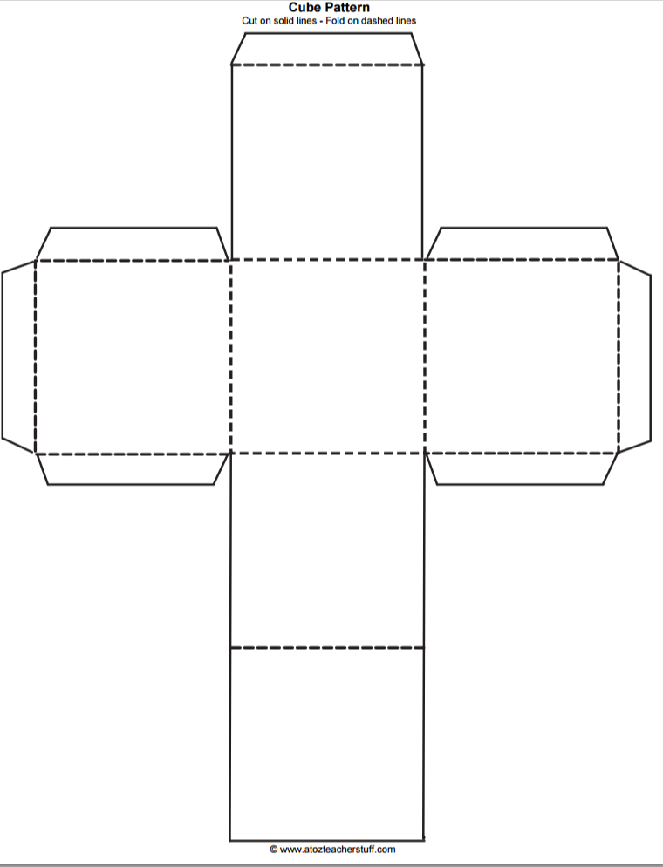**Resource Sheet 2**

6

5

4

3

2

1

**Resource Sheet 3**

|  |  |  |
| --- | --- | --- |
|  |  |  |
|  |  |  |
|  |  |  |
|  |  |  |