STEM INSPIRATION PROGRAMME
“Working with Edinburgh College to support school STEM activities”.
Please see below a list of practical projects and events, facilitated by Edinburgh College, and designed to raise awareness and encourage participation in all areas of STEM learning.

- FREE ‘STEM In a BOX’ Activities for P7 and S1: Classroom-based, small group, problem-solving tasks, encouraging pupils to apply their skills in a real-life, practical context whilst developing knowledge and understanding of the ‘Engineering Design Process’.
- Remote delivery with ‘live’ introduction and feedback sessions on TEAMS
- ALL ‘live’ sessions take place on Thursdays throughout term time.
- All materials provided, free of charge, for classroom use
- Activities include ‘Bridge Building’, ‘Towers’ and ‘Boats’

- FREE ‘STEM Workshops’ S2 and S3: Collaborative, practical projects, delivered on campus, involving greater use of STEM skills and knowledge, and leading to a deeper understanding of engineering processes.
- On campus visit with morning and afternoon STEM sessions
- Available on selected dates only, pre-booking required
- Activities include ‘Water Wheels’, ‘Wind Turbines’ and ‘Hot Air Balloons’

- Host venue for ‘FIRST LEGO LEAGUE’ CHALLENGE Tournament: a highly engaging, ‘hands-on’ STEM experience, combining the engineering challenge of a robotics competition with real-world problem solving.
- Suitable for ages 9 to 16years
- Participation helps to build confidence with coding, and teaches valuable employment and life skills in a meaningful, engaging context
- ‘Challenge Tournament’ event held at Edinburgh College in March 2024 – date to be confirmed.
- All further details, including information about funding and registration can be found at
FIRST® LEGO® League Challenge (theiet.org)

- School visits to support Science/STEM week events: *SUBJECT TO AVAILABILITY* pre-arranged school visits from members of the Engineering department to run STEM challenges and practical tasks as part of a school ‘Science week’ or similar themed event.
- In school, STEM visit for P6/P7 pupils to coincide with school ‘Science’ week
- Hands-on, practical challenges with face-to-face instruction
- All tools/resources and instruction provided, FREE of charge.

STEM INSPIRATION PROGRAMME
What is the value in STEM-learning activities? Participation helps to:
- Raise attainment in all areas of the curriculum through practical application of key concepts in maths and literacy.
- Develop valuable skills such as collaboration, critical thinking and problem-solving
- Inspire pupils to explore ‘STEM’ related pathways into further study and the world of work, making meaningful links with DYW
- HAVE FUN and enjoy your learning!!
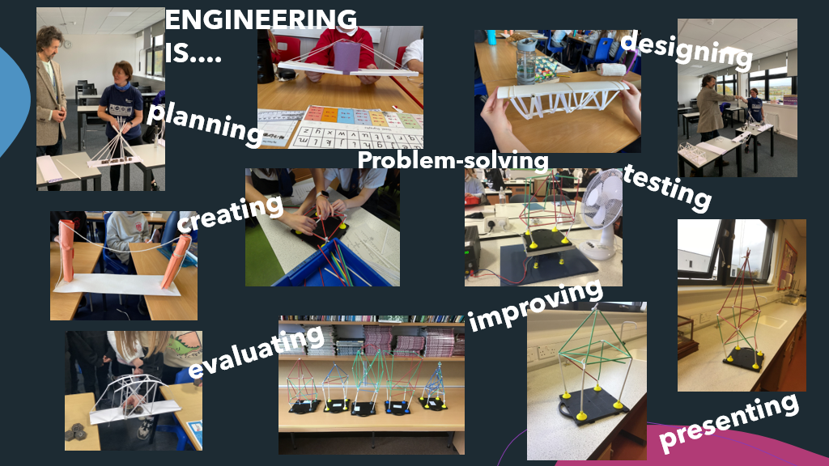

Testimonials and evaluation comments:
Brilliant job doing the event remotely!! It worked well and the pupils really enjoyed it.
The pupils absolutely loved the activity and were completely engaged in it.
Thank you for a wonderful experience! The pupils had a great day. They were thoroughly engaged in the activity and enjoyed learning lots more about STEM. It was very inspiring, helping our young people to learn more about STEM opportunities in the world of work. It was also great to have all the resources organised and dropped off prior to the event. This was really helpful and added to the smooth running of the day. Thank you again for this great opportunity.
A fantastic STEM learning experience for everyone involved. We loved it and learned so much.
The live session was excellent. The learning points were stated very clearly and demonstrated effectively. The best live session we have had!
Thank you! My class loved this STEM activity and it was very well organised throughout.

