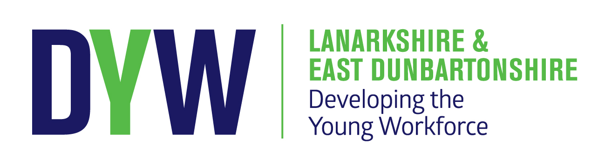

Life Sciences Writing Day 2 – Thur 5 March 2020

Doubletree Hilton, Phoenix Cres, Bellshill ML4 3JQ

Programme

09:00 Tea and coffee on arrival

09:30 Welcome and outline of day

09:40 Development Workshop - Part 1
- Discussion/review of materials produced on 5th Dec:
- Identify links to curriculum
- Option to create a standard outline to accompany resources
- Identify overlap/links between resources
- Identify gaps and next steps for group
- Complete/add to materials

12:15 Lunch &networking

13:00 Development Workshop - Part 2 (coffee/tea available at 14:30)
- Option to continue development collaboration on existing materials or change focus to the uploaded industry presentations – how could these be used?
- A few starter ideas:
  - create a teacher guide for each industry presentation for use in class
  - Create PPT commentary/video short to support their use by practitioners for professional learning
  - Create an accompanying overview of the resources to explain how practitioners could use these for professional learning to develop understanding of the sector and to support learners

15:15 Next steps

15:30 Close

#STEMnation

