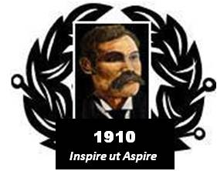

BAIRD of BUTE SOCIETY
Lord Smith of Kelvin KT, Patron

Canadian Science Scholarship
Toronto Canada, July 2016

Eligibility requirements

The Baird of Bute Society welcomes high-quality nominations from young people who have secured an unconditional offer for a university place and who meet the essential criteria:

Personal

- High academic achievement
- Good character
- Can use the experience to have positive impact on others
- Citizen or permanent resident of Scotland
- Possess a passport valid until at least December of 2016
- Meets Canadian Government Visitor admission requirements
- 18 years of age by 1 June 2016
- Unconditionally accepted to a Scottish University life science course or related discipline
- No criminal record
- Record of community involvement
- Team player
- Prepared to maintain daily blog with other participants
- Prepared to complete weekly blog during 1st year of University
- Able to be insured for Visitors to Canada health insurance coverage
- Submit a personal Letter of Application
- Agree to be interviewed, as required, for selection (in person or on-line)
- Possess immunisation as may be required by participating institutions

Local
- Proposed, endorsed and supported by their school
- Prepared to fundraise, as might be required, to cover personal incidentals and travel to/from Glasgow airport

