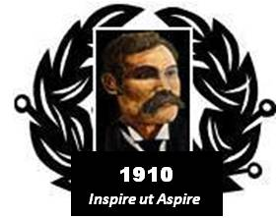

BAIRD of BUTE SOCIETY
Lord Smith of Kelvin KT, Patron

Canadian Science Scholarship
Toronto Canada, July 2016

Online information

YouTube

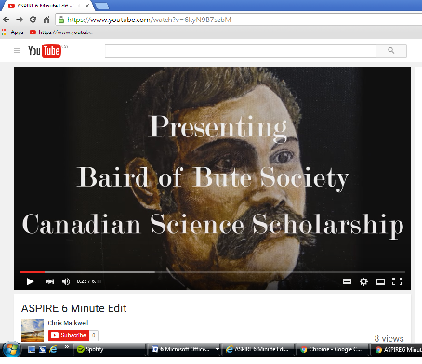

“ASPIRE 6 Minute Edit”
https://www.youtube.com/watch?v=6kyN9B7szbM

OR

View previous participants’ blogs

2014 2015
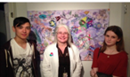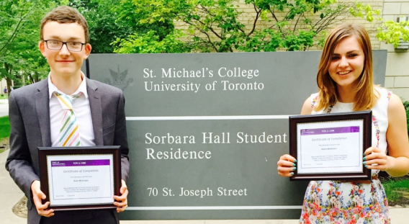
Joshua and Bonnie Ewan and Nisha
bairdofbute2014.wordpress.com/ bairdofbute2015.wordpress.com/

