

**National 5 Chemistry**

**Relevant Past Paper Questions from SQA Standard Grade Credit**

**and Intermediate 2 papers**

**Problem Solving Questions**

**March 2014**

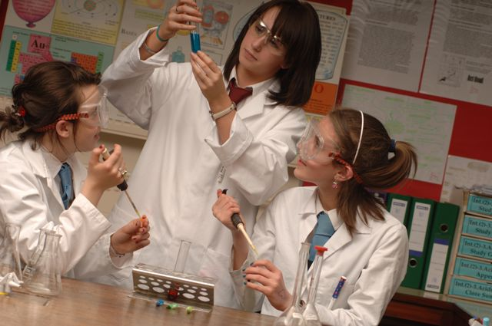

Transforming lives through learning

**N5 Chemistry Past Paper Questions**

This resource has been produced in response to the requests from practitioners who attended the National Qualifications Sciences events at Hampden Stadium in December 2013 which Education Scotland organised in partnership with the SQA.

The questions in this resource relate to Problem Solving for National 5 Chemistry and have been taken from the 2011, 2012 and 2013 Standard Grade and Intermediate 2 Past Papers.

In cases where the questions relate to more than one of the National 5 Units, the constituent parts of the question have been separated into their respective key areas. The stem of the question has been retained to give the context of the question. If practitioners require the full integrated question, they should refer to the original past paper on the [SQA website](http://www.sqa.org.uk/pastpapers/findpastpaper.htm?subject=Chemistry&level=).

Past paper questions for the National 5 Chemistry Units, Chemical Changes and Structure, Nature's Chemistry and Chemistry in Society, are also available from Education Scotland’s National Qualifications Glow portal: <http://www.educationscotland.gov.uk/nqcoursematerials/> (cut and paste link into your browser).

Education Scotland would like to acknowledge the support of the SQA in helping us produce this resource. We hope it proves helpful to practitioners across Scotland and assists with the implementation of the national qualifications.

|  |  |  |  |
| --- | --- | --- | --- |
|  | **Problem Solving** | |  |
|  | **Not linked to any particular key area** | |  |
|  |  | | Marks |
| St Gr 2011 Q12 (b) i & ii | The table below shows the relationship between the percentage of ethanol and the density of alcoholic drinks. | |  |
|  | (a) | Write a general statement describing how the percentage of ethanol affects the density of the alcoholic drink. | 1 |
|  | (b) | The density of a particular brand of alcoholic drink is 0·970 g/cm3.  Predict the percentage of ethanol in this alcoholic drink. | 1 |

|  |  |  |  |
| --- | --- | --- | --- |
| Answer | | Sample Answers and Mark Allocation | Notes |
|  | (a) | As the percentage increases…the density decreases  As the percentage decreases…the density increases  Density increases as percentage decreases  Density decreases as percentage increases etc **1** | **Not acceptable:**  As the density increases percentage decreases eg wrong cause and effect |
|  | (b) | 20 **1** |  |

|  |  |  |  |
| --- | --- | --- | --- |
|  |  | | Marks |
| St Gr 2012 Q17 (a) i & ii | A solution of 0·1 mol/l hydrochloric acid has a pH of 1. | |  |
|  | (a) | What colour would universal indicator turn when added to a solution of hydrochloric acid? | 1 |
|  | (b) | Starting at pH 1, draw a line to show how the pH of this acid changes when diluted with water. | 1 |

|  |  |  |  |
| --- | --- | --- | --- |
| Answer | | Sample Answers and Mark Allocation | Notes |
|  | (a) | Red, pink, orange, yellow 1 |  |
|  | (b) | Line must be increasing  Line stops at pH7 or below  **1** |  |

|  |  |  |  |
| --- | --- | --- | --- |
|  |  | | Marks |
| St Gr 2012 Q 18 | A student investigated how the concentration of sodium chloride in water affected the freezing point. | |  |
|  | (a) | What type of bond is broken in sodium chloride when it dissolves in water? | 1 |
|  | (b) | The table shows information about the freezing point of different sodium chloride solutions.    Describe the relationship between the concentration and freezing point. | 1 |
|  | (c) | Predict the freezing point of a 0·55 mol/l sodium chloride solution. | 1 |

|  |  |  |  |
| --- | --- | --- | --- |
| Answer | | Sample Answers and Mark Allocation | Notes |
|  | (a) | Ionic  Ionic lattice  Ionic network  **1** | **Not acceptable:**  Ionic molecular  Lattice on its own  Network on its own  Sodium to chlorine bonds |
|  | (b) | As concentration increases/decreases freezing point decreases/increases  The freezing point decreases/increases as concentration increases/decreases  As concentration increases freezing point gets colder  **1** | **Not acceptable:**  Wrong cause & effect eg:  As freezing point decreases concentration increases. |
|  | (c) | -1.8 to -2.0 inclusive  **1** | **Not acceptable:**  Statement  Less than -1.5 |

|  |  |  |
| --- | --- | --- |
|  |  | Marks |
| Int 2 2011 B Q9(d) | A student investigated how the concentration of sodium chloride in water affected the freezing point.    Using information in the passage above, calculate the volume of alcohol solution the tree shrew drinks each day. | 1 |

|  |  |  |  |
| --- | --- | --- | --- |
| Answer | | Sample Answers and Mark Allocation | Notes |
|  | (a) | **1**  2·96/2·9605/2·961/2·9605263 on its own – 1 mark  3·0 or/3 with working | 2·9 or 3·0 or 3 without working – zero marks |

|  |  |  |  |
| --- | --- | --- | --- |
|  |  | | Marks |
| Int 2 2011 B Q13 | Some indicators can have different colours when in solutions of different pH values.  The tables give information about two indicators, bromothymol blue and methyl orange.    The pH of three solutions was investigated using both indicators.  The results are shown below. | |  |
|  | (a) | Which solution is alkaline? | 1 |
|  | (b) | Suggest a pH value for solution B. | 1 |

|  |  |  |  |
| --- | --- | --- | --- |
| Answers | | Sample Answers and Mark Allocation | Notes |
|  | (a) | (solution) C  Last one/bottom one  **1** |  |
|  | (b) | any value above 4·4 and below 6·0 (not inclusive)  must acknowledge both parameters  number within range **1** | **Not acceptable:**  value below 6·0  value above 4·4 |

|  |  |  |
| --- | --- | --- |
|  |  | Marks |
| Int 2 2013 A Q15 | The first four members of the amine homologous series are:    What is the general formula for this homologous series? | 1 |

|  |  |  |  |
| --- | --- | --- | --- |
| Answer | | Sample Answers and Mark Allocation | Notes |
|  |  | B **1** |  |

|  |  |  |
| --- | --- | --- |
|  |  | Marks |
| Int 2 2013 B Q9(a) | Alkenes can undergo different reactions.  In ozonolysis an alkene reacts with ozone forming two molecules. The ozonolysis of hex-3-ene is shown.    Draw the products formed by the ozonolysis of hex-2-ene. | 1 |

|  |  |  |  |
| --- | --- | --- | --- |
| Question | | Sample Answers and Mark Allocation | Notes |
|  |  | both required for **1** mark  allow one missing H or one missing C to H bond | **Not acceptable:**  No 5 bonded carbons |