The sciences

Resource guide

[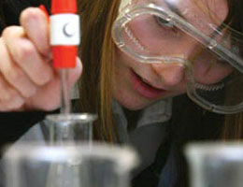](http://www.educationscotland.gov.uk/learningteachingandassessment/curriculumareas/sciences/principlesandpractice/index.asp)

**Education Scotland’s website** provides practitioners with excellent resources and guidance to help develop learning and teaching within the sciences. <http://bit.ly/16l2nOD>

The following links may be particularly useful in planning for the sciences:

**Sciences experiences and outcomes** – <http://bit.ly/1bCgA0u>

**Sciences principles & practice** – <http://bit.ly/15Q6O7x>

**Concept development in the sciences** – <http://bit.ly/19yzI9E>

**Assessing progress and achievement in the sciences** – <http://bit.ly/17kLhTM>

**Sciences 3-18 Impact Report, updated September 2013**–<http://bit.ly/18TbPbO>

Education Scotland’s **Journey to Excellence** website contains many examples of interesting and innovative practice. Check out our new suite of videos for the sciences – just enter ‘science’ into the search facility.

[**http://www.journeytoexcellence.org.uk/**](http://www.journeytoexcellence.org.uk/)



Our **STEM Central** website provides high-quality resources, teaching ideas, videos and interactive activities to develop learning experiences relating to sciences, technologies, engineering and mathematics (STEM). <http://www.educationscotland.gov.uk/stemcentral/>



Keep up to date - Read and respond to the many and varied science activities and events you and your school could participate in through our **STEM Central in MOTION blog**. <http://bit.ly/1aY16DS>



Join our **#STEM online community** on Glow. <http://bit.ly/1e8UAMF>



Our **Twitter** feed is another easy way to keep up to date. Follow us **@susdeved**

Resources

[](http://www.twigonglow.com/mind-map)

Check out the hundreds of high quality science videos available through the award-winning **TWIG on Glow** resource. <http://bit.ly/1gUu99I>

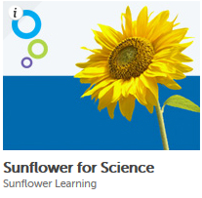

**Sunflower Science** in Glow provides interactive animations which demonstrate many important scientific concepts. <http://bit.ly/1dF2jhQ>

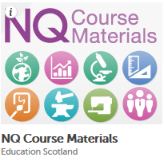

Access National Qualifications course materials for sciences:

NQ course materials - <http://www.educationscotland.gov.uk/nqcoursematerials/>

NQ Higher Sciences - <http://www.educationscotland.gov.uk/highersciences/index.asp>

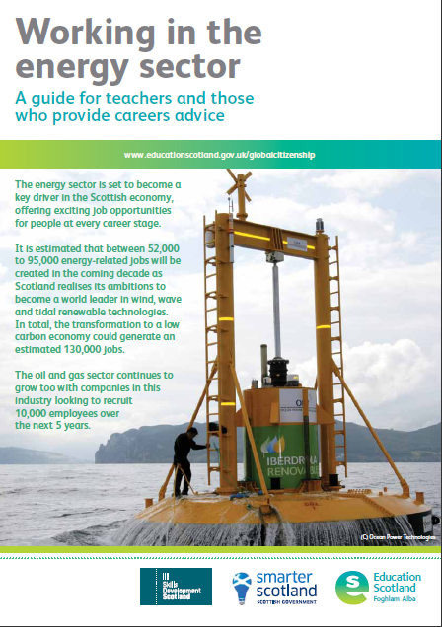

Our **Working in the energy sector** leaflet gives you key facts about career opportunities in this exciting sector.<http://bit.ly/QZfZwg>

Websites

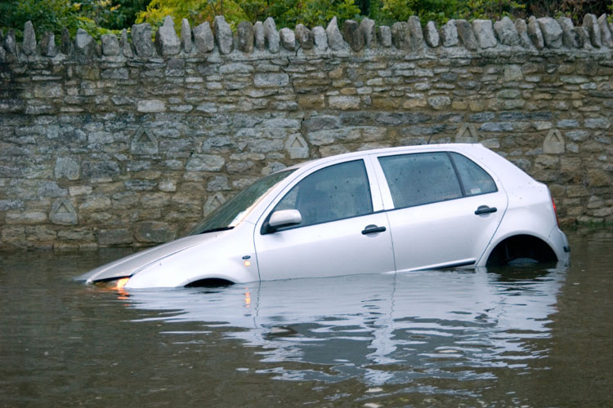

**Weather and Climate Change** <http://www.educationscotland.gov.uk/weatherandclimatechange/>

Resources, background information and videos for practitioners

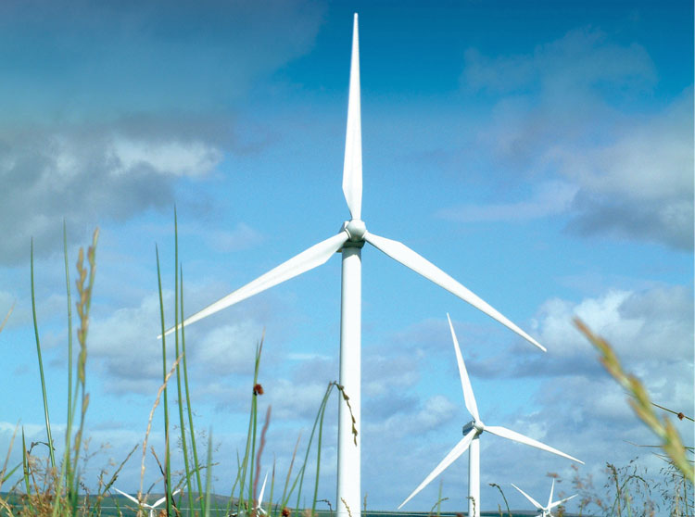

**Exploring Climate Change**

<http://www.educationscotland.gov.uk/exploringclimatechange/>

More climate resources and information for secondary schools

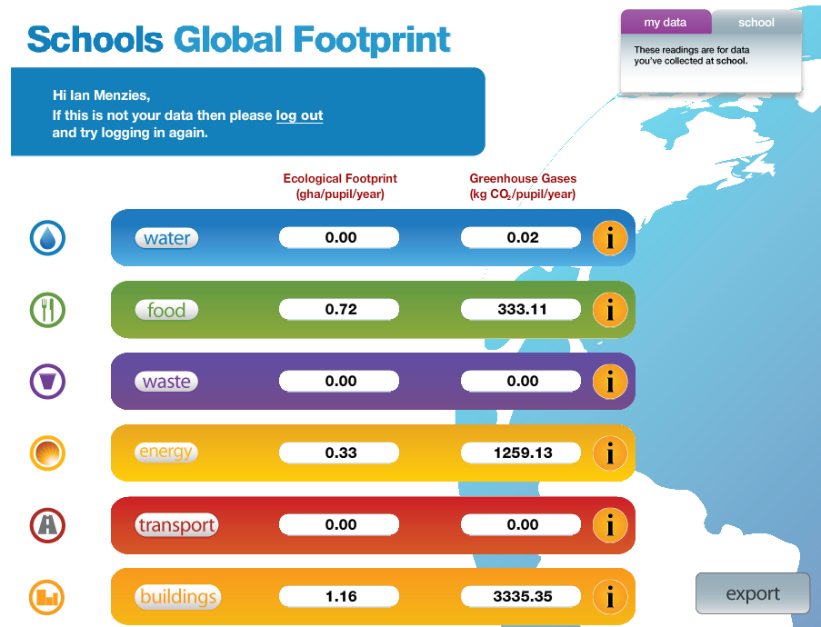

**Schools Global Footprint**

<http://www.educationscotland.gov.uk/schoolsglobalfootprint/>

Calculate your school’s ecological and carbon footprint

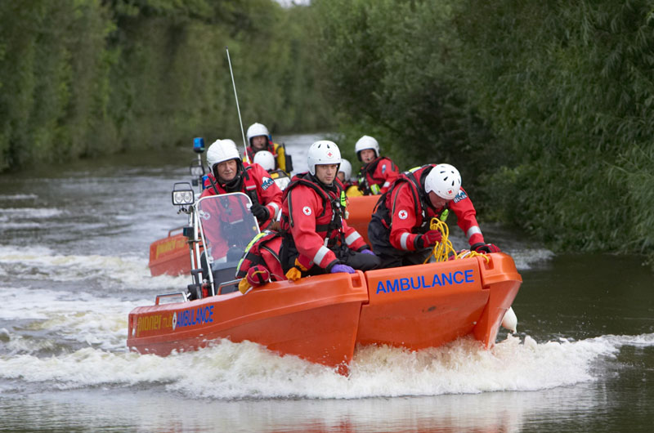

**Ready for Emergencies**

<http://www.educationscotland.gov.uk/readyforemergencies/>

Help learners and their communities prepare for emergencies

Useful links

Scottish Schools Education Research Centre – <http://www.sserc.org.uk/>

STEM Scotland/STEM Ambassadors – <http://www.stemscotland.com/>

Young Engineers and Science Clubs – <http://www.yecscotland.co.uk/resourceskits.html>

Science Centres and Generation Science – <http://bit.ly/18FiyJU>

Scottish Qualifications Authority ­– <http://www.sqa.org.uk>

Scottish Environment Website – <http://www.environment.scotland.gov.uk/citizen_science.aspx>