Food for Thought: Education Fund
The spread of successful applications across Scotland  - There were 61 successful applicatons across 25 Local Authorities  - There were five applications that were across whole authorities (North, East and South Ayrshire, and two across Moray)  - There are two pairs of schools working in collaboration  - There are six applications with schools working associated school groups and one as a geographical cluster  - A total of 333 schools will be impacted as a result of this round of funding. The monitoring and evaluation data will gather how many children, practitioners, parents and community have been directly impacted as part of the projects |  |  |  |  |  |  | 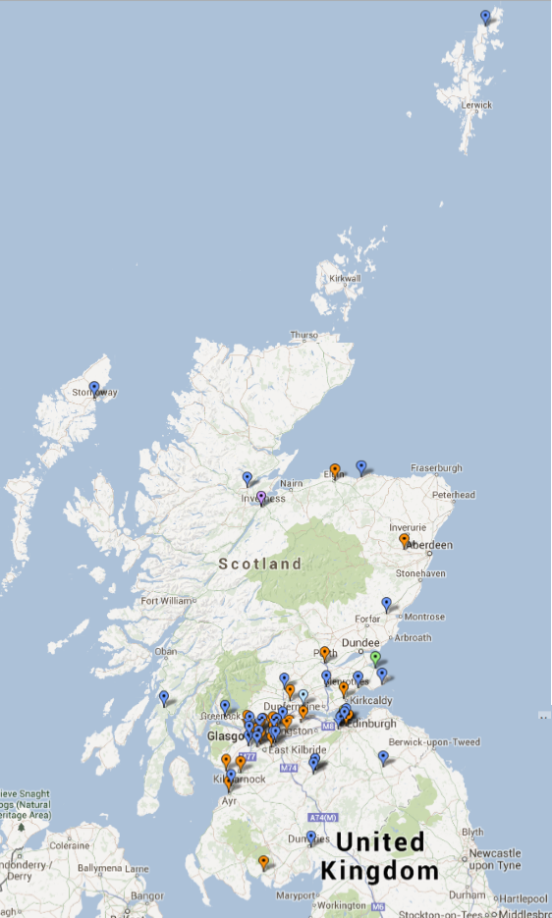
Examples of some of the successful applications
Local Authority | School/s | Funding  allocated | School fme | LA ave. fme | Scot ave. fme | Please summarise the work for which you are seeking funding. |  | Name of Business/Community organisation link
Fife Council | Tulliallan Primary School | 3,385 | 21.6% | 23.4% | 22.1% | - We aim to create a café with Tulliallan, driven by sustainable, healthy choices that will operate as a fully functioning business, owned and managed by the pupils.  - This IDL learning environment will equip our pupils with skills for learning, life and work, fostered through partnership links and a meaningful contextualised environment. |  | Adam Smith College and Fife Food Network
Moray Council | Moray Council | 24,990 | 8.7% | 8.7% | 22.1% | Development of a Moray School Food Education Strategy, staff training and Pilot Project to:  - drive and support further improvement in food provision and food education in schools and early years’ centres  - support children and young people to make healthier lifestyle choices |  | Community Food Moray
Falkirk Council | Drumbowie Primary School | 3,000 | 27.3% | 17.6% | 22.1% | - This year long food focus will revolve around establishing a local Fruit and Vegetable Barra to service the needs of our rural community.  - Each month children will share their learning at the pop-up market stall. Topics covered include foraging, food care and producing a soup recipe book. |  | Autokool Central Ltd (Air Conditioning Engineers)
South Lanarkshire Council | St Bride’s Primary School / Bothwell Primary School | 10,000 | 15.2% | 21.3% | 22.1% | The funding will go towards supporting a link ‘shared garden between St Bride’s and Bothwell Primary schools.  - The schools will use cutting edge technology, ICT and the shared garden to educate each other, parents and the community on growing and developing sustainable foods, while also selling our produce onto a local fruit shop.  - The project will involve parents, pupils, school staff, grandparents and the local horticultural society with the Year of Natural Scotland and the Commonwealth Games as a classroom linking theme. |  | The Fruit Shop, Uddingston
Glasgow City Council | Shawlands Academy | 5,000 | 19.0% | 29.3% | 22.1% | - ‘The Stand’ is a mobile Food Education learning community resource. The Stand challenges families from the early years to question what we are eating and gives practical resources to make affordable changes, gaining momentum through social media.  - This is a partnership project between schools, educational organisations and the food industry. |  | Greencity Wholefoods
Shetland Islands Council | Burravoe Primary School/  Cullivoe Primary School | 5,200 | 0.0% | 8.3% | 22.1% | - The children in both schools will work together to share learning about aquaculture with each other, with parents and with members of the wider community.  - They will learn about the importance of fish as part of a healthy diet as well as understanding its importance as a locally produced food. |  | North Isles Marine LTD/C&A Thomason
West Dunbartonshire Council | St Eunan’s Primary School | 2,841 | 34.0% | 28.5% | 22.1% | - Pupils will work in partnership with Ardardan Estate. They will experience life on a farm and learn about keeping hens as a source of food.  - They will learn about the world of work in the Farm Shop and Tearooms. They will host a Homecoming Farmer’s Market. |  | Farm Shop & Tearooms
City of Edinburgh Council | Castleview Primary School | 4,400 | 64.9% | 20.8% | 22.1% | - Each class will adopt a country/continent to focus their study.  - Candidates from each class will be given the opportunity to decide/develop the concept of the festival and what they would like the event to look like.  - Classes will be responsible for choosing and growing fruit/vegetables for their stall. |  | International Resources and Recycling Institute (Local Environmental Charity
Western Isles Council | The Nicolson Institute | 5,000 | 13.6% | 11.4% | 22.1% | - We plan to strengthen and expand our local business partnerships and pupils will use local produce, where possible, to design and make healthy products for a target market.  - Inspired by the Glasgow 2014 Commonwealth Games we aim to engage pupils and teachers within our learning community and provide high quality learning experiences. |  | Stag Bakery Ltd and 40 North Foods – independent food producer and retailer
Scottish Borders Council | Earlston High School | 4,845 | 7.2% | 11.1% | 22.1% | - To maximise our students learning experiences we will harness the power of outdoor learning by working on an eco-garden resource for all learners from early years to fourth level and beyond.  - All learners will have the opportunity to explore the concept of seed to plate, whilst gaining new skills and knowledge in horticulture, IT, home economics and business management. |  | tbc

The successful applications are linking to;
- Scotland – past, present and future (e.g. Year of Natural Scotland 2013, World War One 100 year anniversary, Homecoming 2014 and beyond)
- Active Scotland: Inspiring Scots to lead healthier lifestyles (e.g. Commonwealth Games 2014)
- Local food issues and/or Global food issues(e.g. food security or sustainability)
- Enterprise, employability and skills for learning, life and work
- Creativity - innovative approaches to food education nutrition/changing habits/understanding behaviour change and relationships with food
- Whole school food ethos
- Linking food and health issues to the economy, access and affordability, health or the environment?
- Food provenance. Where does our food come from?
- Exploring the science of food
- Increase the knowledge and skills of staff around food education
- Sustained partnership working within the learning community to enhance food education for children and young people
- A shared understanding of the progression of learning in food education from early to fourth level
- IT in Food Education
- The role of food to overall health and wellbeing
- IDL around Food Education
- Outdoor Learning and Food Education
- Additional Support for Learning and Food Education
- Linking to Battle of Bannockburn Anniversary
- Linking to Glasgow 2014 Commonwealth Games
- Linking to Homecoming 2014
- Linking to Ryder Cup
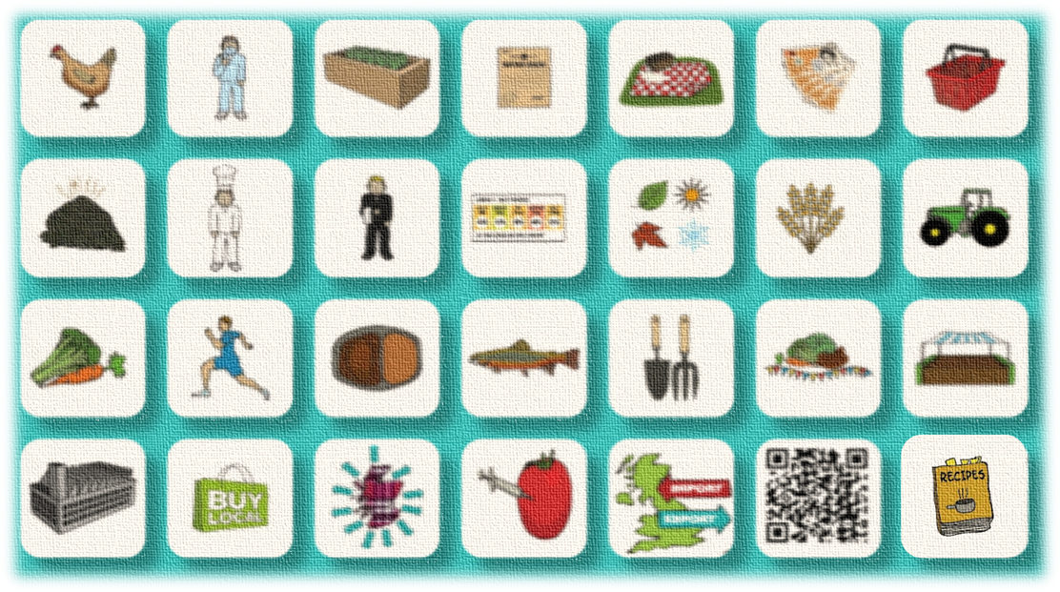
- Linking to World War One Centenary
- Linking to Year of Natural Scotland

