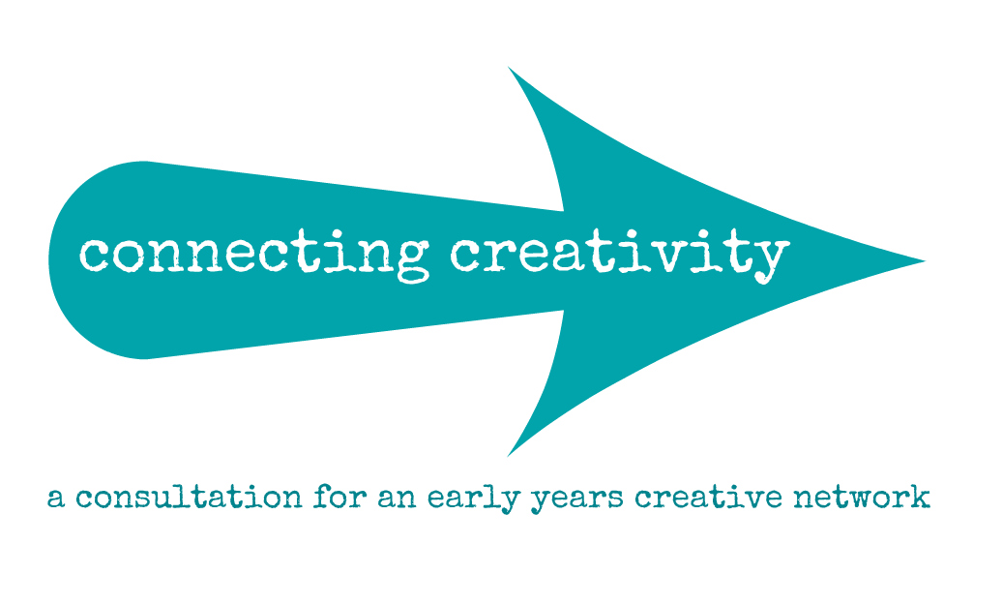

What creative activity for early years happens in your community?
Would you like more access to the arts and creativity for early years?
Would an Early Years Creative Network help?

Starcatchers is carrying out some research into the potential of an Early Years Creative Network for Scotland.

We want to hear the views from people across Scotland as part of this process – from nursery staff, parents, artists, arts organisations, local authorities and other organisations working with Early Years

We would like to invite you to a consultation event to share your views. We are holding a series of events that you can attend:
- Tuesday 25th September at Eden Court, Inverness from 2pm - 4pm
- Wednesday 26th September at Macrobert Arts Centre, Stirling from 3.30pm - 5.30pm
- Tuesday 2nd October at Rothes Halls, Glenrothes, Fife from 2pm - 4pm
- Wednesday 3rd October at Tron Theatre, Glasgow from 4pm - 6pm
- Monday 8th October at The Lemon Tree, Aberdeen from 10.30am - 12.30pm
- Tuesday 9th October at the Festival Theatre, Edinburgh from 4pm - 6pm

Please RSVP to info@starcatchers.org.uk to reserve your place

For further information about this initiative, please contact Rhona Matheson, Starcatchers’ Director at rhona@starcatchers.org.uk

