document%202017%20Logo.ai

TRGlogoFULL.ai

Talbot Rice Gallery in association with Document Human Rights Film Festival present-

**FREE WORKSHOP & FILM SCREENING OPPORTUNITY FOR EDINBURGH HIGH SCHOOLS**

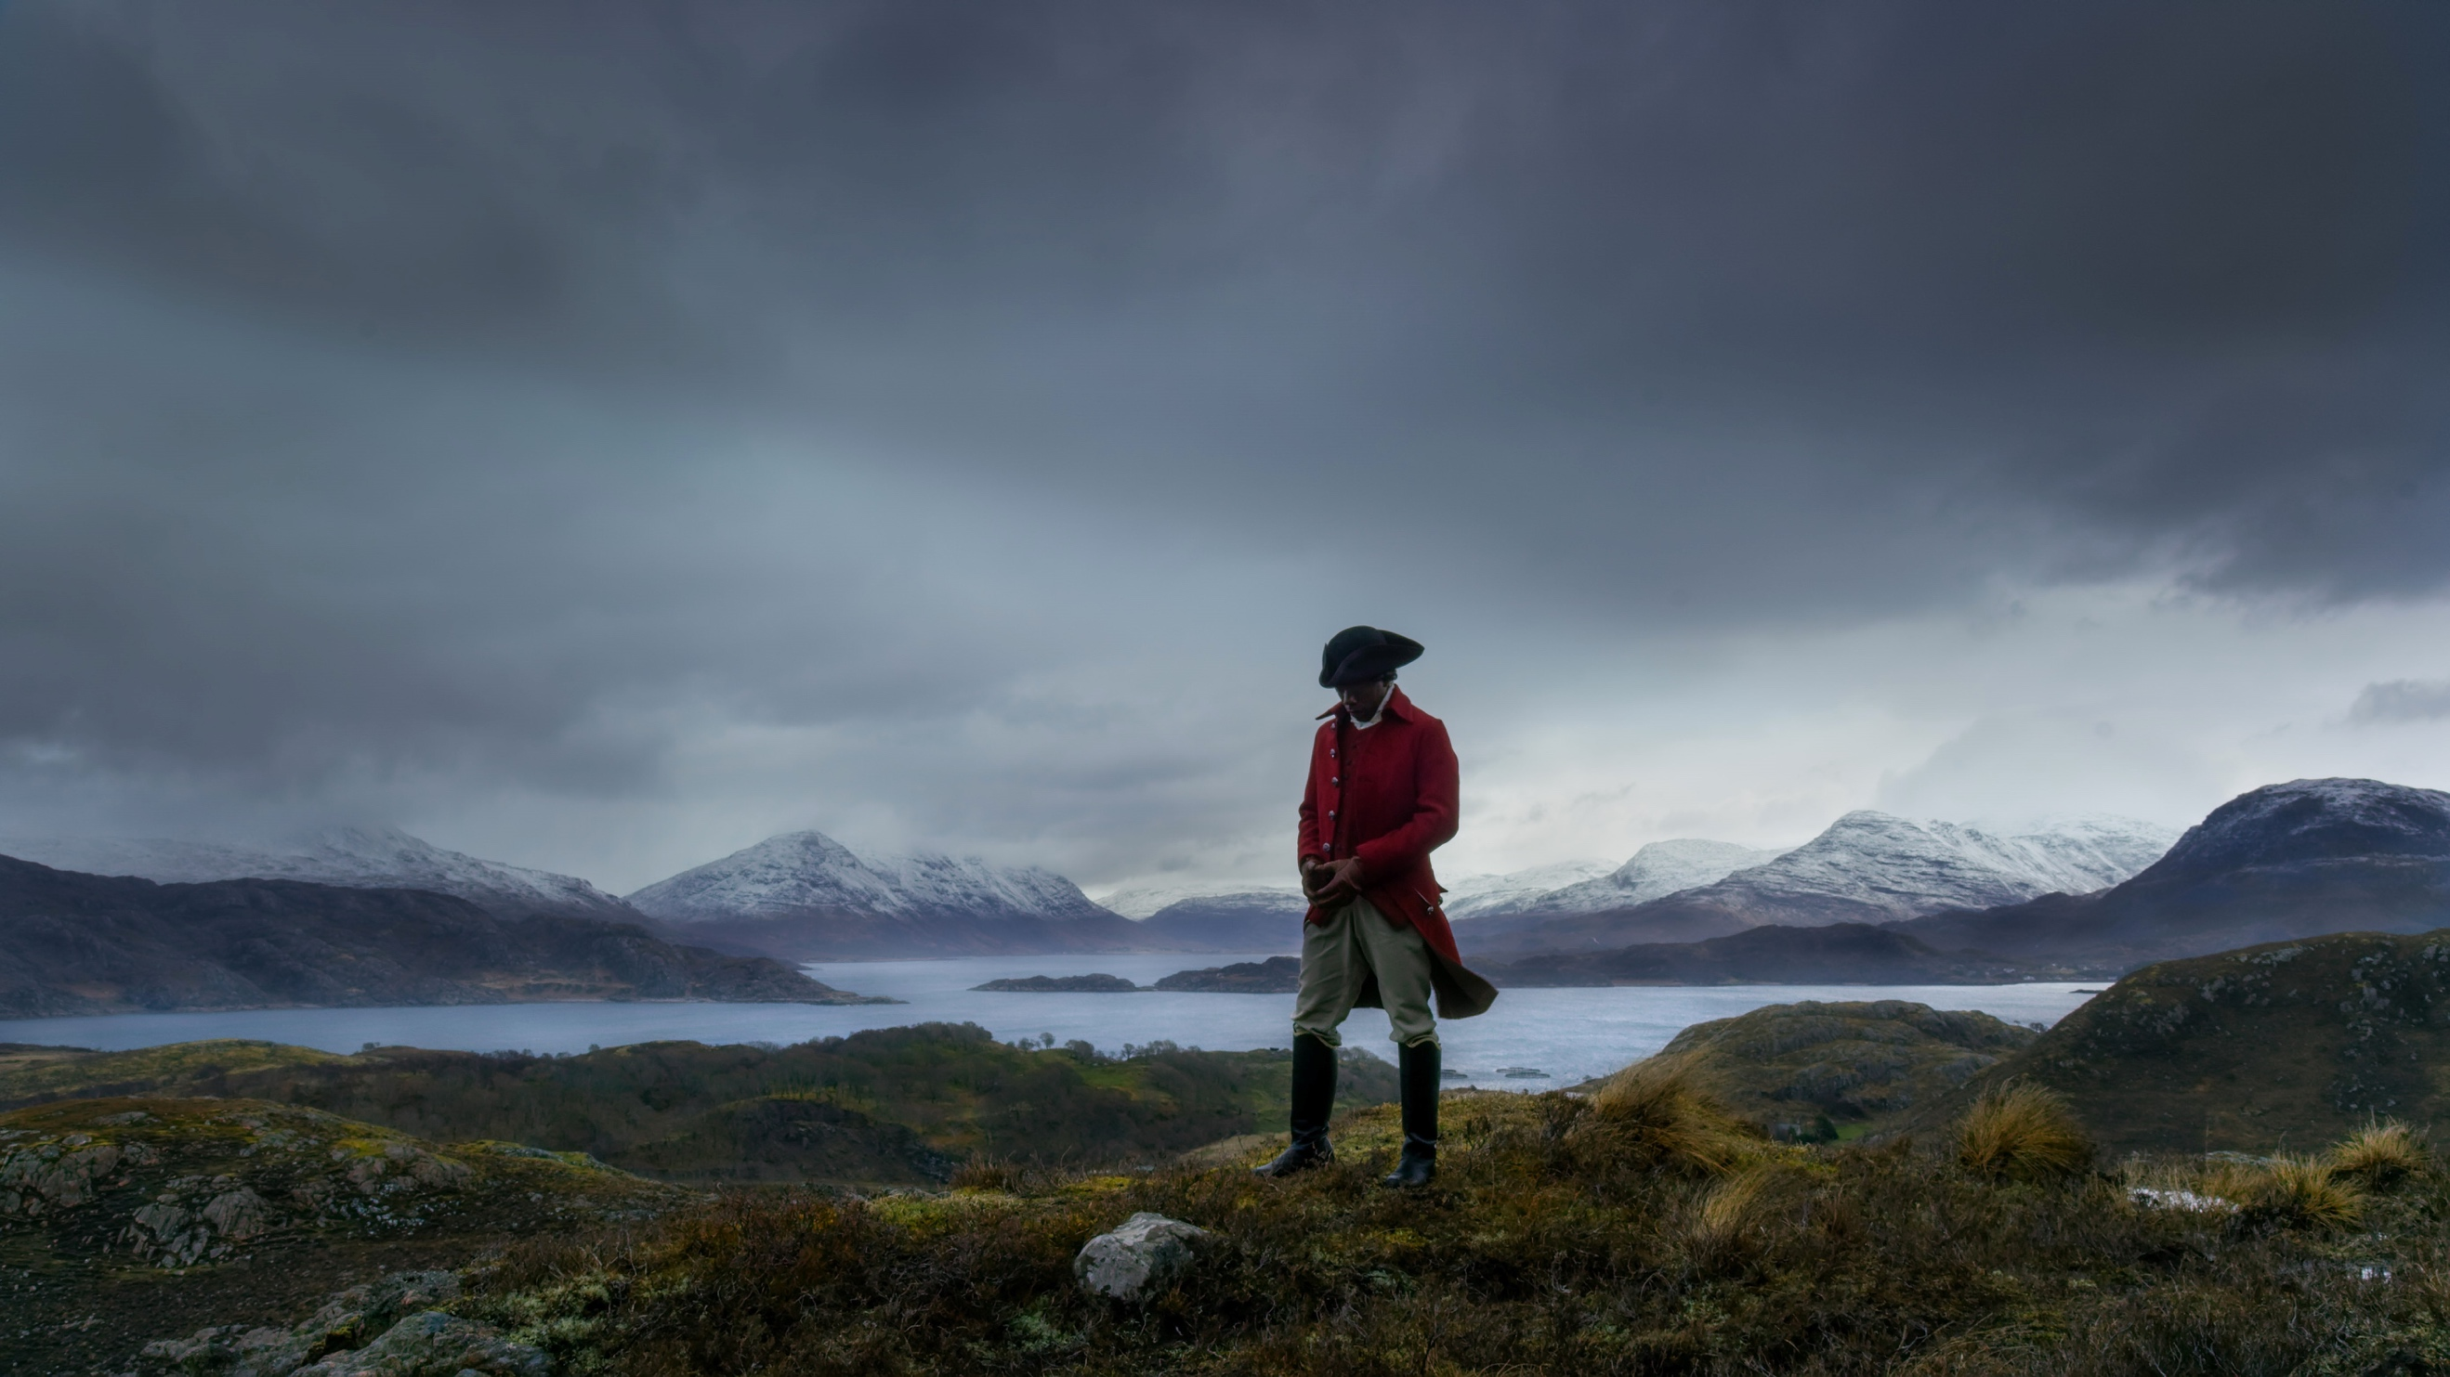

Image: John Akomfrah, Vertigo Sea (film still), 2015. © Smoking Dog Films. Courtesy Lisson Gallery.

Talbot Rice Gallery are collaborating with Document Human Rights Film Festival to present an exciting and timely workshop opportunity for schools. A day of discussion and creative workshop activity led by inspirational artist educator Juliana Capes will give pupils and teachers the chance to explore our next exhibition by acclaimed artist John Akomfrah.

**What is the exhibition about?**

Vertigo Sea is a poetic three-screen film installation which uses the metaphor of the sea to consider the significance of the ocean and man’s often troubling relationship with it. This installation explores migration, the history of slavery, war and conflict and current ecological concerns.

**Who is the artist?**

John Akomfrah is a multi-award-winning artist and documentary filmmaker who uses his work to explore questions around what it is to be a migrant - to live somewhere and be from somewhere else, ethnicity, identity and the environment.

John Akomfrah is a migrant himself, born in Ghana and moved to the UK when he was 4 years old.

**Themes we will explore**

* MIGRATION
* HUMAN RIGHTS
* ETHNICITY
* GLOBAL CITIZENSHIP
* GLOBAL POLITICS & CAMPAIGNING
* OUR RELATIONSHIP WITH THE SEA
* HOW ARTISTS CREATE UNIQUE PERSPECTIVES ON HISTORY & CURRENT AFFAIRS
* FILM/DOCUMENTARY/INSTALLATION/SCULPTURE

**Learning objectives**

* To motivate and engage pupils with the exhibition.
* To learn new conceptual and practical skills making art-work inspired by the exhibition.
* To recognise the many forms that art can take.
* To introduce pupils to new themes and ideas through the unique view-point of the artist.
* Learn about human rights and why they are important.
* Consider the histories of the sea.
* Recognise current issues relating to migration.

**What we will do**

* **EXHIBITION TOUR** - Interactive tour of the exhibition and gallery by artist educator, Juliana Capes.
* **FILM SCREENING**- Watch and discuss a short-film presented by Document Human Rights Film Festival – *Stateless in Lesvos*, an eyewitness account filmed on one of the islands considered to be a the front-line of the refugee crisis.
* **CREATIVE WORKSHOP** – Developing the day’s themes and our own ideas through talking, writing and art-making, bringing the exhibition to life and making it relevant for the participants.

**Audience**

* Target Audience – S1-6 (Social Studies/Religious and Moral Education/Expressive Arts).
* 30 participants per session (max.)

**Practical details**

* Sessions will take place on a Monday. Available dates as follows-
* 30/10/2017
* 06/11/2017
* 13/11/2017
* 20/11/2017
* 27/11/2017
* 04/12/2017
* 11/12/2017
* 18/12/2017
* 08/01/2018
* 15/01/2018
* 22/01/2018
* Time – 10am-3pm (lunch 12-1pm, morning and afternoon breaks)
* Pupils can bring their own lunch or alternatively there are many shops on campus where lunch can be purchased. Lunch can be eaten at the University refectory.
* Talbot Rice Gallery is located in the Old College of The University of Edinburgh, South Bridge, EH8 9YL. Easily accessed by public transport with coach drop off points nearby.
* Talbot Rice Gallery is fully accessible.

**Booking**

To book or for further information please contact Clare McAllister on 0131 651 4540 or clare.mcallister@ed.ac.uk.

**Links for More Information**

Talbot Rice Gallery - [Vertigo Sea](http://www.ed.ac.uk/talbot-rice/exhibitions/future-exhibitions/vertigo-sea-john-akomfrah)

[John Akomfrah](http://www.documentfilmfestival.org/)

[Juliana Capes](http://www.documentfilmfestival.org/)

[Document Human Rights Film Festival](http://www.documentfilmfestival.org/)