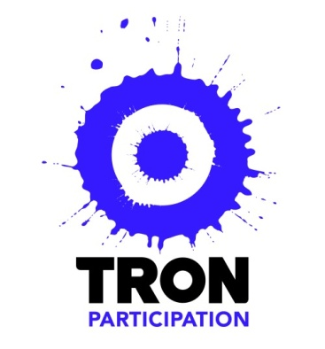

Tron Participation

Aim: To provide opportunities to participate in art activities regardless of age, ability or background.

Why: To encourage the behaviour of theatre-going as both audience and artist because we believe participating in cultural activity enriches your life.

How: Participating in our program can lead to developing new skills, meeting new people and embarking on a life-long relationship with the Tron.

Ambassadors Scheme

Tron Ambassadors scheme will give pupils the chance to be behind the scenes of a working
theatre. It will enable you to make a deeper connection with the Tron Theatre and gain a better
understanding of the industry.

Tron Participation are looking for pupils who –

- Have an interest in theatre
- Use social media such as twitter, Instagram, tumblr, wordpress as a way of conveying their thoughts and opinions with an audience
- Are comfortable talking to groups of people
- Are willing to promote the work of the Tron with family, friends and peers
- Are up for a challenge and happy to learn new skills and work as a team
- Are interested in developing employability skills
- Looking to expand their C.V to aid with college/university/job applications

Tron Ambassadors will –

- Meet 1-2 times per month at the Tron Theatre (after school weekday meetings)
- Take part in tasks and challenges out with allocated Ambassador meetings
- Keep in contact via email with Tron Drama Officer on related tasks and challenges
- Take part in a variety of theatre workshops/master classes
- Attend Tron Shows
- Host Tweet Meets within the Tron Theatre linked to Tron productions
- Promote the Tron to friends and family
- Blog, tweet and post about the Ambassadors scheme, Tron shows and events
- Work as a team to create a Front of House event at Tron Skillshops show

Does this sound like something you would like to be involved in? If so, email deborah.mcarthur@tron.co.uk by 3pm on Friday 22nd August stating your name, age, school, why you would like to be an ambassador and what skills you possess that would make you a successful Ambassador, should you be successful you will be invited along to a recruitment workshop on Thursday 28th August 2014.

