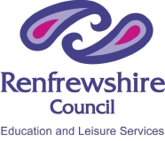 Renfrewshire Council – Education and Leisure Services 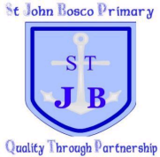

St John Bosco Primary School and Nursery Class
Rights Respecting School – Experience and Outcome Coverage
RERC/RME with Health and Well Being

Our School Gospel Values
“We want our children to be good Christians and upright citizens”

