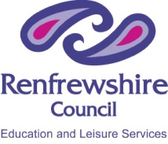 Renfrewshire Council – Education and Leisure Services 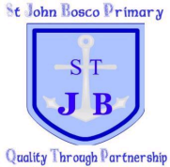

St John Bosco Primary School
3 Column Approach
Primary 1

We thought about a Right which we should enjoy. We decided on what we could all do to help other people receive this right in Primary 1.

Children in Primary 1 will | United Nations Convention on the Rights of the Child | Adults helping Primary 1 will
- Be kind to others when we are playing and relaxing together.  - Be nice to other people in our games  - Be fair when we are playing.  - Let other people join in our games and activities.  - Take turns when we are playing or relaxing together. | Article 31  Every child has the right to relax, play and join in a wide range of cultural and artistic activities. | - Make sure we have a chance to relax and play.  - Look after us in the playground.  - Make sure the playground and dining hall are safe for us.  - Help us to understand games and activities.

