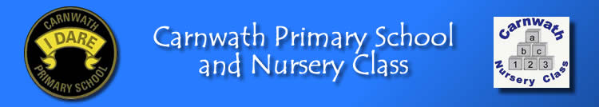
Carnwath Primary School | We Dare to Aim for Excellence
Event Invitation - Live Chat Show: UNICEF Rights Respecting School
Carnwath Primary School and Nursery Class are pleased to invite parents/guardians to a Live Chat Show hosted by the children for the children.
As well as teaching children’s rights in a fun and engaging way, the pupils of Carnwath will be given the right to have their opinions taken into account, the right to receive and share information and the right to reliable information from the mass media. We look forward to welcoming you to a lively discussion.

Date: 19th April 2012
Time: 1.30pm to 2.30pm Fairtrade refreshments will be served after the live chat show
Place: Carnwath Primary School, Couthally Terrace, Carnwath ML11 8HY
Contacts: Email: office@carnwath-pri.s-lanark.sch.uk Phone: 01555 840263
Please confirm your attendance by the 30th March by completing the tear off slip below.
The live chat show panel will consist of special guests:
Tam Baillie, Children’s Commissioner for Scotland
In 2009, Tam Baillie was nominated as Scotland’s Commissioner for Children and Young People. His job is to make sure that all children and young people in Scotland have their human rights respected. Children and young people from across the country helped to choose Tam as their Commissioner by interviewing him and asking lots of questions about what he was going to do to help young people know more about their rights.
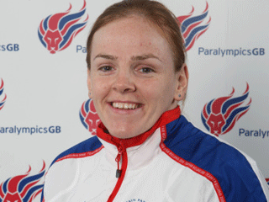 Mhairi Love, Former Great Britain Paralympics Swimmer
Mhairi Love from Larkhall, South Lanarkshire is the former 400m free word record holder. Mhairi has represented the Great Britain swim team at the Athens and Beijing Paralympics. A medal winner at Athens in 2004, Mhairi won 2 silver medals: for the 400m freestyle and the 4 x 50m free relay. Following success in the pool Mhairi went on to found the ‘Love 2 Swim’ school and has over 100 children of all abilities learning every week. Mhairi also holds an MA in Psychology from Stirling University.
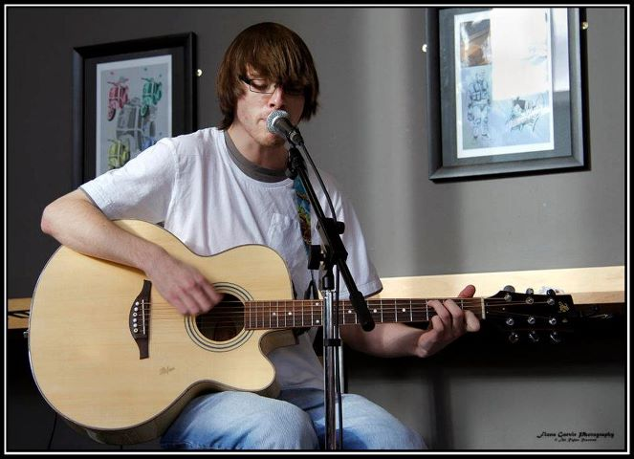 Matthew MacConnell, Singer and Songwriter
19 year old Matthew is a musician and singer/songwriter from Lanark. Matthew has been playing the guitar and performing lead vocals for four years in the band Static Rock. He will be rocking the house with an exclusive solo set for the friends and guests of Carnwath Primary School.

Carnwath Primary School is proud to hold awards from UNICEF, The Fairtrade Foundation, The British Council Global School Partnership Programme, Eco-School Scotland and is a gold Health Promoting School and Nursery.


Live Chat Show

I would like _________ tickets to attend the ‘Live Chat Show’ on Thursday 19th April 2012 at 1.30pm – 2.30pm.

Signed (Parent / Carer ) _________________________ Pupil’s Class___________________

