**Clydemuir Primary School**

**International Day**

June 2013

One of the members of the working party took on responsibility for organising this house day.

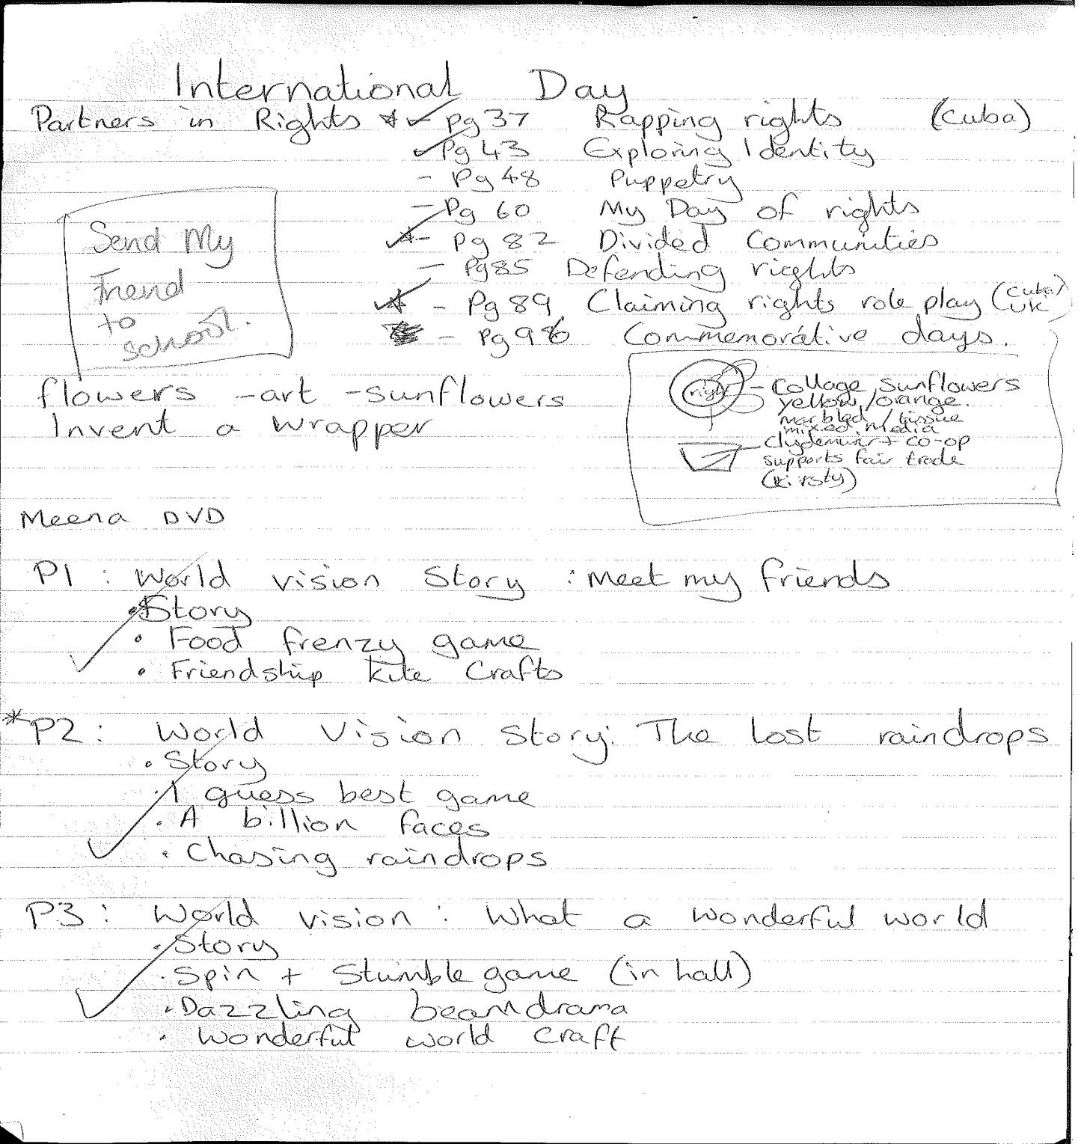

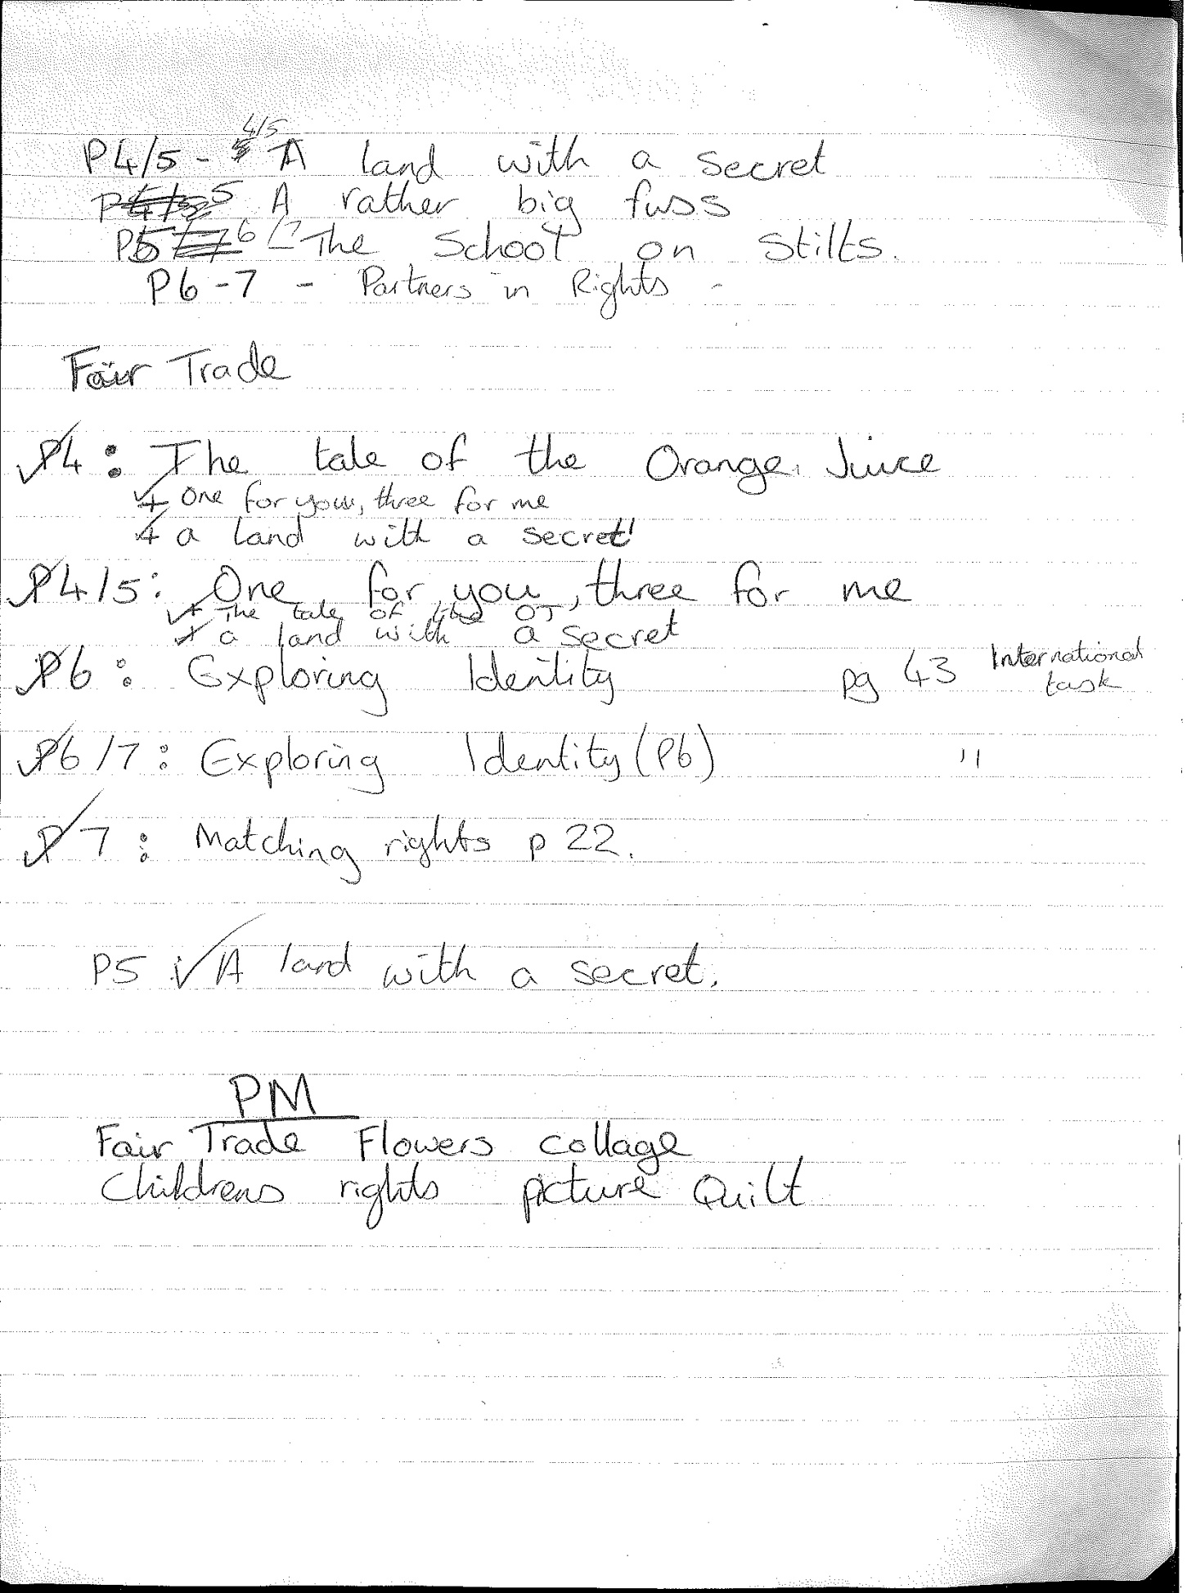

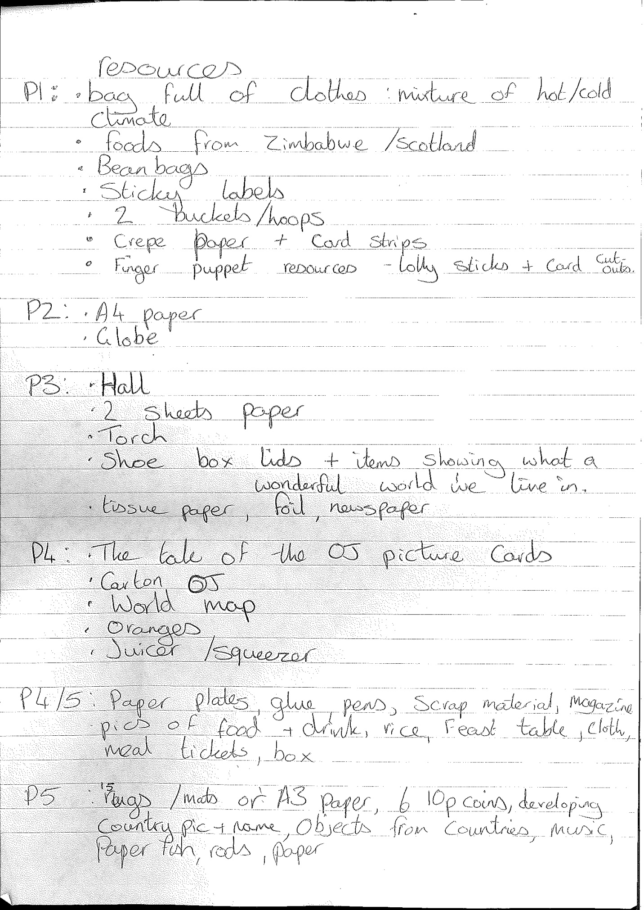

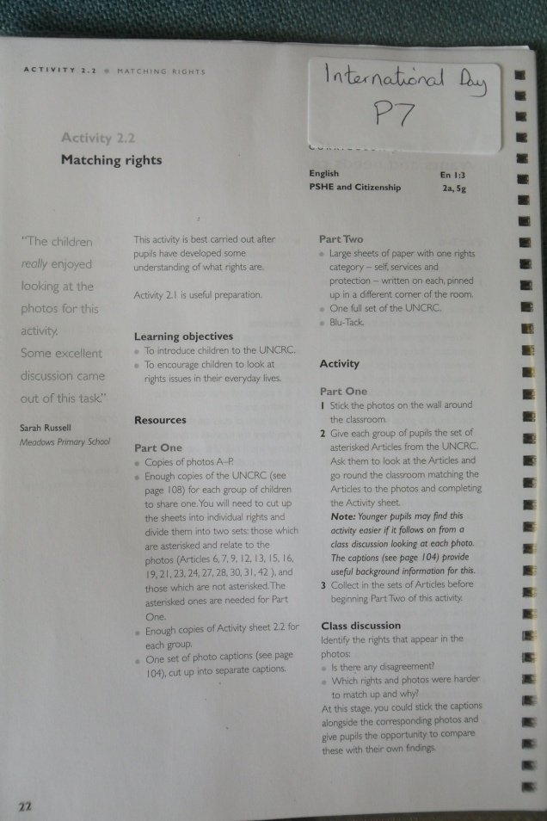 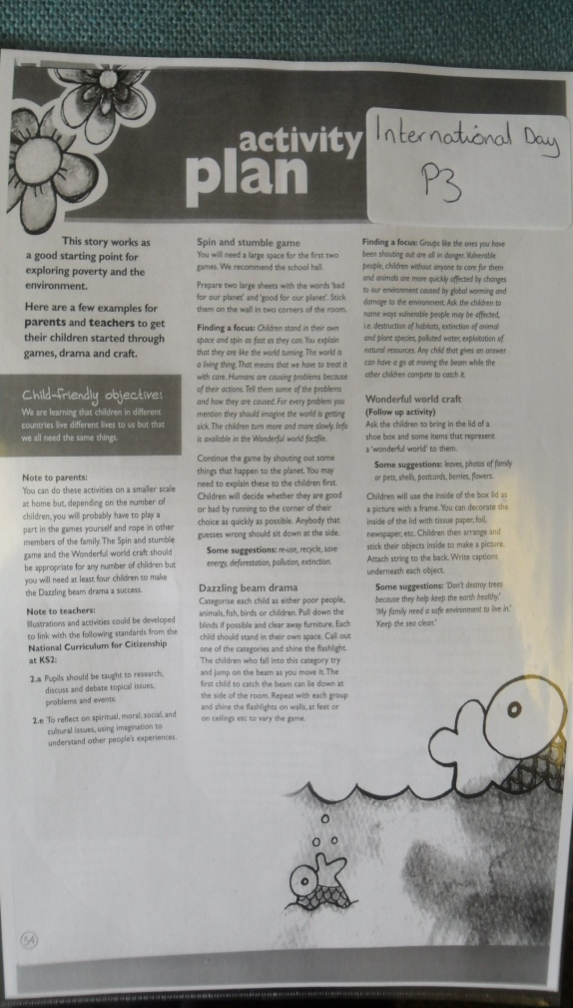

**Drag to expand**

(Examples of the resources given to each class for this house day.)