Clydemuir Primary School
Health Day
Thursday 4th October

AM Activities

Fun run/walk with obstacle course on the pitch – Infants – 9.30am (20 mins)
Juniors – 10.50am (20-30 mins)
Seniors – 11.40am (20-30 mins)
(Parents can come and participate)

Activity 1 - All classes to make class charters as part of Rights Respecting Schools (see information below).

Activity 2 – Juniors – Why does Health matter?

Infants – Born Free book and discussion (there is one book for P1, one for P2 and one for P3 so they can be swapped between classes
Seniors (swimming, football, kitchen and leaders in infants)

Activity 3 – Olympics clips – there will be links to these within the shared area and they can be shown on the smartboard and discuss pupil reactions.

PM Activities
Split into house groups. Meet in hall just after 1pm. Children should have been told beforehand which house they are going too, we will try to do it without reading out all of the names. Olympics pictures playing in the background.

Activity 1 – What is Health?
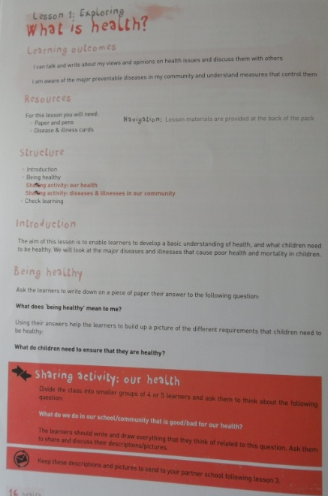

Activity 2 – School health statement and Action Plan (see attached info) This is for sharing ideas that could go into a school Action Plan

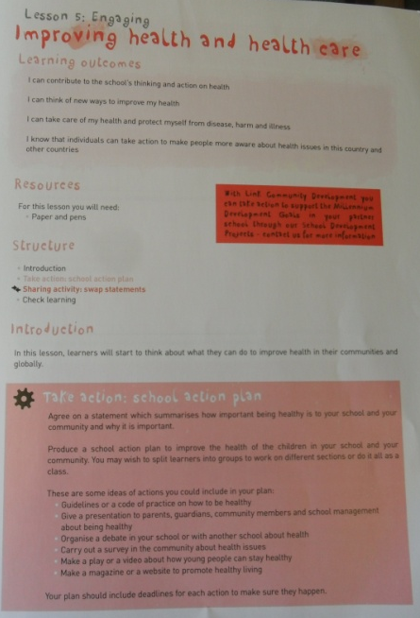

Activity 3 – Posters for Fumbwa Primary on a health and wellbeing theme: perhaps on benefits of exercise, brushing your teeth, mosquito nets, importance of clean water etc. (If time)

Activity 1 AM
Class Charters

For the RRS Award every class to develop a classroom charter.

Each class will focus on a minimum of 3 rights from the following that have been chosen as most relevant to school:
Articles 12, 13, 14, 15, 23, 28, 29, 31.
Each class chooses which rights they wish to focus on.

Here is some advice from UNICEF on writing the charter:

- Use the 3 most popular articles for the class charter / agreement; the children need to identify the behaviours to be considered by EVERYONE in the class to ensure ALL children can experience the rights identified.

- Agree the wording and ownership by the class. Allow time for discussion around any issues that the children have – for example signing them, wording, what happens if new people arrive.

- Link the wording on the charter to the CRC.

- Regularly revisit the charter.

The main points to remember are:

- In learning that these rights are universal, children understand that this means that their
rights are something everyone has as a result of being born. No one has power to give them to you or take them away from you. There are no conditions attached to them.
- When we learn about rights, we learn that not only do we have them ourselves, but everyone else has them too. When we are enjoying our own rights, therefore, we have a duty to make sure that we do so in a way that doesn’t deny other people theirs. A rights-based approach encourages respectful behaviours.

- Adults working with children need to model rights respecting behaviour and use rights respecting language in order to reinforce the benefits of this values system.

- It is important that adults and children alike learn not only that all children should be rights respecting but also that adults bear the responsibility for ensuring these rights are known, understood and realised (article 42).

When the class have chosen their articles there are two questions to consider for each one:
- What do the children agree to do to ensure that everyone has their rights realised and enjoyed?
- What actions will adults take to ensure that this right is realised and enjoyed by all?

