Clydemuir Primary School
Global Citizenship and Rights
Rights Respecting Schools/International Day

May 2012
AM activities

In the morning could everyone please complete activities 1, 2 + 3. Activities 4 and/or 5 can be done if you have time. Please do them another time this term if you do not have time today.

AM – Activity 1
What is a global citizen?
(Develop self-worth and respect and make a difference)

- Photocopied activity 41 p.83-84
- Statements and diamond diagram are included in your pack.
- Complete this activity to the point where the children discuss their answers and what they can do to show they are doing these things. Please do not glue onto the diamond diagram at this point – we will use them again in the afternoon.

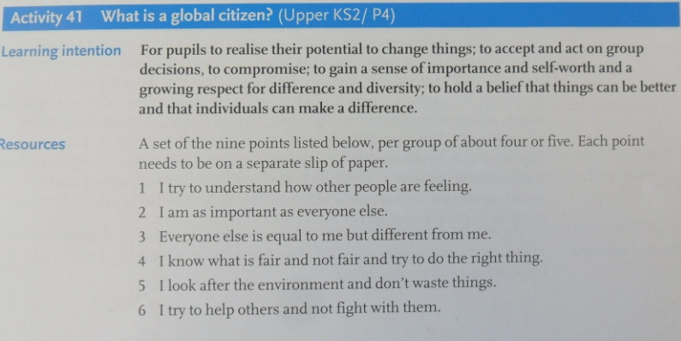 Drag to expand

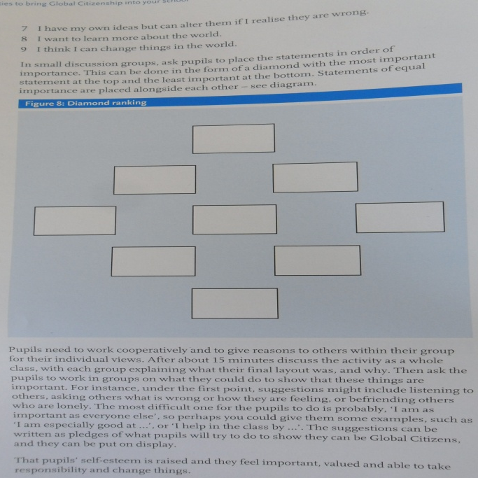 Drag to expand

AM – Activity 2
Where is this place?
(Awareness of stereotypes and prejudice)

- Photocopied activity 56 p.93-94
- Worksheet included in your pack.
- Power point with pictures and information about Thailand are within the shared area on the server.

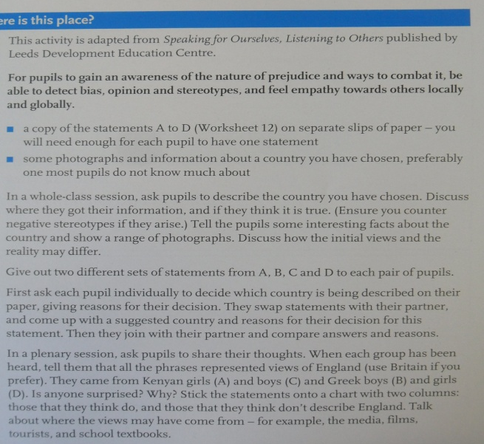 Drag to expand

AM - Activity 3
What do you know (or think you know) about Africa?
(Baseline activity)

- Outline maps of Africa with questions on them in your pack.
- Pupils complete a co-operative learning task in groups going round each sheet answering the questions.
- This will give us a baseline of what the pupils know (and/or the stereotypes they have) which we can redo at a later point to see the knowledge they have gained.
- Please put the stage at the top of the sheets so we know their rough age at the time of doing the activity.

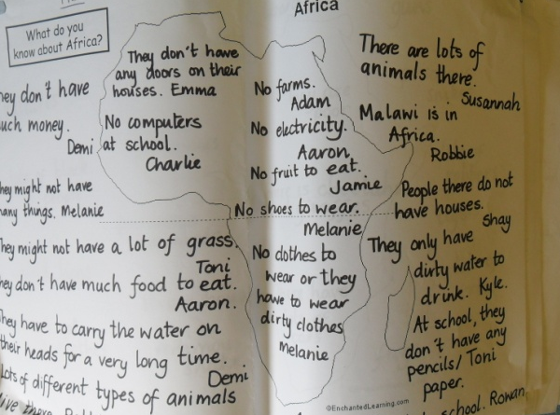 Drag to expand

AM – Activity 4
Our links around the world
(awareness of cultures, trade and world events)

- Photocopied activity 42 p.85-86
- Worksheet is included in your pack.
- This activity could be completed in pairs or groups or as global bingo which is described within the activity.

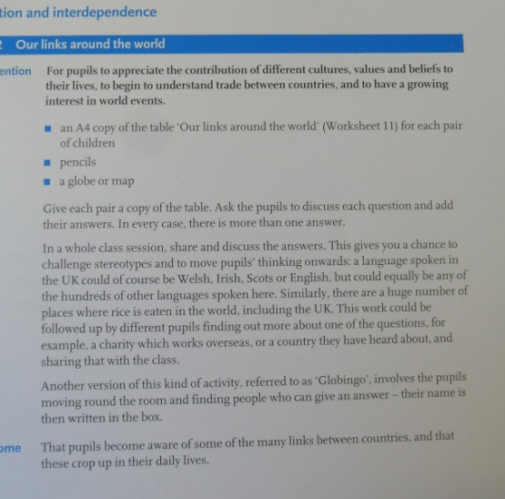 Drag to expand

AM – Activity 5
Malawi link school

Pupils can complete an activity for our Malawi link school. This could be:
- Fact sheet about Scotland or our local area or the school.
- List of questions for the pupils to ask the teachers who are coming from Malawi.
- Art/picture activity related to the morning’s activities to take over to Malawi or for our wall display.
- Fact sheet about the different foods we eat/grow in Scotland. (The children/teachers in Malawi always ask about this)
- Describe a playground/PE game for children to play in Malawi – remember they do not have many resources. We will be taking balls over.
- Make number of alphabet strips for us to take over for infants to use, or a times tables display chart or other resources you can think of.

