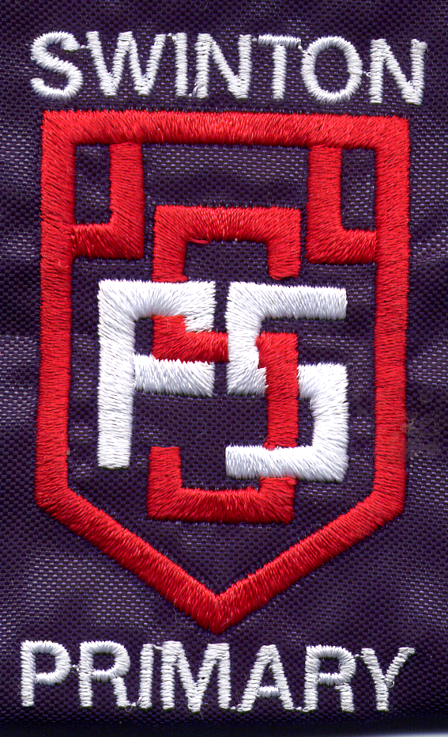
Swinton Primary School

Assembly Themes

In order to support the on going whole school development in Rights Respecting Schools each month will have a particular theme. The theme will be introduced at the start of the month by AHT and at the end of the month you will award certificates to children relating to this theme. The children will bring their certificates to assembly to celebrate their achievements.

Month | Theme | Rights of the Child Article Numbers
September | Listening | 12
October | Eco school | 27 & 24
November | Anti Bullying | 31
December | Developing skills and Talents | 15 & 29
January | Healthy Lifestyle | 6 & 24
February | Fairtrade | 2
March | Citizenship | 28
April | Healthy Choices | 24 & 6
May | Conflict and Change | 22 & 10
June | Success and Ambition | 3

There are a number of resources within the school that will support you in further developing these themes within your classes.

If you are looking for further information on these please see Michelle.

