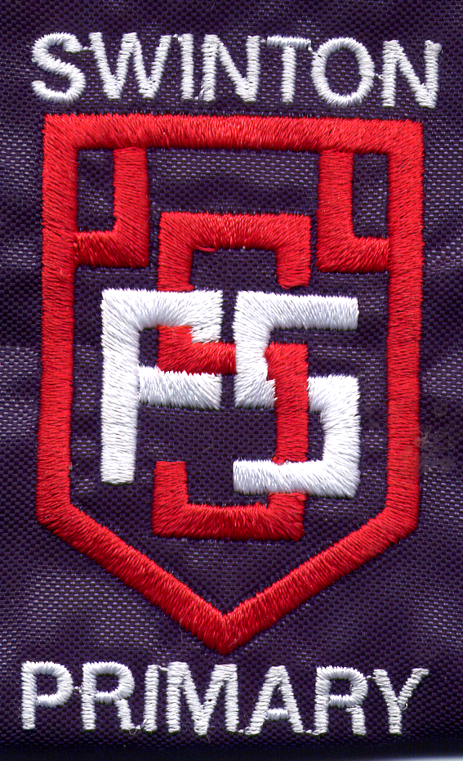

Swinton Primary School

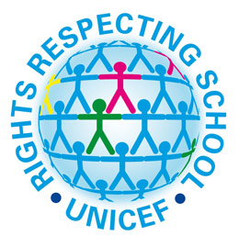
Think about the curricular areas and the learning and teaching you have planned for this term.
It is really important that the children are well informed of the links between what they are learning and the Rights and that you have this clearly outlined in your displays.

Please think of the learning taking place in your class – reading books, novels, topics, RE and note down below the Rights you expect the children to be able to discuss from their learning.

Curricular areas | Rights to be focussing on with the children
Literacy
Numeracy
Health & Wellbeing
Expressive arts
Social Studies
Technologies
Sciences
RE
Other

