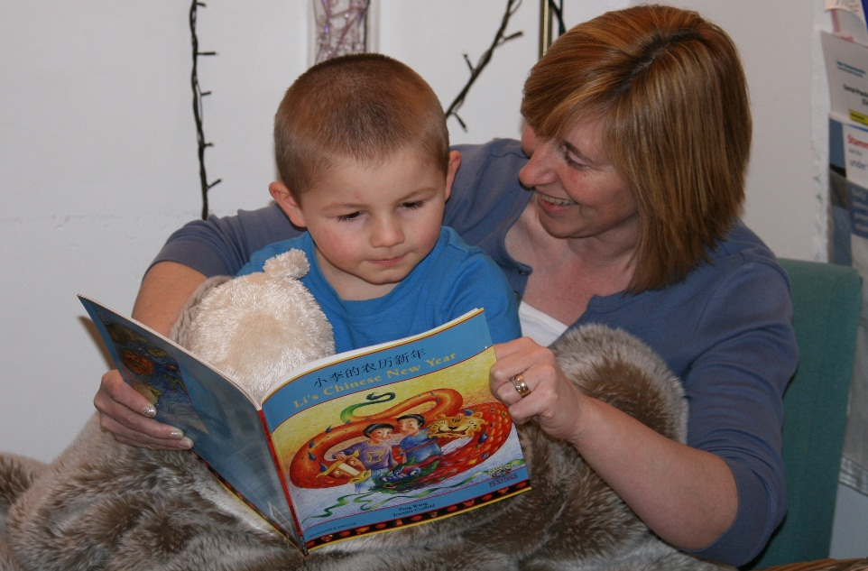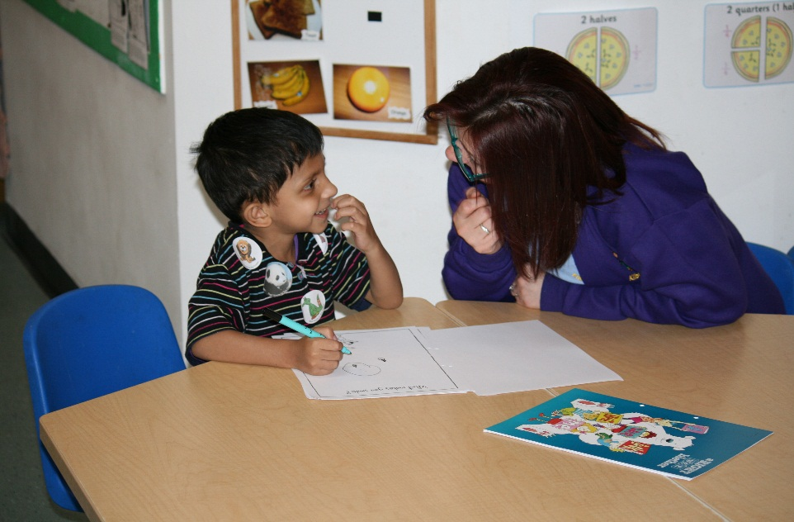

**Article 28**

You have the right to an education

*Articles of the UNCRC*

**Article 12**

Your have the right to an opinion and for it to be listened to and taken seriously.

*Articles of the UNCRC*

Everyone under 18 has these rights