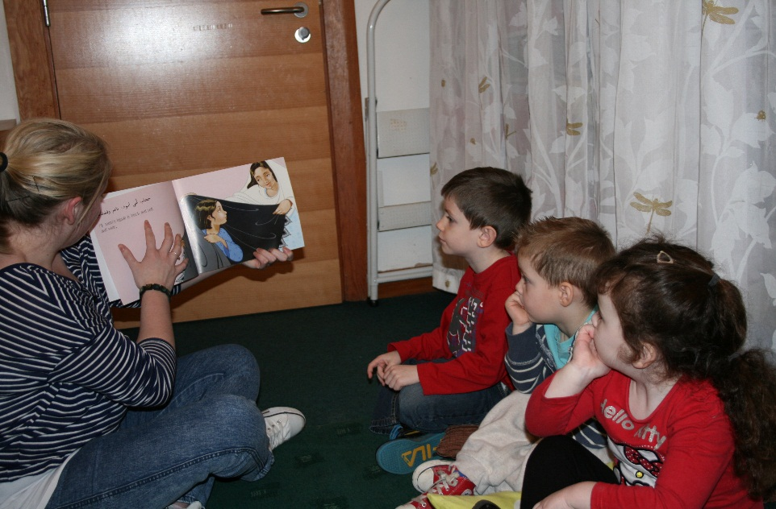

**Article 2**

You have the right to protection against discrimination.

*Articles of the UNCRC*

**Article 1**

Everyone under 18

has these rights.

*Articles of the UNCRC*

Everyone under 18 has these rights