**Our Rights Respecting School Journey – Inverkip Primary School**

**What is the Rights Respecting Schools Award?**



UNICEF UK’s Rights Respecting

Schools Award helps a school

community to use the United

Nations Convention on the

Rights of the Child (UNCRC)

to help develop a clear set of values

that are actively upheld by pupils.

**What are children’s rights?**

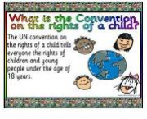All human beings – adults and children alike – are entitled to basic human rights. Children have a particular set of rights due to their vulnerability and need for protection. The UNCRC sets out the rights that must be realised for children to develop to their full potential, free from hunger and want, neglect and abuse. These rights are not something that children need to earn or that adults and governments can take away as a punishment. They contain the basic protection and support that all children are entitled to. All children have the same rights, no matter what their background or where they live.

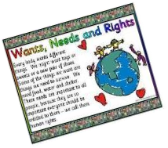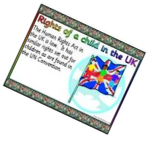

**How did we start our journey?**

First of all Rights Respecting Schools was included in our School Improvement Plan and in our 3 year Strategic Plan.

Then, we put a Steering Group together, consisting of teachers, parent, community leader and several children from Primary 4 -7.

We accessed the RRSA website and spoke to our local Children’s Rights and Information Officer to guide us on our way. One of our teachers visited a Children’s Rights Showcase in Glasgow to get ideas and to speak to people already on the journey.

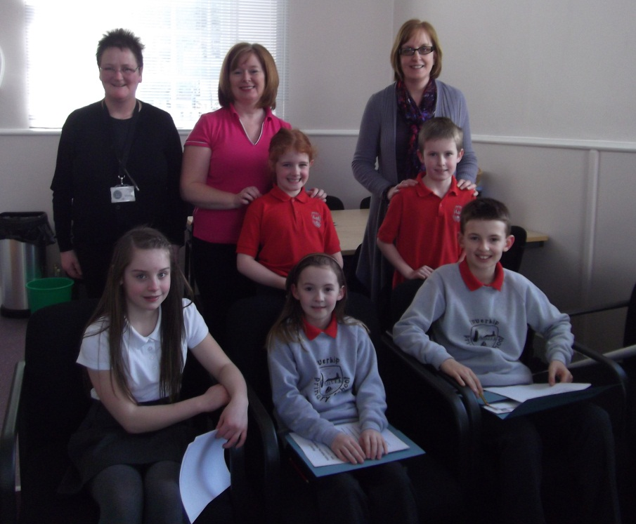

The Steering Group 2012-13

**What we did:**

* From August 2012 we decided that all of the monthly class assemblies would focus on an Article from the CRC (UN Convention of the Rights of the Child). The whole school and parents were then invited to the assembly to see what the children had learned.
* The Steering Group met regularly and produced an Action Plan to help the school achieve Level 1 status of the RRSA.
* The Steering Group developed a whole school awareness of the CRC by creating and developing a noticeboard at the Reception area of the school to let everyone see what was going on in the school as regards Children’s Rights and to give them more information about the CRC.
* The children in the Steering Group identified the Articles of the CRC that linked to work and areas in the school and put up labels recording what these Articles were.
* Links between the CRC Articles and learning at school were made and documented.
* Each class, including the nursery, created Class Charters. They identified the CRC Articles that suited each individual learning environment and classroom and displayed these artistically.
* Every child in the school and nursery learned about and discussed the differences between wants and needs in our daily lives.
* Every child also completed homework to discover how their name was chosen for them. This linked to the CRC Article 7 –the right to a name.
* The children in the Steering Group designed a leaflet to send home to all parents and careers to ensure that they were all aware of Children’s Rights and the work that was being done in the school.
* The Steering Group, with the help of a teacher ensured that there was a link on the school website to the Unicef website and to the RRS work being done in the school.

**Where are we now?**

May 2013- We are soon going to be assessed for Level 1 Status. The Steering Group are busy making sure that everything is in order. Hopefully we will have good news to report.