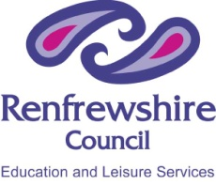 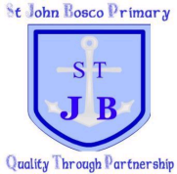 Renfrewshire Council – Education and Leisure Services
St John Bosco Primary School and Nusery Class
Articles Bingo!
2 |  | 8 | 14
 | 19 |  |  | 3
9 | 4 | 20
 |  | 6 |  | 7
 | 1 |  |  | 16

