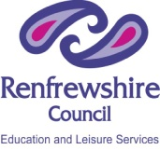 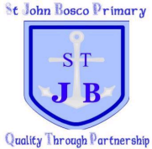 Renfrewshire Council – Education and Leisure Services
St John Bosco Primary and Nursery Class
Articles Bingo!
22 |  |  | 26
 | 23 |  |  | 27
33 | 36 | 30
 |  | 29
 |  |  |  | 32

