Glow Blogs e-Portfolio Plugin
Table of Contents
Before you start 2
Creating a new e-Portfolio 3
e-Portfolio Profile Tags 3
Creating a Profile 4
Editing a Profile 4
Add Profile Screen 5
Editing a Profile 2 6
e-Portfolios: Profiles, View, Print or Download 8
e-Portfolios: all Profiles 9
Privacy Settings 10
Adding Users Setting Roles 11
Accessing and Keeping track of e-Portfolios 13
Privacy Settings Considerations 13
Setting Up a Blog to Share links 13

Glow Blogs provide one way to tackle e-portfolios/profiling.
A Glow Blog e-Portfolio is a blog with the e-portfolio plugin activated.
Prior to November 2015 e-portfolios in Glow were developed using one of the special e-portfolio themes. These now cannot be selected in the theme picker. We recommend that these are no longer used and e-portfolio blogs are converted to use different themes and the plugin. The old themes will continue to work on blogs they are already applied to for now.
An e-Portfolio blog consists of a series of posts. The plugin adds a new taxonomy Profile Tags, to these posts. The profile tags help to create a profile from the posts.
Profiles are creates, edited and published from the Profiles section of the Dashboard. The process is greatly simplified from the earlier theme based profiles.
Profiles can be viewed on the blog, printed and saved to PDF.
An e-portfolio can use any theme, which can be customized by pupils. This customization will not be reflected in the profile, pdf or printed profile.

Before you start
There are a few factors to consider before beginning to set up e-Portfolios with a school or class.
- Privacy and Permissions
- Access to e-Portfolios
These are linked. E-Portfolios, like any other blog, can have a variety of permissions set on them.
Currently most e-portfolios have been set up as Private blogs. Private blogs can only be accessed by users who have been added to the blog.
Some schools/classes make their e-portfolio blogs Glow Only this means they can be accessed by anyone who has the link to the blog and who can log onto Glow.
Practical aspects of how set permissions and add users are covered later in this document.
It is also necessary to have a way for teachers, and if pupils are sharing their blogs with their peers, peers to find the e-Portfolios. Several methods are listed later in this document.
You will probably have to gather a set of usernames and create a place for links to be shared before you start.

Creating a new e-Portfolio
A Glow WordPress e-Portfolio blog is just a normal blog with the e-portfolio plugin activated.
When creating a new blog you can automatically activate this by selecting e-portfolio as a blog type.
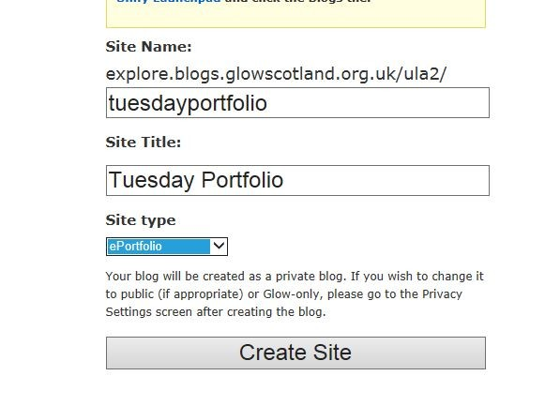
This will automatically activate the plugin and add the profile widget to the sidebar of your blog.

e-Portfolio Profile Tags

Profile Tags are added to e-Portfolio posts to help create the profile.  You can only have one Profile Tags per post.  To add a Profile Tags to a post:  - Create the post in the usual way  - Highlight the appropriate radio button  - Publish the post.  You can edit the post and change or remove the Profile Tags at any time. | 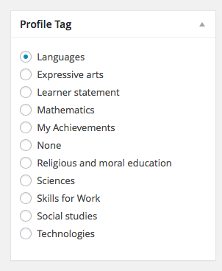

Creating a Profile
You can create any number of profiles from your posts on an e-Portfolio blog.
Profiles differ from Posts and Pages on a blog as once Published they cannot be edited. They can however be cloned and that clone edited.
There are tow ways to add a new Profile to your blog:
- In the Dashboard got to Profiles -> Add New
- On if you are on the front of your blog choose Profile from the New menu on the Admin bar.
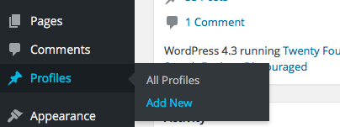 | 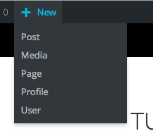

Editing a Profile
The Add new profile page will let you do the following:
- Name the Profile
- Add your school name and class.
- Add a badge image (for school badge for example) and a Profile image.
- Order the Profile sections and adjust their content.
- Save a Draft Profile
- Preview a Profile
Publish a Profile.

Add Profile Screen

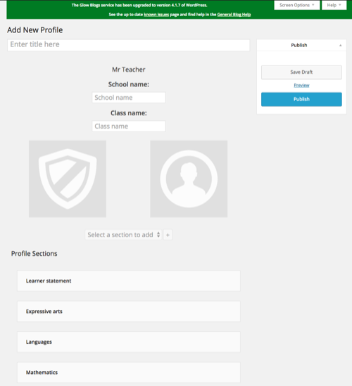

Editing a Profile 2
On creating a new Profile the profile sections that have posts with the relevent Profile Tags will be added to the profile.
Profile sections can be rearranged by drag and drop.

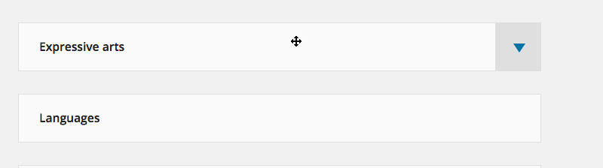
Rearranging sections
When you hover over a profile section the cursor changes to a ‘move‘ cursor and a disclosure arrow appears.

Profile sections can be removed: Expand the section and click remove selection.
The content of profiles sections can be edited.
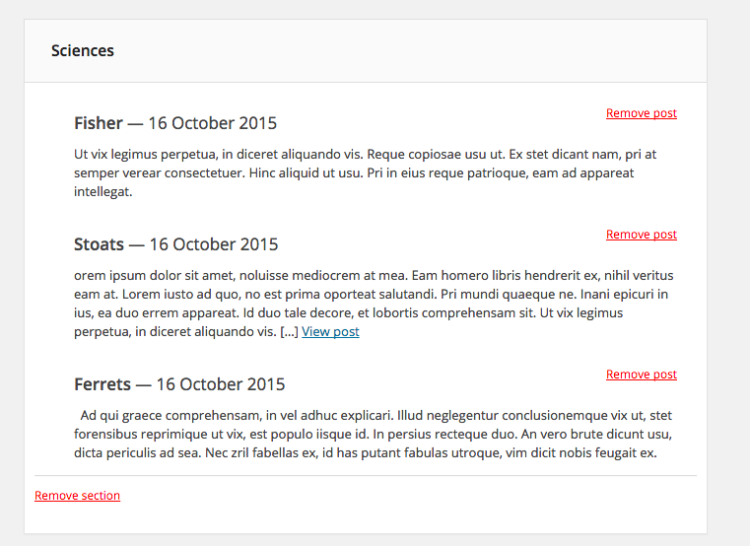
Expanded Section
By default the profile section will show the last 3 posts with the appropriate profile tag. These can be removed. Once removed you can add other post with that tag with the pop-up at the bottom of the section.

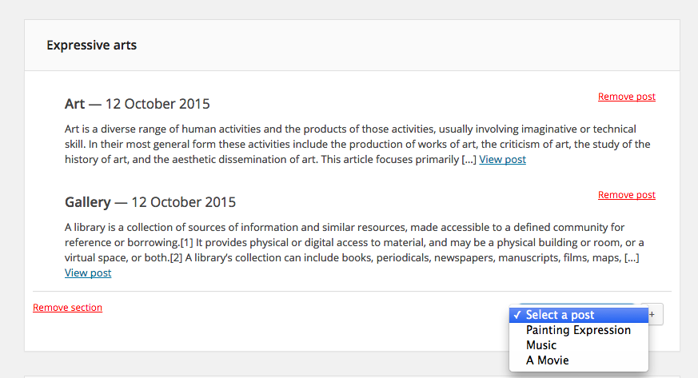
Adding a Post to a Profile Section 1
Profile can be saved as Drafts or Published.
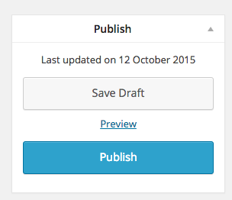
Publish Metabox

Once published Profiles cannot be edited, although a clone can be made and that clone edited.
If a profile has been saved as a Draft you can preview the profile.

e-Portfolios: Profiles, View, Print or Download
Once a profile is published you can view, print, save, download as a pdf or clone that profile.
Immediately on publishing the profile you get a link to View Profile.
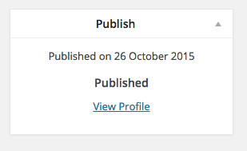
Clicking that link will take you to the profile where you can see links to Print, Download or Clone the profile, in the blogs admin bar.
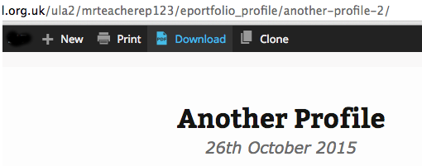
Clicking Print will print the page as it appears in the browser.
Download will download a pdf of the profile.
NB, the pdf may be more suitable for printing that the browser page. In the browser page, video and embedded content will appear as an image, in the pdf they will be represented but a URL.
Clone will allow you to make a draft copy of the published profile that you will be able to edit.
You can also View (and then print), Download and clone your profile from the All Profiles page.

You can also access all Draft and Published profiles from your Dashboard.

e-Portfolios: all Profiles
The All Profiles Screen lists your draft and published profiles.
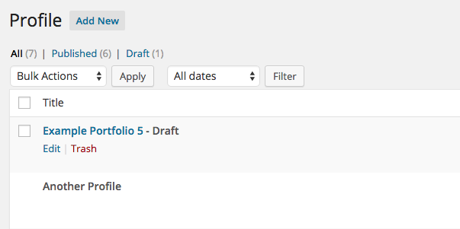
Draft Profiles are listed as draft hovering the mouse over this shows link to Edit and Trash the post (on a tablet these will always be visible) .
There are Different options on a Published Profile.
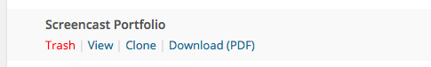

You cannot edit a published profile. If you need to edit a published profile you can make a clone and edit that.
View will allow you to view the profile, where you will see options to Print, Download and Clone.
NB. the pdf may be more suitable for printing that the browser page. In the browser page, video and embedded content will appear as an image, in the pdf they will be represented but a URL.

Privacy Settings
As pupil set up their e-Portfolio blogs they may want to change the privacy settings.
Glow blogs can be set to have three different privacy settings:
Private, this is the default for newly created blogs, only members of the blog can view it.
Glow only, these blogs can only be viewed by authenticated (logged on) glow users.
Public, these blogs are open for anyone with an internet connection to view.

It is unlikely that e-Portfolios will be made public, if you do need an e-Portfolio blog to be made public a teacher would need to be added to the blogs as an Admin and change the settings.
The advantage of setting the e-Portfolio as a Glow Only blog is that other teachers and pupils can view the blog and profiles without having rolls on the blog.
Accessing the settings
After you log onto glow and visit the Dashboard of your blog the Settings menu is at the bottom of the left hand navigation menu.
If the Setting menu is collapsed you can expand it by clicking on the disclosure arrow [1]
Then Click Reading [2]
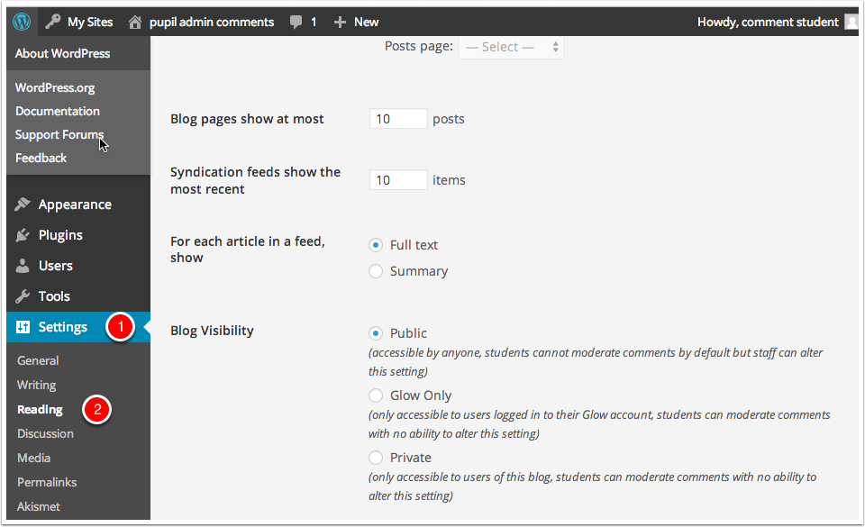
The settings screen is very straightforward, you just choose the radio button for the setting you want and click Save Changes,

Adding Users Setting Roles

On the Dashboard the Add Users screen is accessed from the Users section of the left hand navigation, you may have to expand the Users section by clicking on Users [1] before clicking Add Users [2].
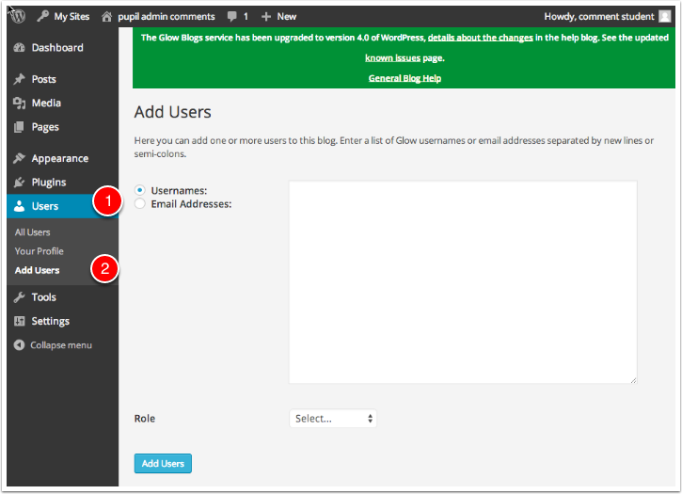
Add Users
To add users you
- Type or paste the list of users you want to add to the blog ino the username fields. Alternatively you can use an email address if they have already logged on to Wordpress and added an email. At this time it is best to avoid using the Email Address option. At the time of writing we believe that the username is the best option, there may be problems with how we are dealing with email addresses.
Choose the WordPress role you want those users to have from the popup.
Click Add Users
You will see a message at the top of the Add Users screen.
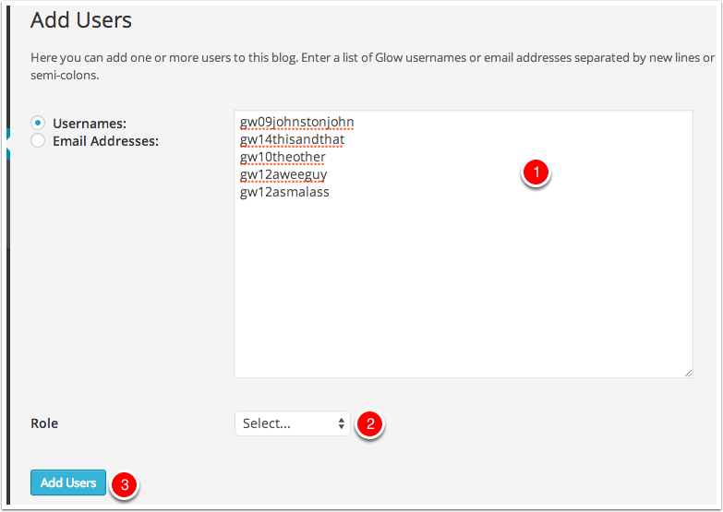

After users have been added to the blog they can be managed from the All Users screen
You can view information about the users and change or remove their role on the blog.

Roles
- Administrator – somebody who has access to all the administration features within a single site.
- Editor – somebody who can publish and manage posts including the posts of other users.
- Author – somebody who can publish and manage their own posts.
- Contributor – somebody who can write and manage their own posts but cannot publish them.
- Subscriber – somebody who can only manage their profile.
The Subscriber role can be used to allow Glow users to see a private blog. This can be used to allow a child’s peers to access the blog for peer assessment and to provide an audience.

Accessing and Keeping track of e-Portfolios
One of the challenges for teachers in keeping track of their pupils e-Portfolios and profiles is finding the blogs.
In a future phase of development we hope to provide a way for teachers to get updates pushed to them from pupil e-portfolios. For now, the process needs to be a bit more mechanical.

Privacy Settings Considerations

If a pupil’s e-Portfolio is private the pupil needs to add any teacher (and fellow pupils) to the users list in their blog. Often they will want to add at lease one teacher as an admin.
If a pupil’s e-Portfolio is made Glow Only, any Glow user will be able to access their blog, if they know the URL.
In both cases the urls will need to be shared with the teachers and pupils who need to access them.
Before Oct 2014 in ‘old’ glow these links were generally gathered in a weblinks web part in SharePoint. This method will still work. Other options might include a shared Word document, OneNote, or the creation of a shared Blog or Wiki with links to a set of e-Portfolios.

Setting Up a Blog to Share links
Create a blog. This can be kept as private.
Add all the pupils in a class or set to the blog as Editors.
Each pupil logs onto the blog and adds a link to their e-portfolio:
Dashboard->Links->Add New

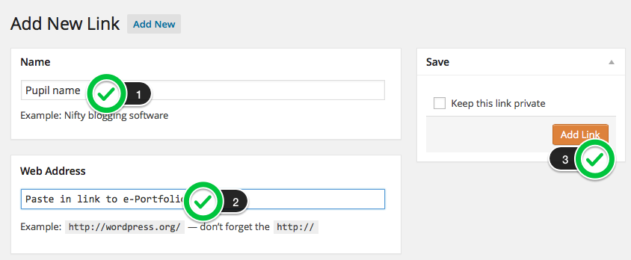
The Teacher/Admin can add the weblinks widget to the side bar: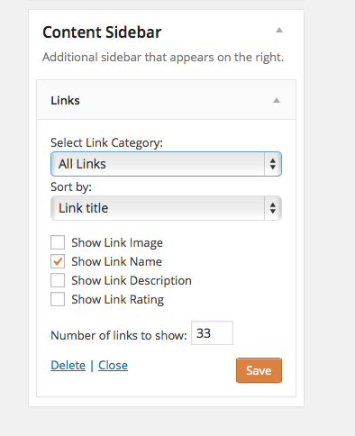
And the blogs can be visited via the ‘hub’ blog.
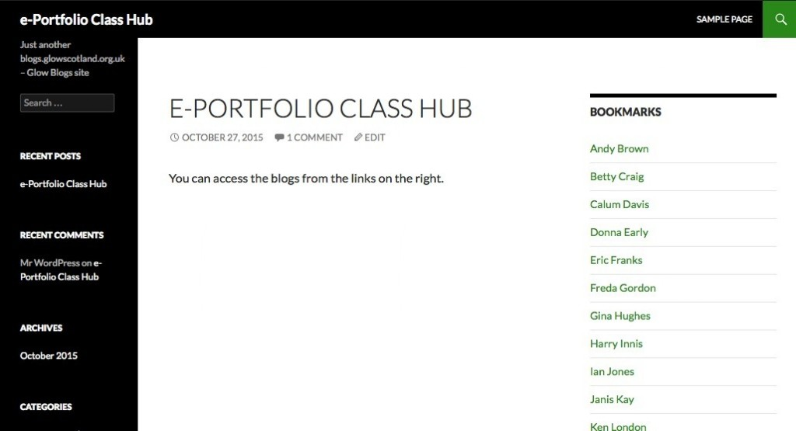
For teachers regularly visiting multiple e-portfolios we would recommend bookmarking them to a folder in their browsers bookmarks. This means that they can open all the blogs in tabs with one click (be sure to log on to Glow Blogs first!

